Java

# Spring & Hibernate for Beginners (includes Spring Boot)

# Introduction and Setup(pdf)

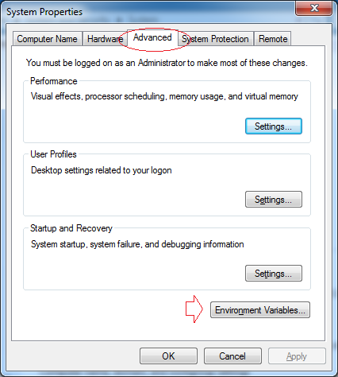

Nhấn ***New*** để tạo mới một biến môi trường có tên **JAVA_HOME**.

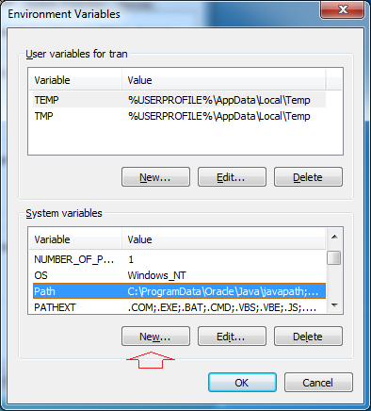

Nhập vào đường dẫn tới thư mục JDK.

* **Variable name:** JAVA_HOME
* **Variable value:** C:\DevPrograms\Java\jdk1.8.0_45

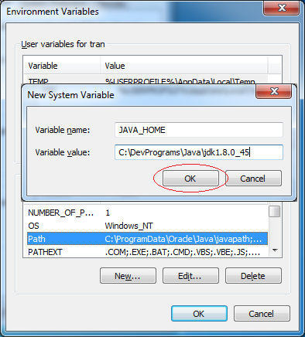

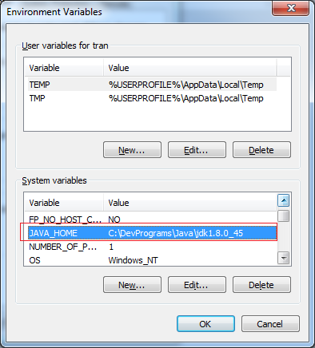

Tiếp theo sửa đổi biến môi trường ***path***

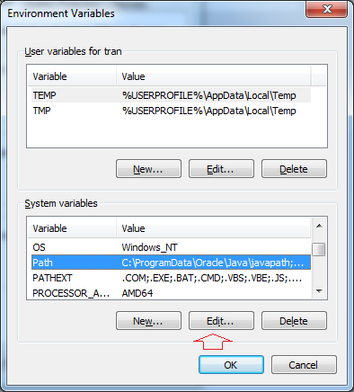

Thêm vào phía trước giá trị của biến môi trường ***path***:

* **%JAVA_HOME%\bin;**

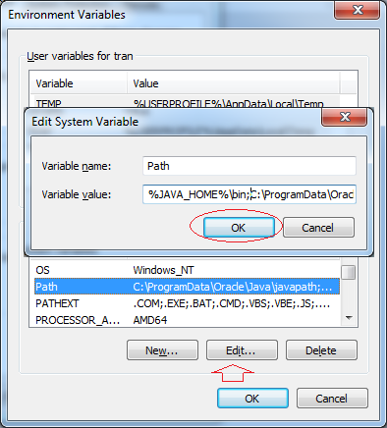

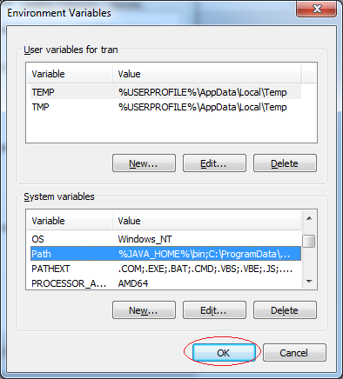

Bạn đã cài đặt và cấu hình Java thành công.

Check: java -version

Cách expand xem list file:

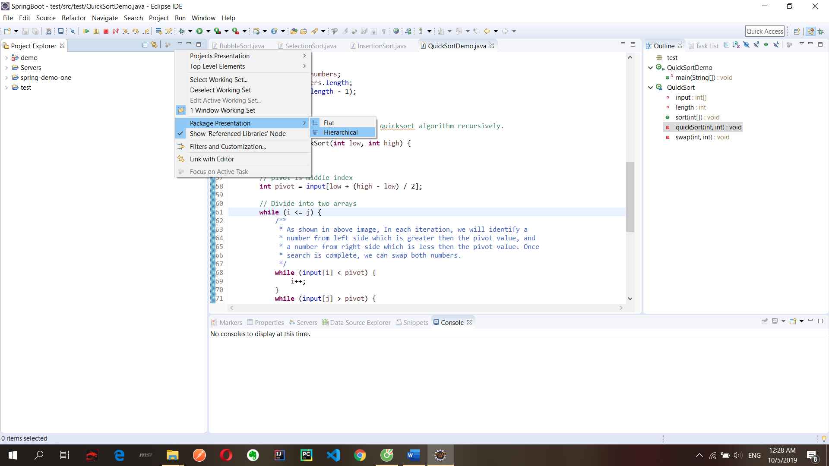

Quick diff

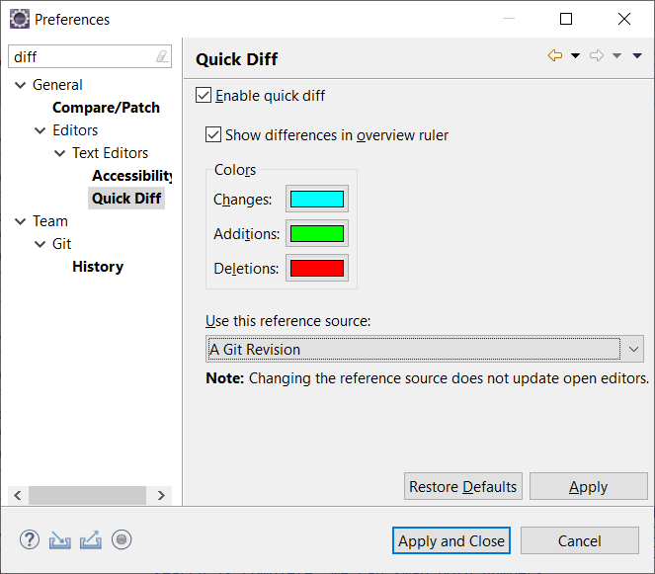

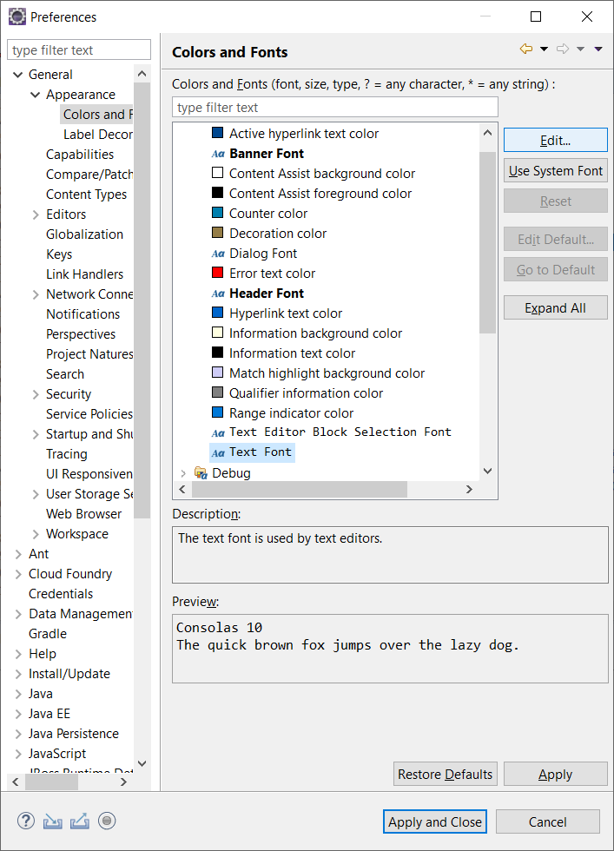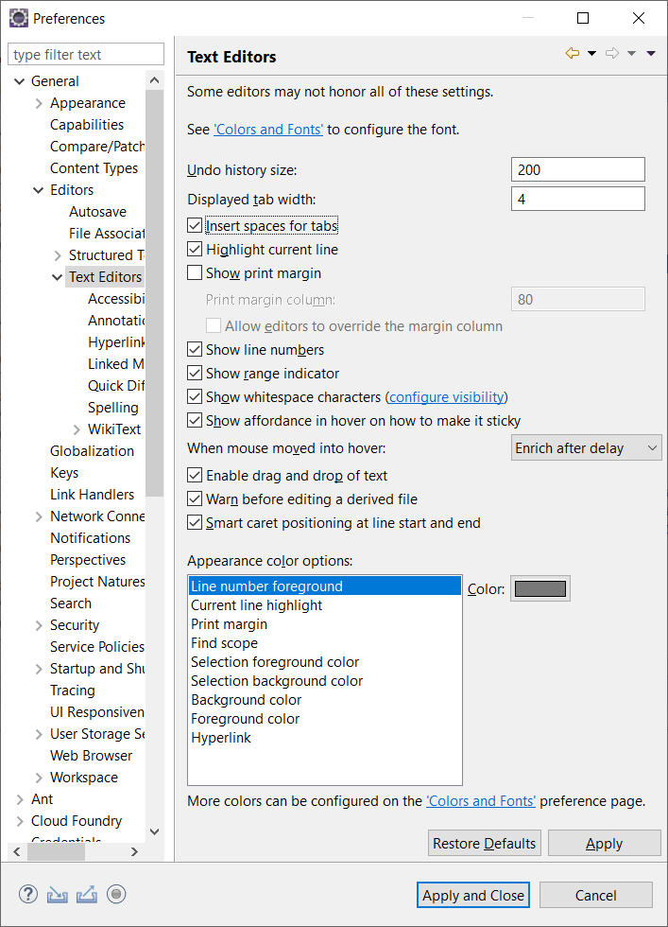

* <https://studyeasy.org/java/arithmetic-operators/>
* Cách import vào project trên eclipse: <https://www.youtube.com/watch?v=fiuSckgjdmY&feature=youtu.be>
* Cài inteliji file new project/ Hello word project
* Import eclipse project into inteliji: New/ Project from existing sources…/ chọn import project from external model/ rồi next

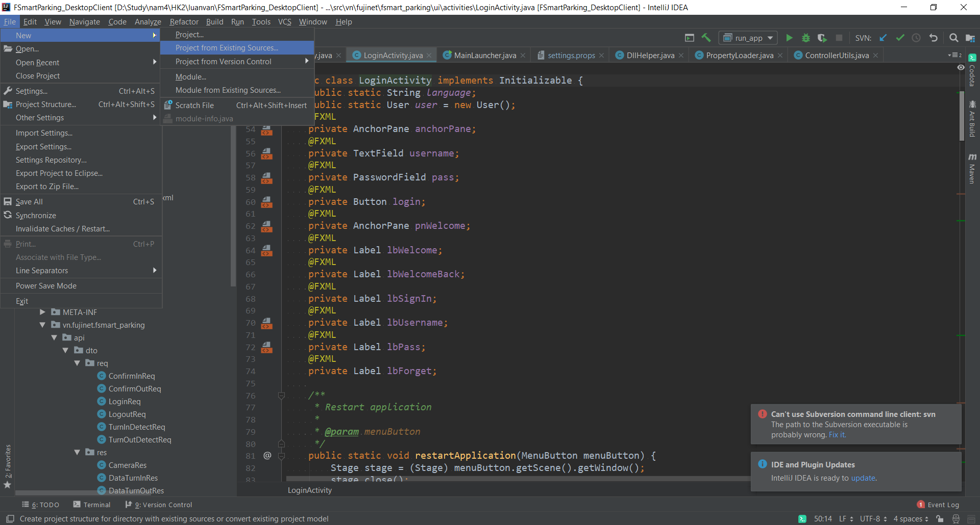

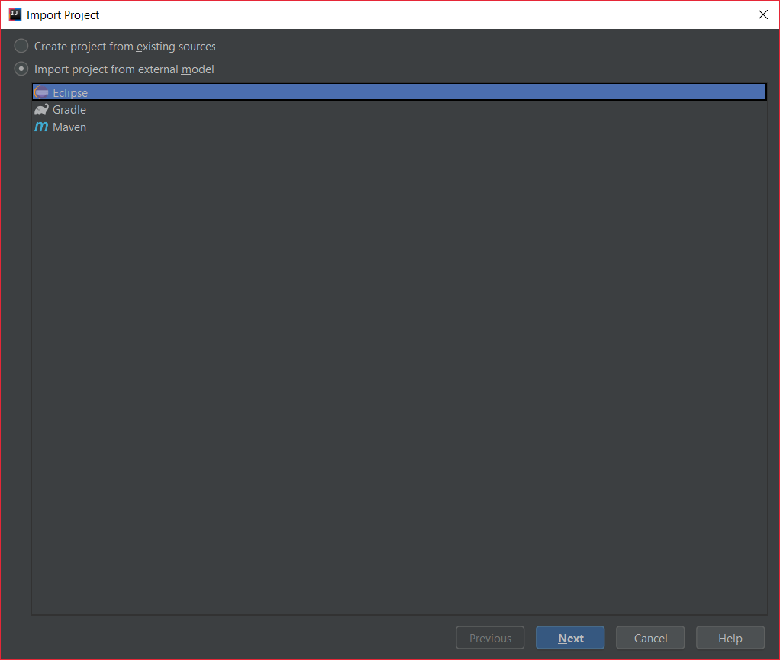

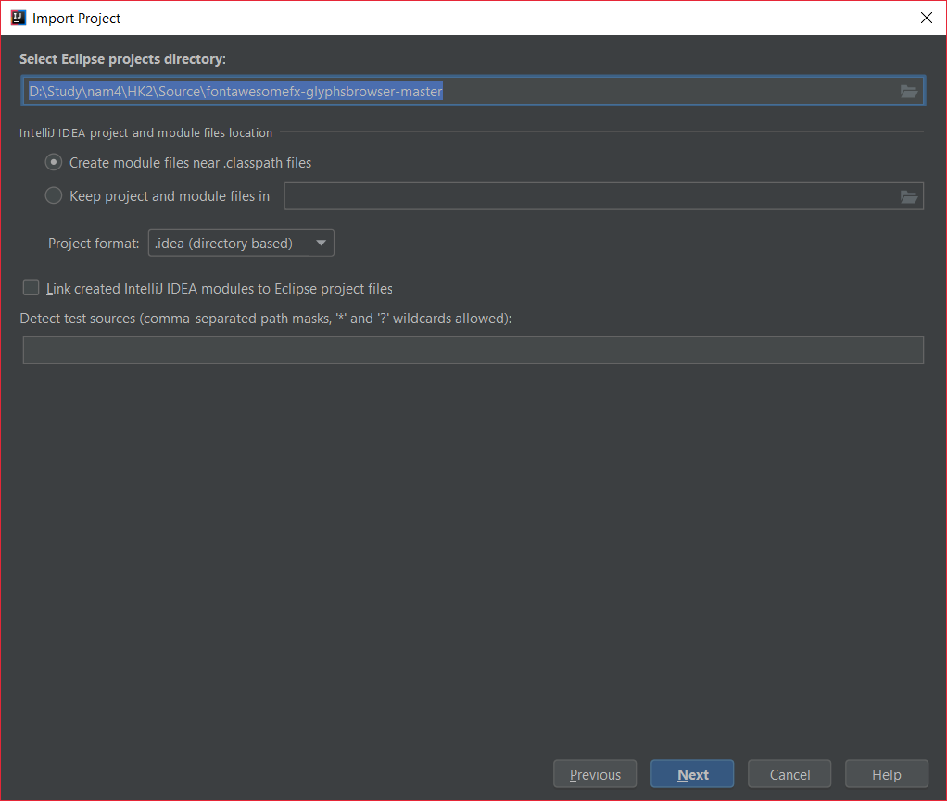

* Sau đó xóa các file desktop.ini
* Lợi ích của tính đa hình là có thể tạo 1 List<Animals> mà k cần biết các object ở trong vì nó kế thừa lớp Animals
* Types of nested class

# 2. Spring Overview

## 1. Downloading the Source Code and PDF Files

**Download Source Code:**

This only includes the source files, no JAR files. You will need to add JAR files separately on your own.

<http://www.luv2code.com/downloads/udemy-spring-hibernate/spring-hibernate-source-code-v26.zip>

---  
**Download PDF Files**

All slides which are shown during the course are available also as a reference and can be downloaded here:

<http://www.luv2code.com/download-spring-hibernate-pdfs>

**Setting eclipse**

<http://www.luv2code.com/eclipse/>

Cài JDK

<http://www.luv2code.com/install-java>

**free download**   
<https://freecoursesite.com/1-spring-hibernate-for-beginners/>

<https://github.com/darbyluv2code/spring-and-hibernate-for-beginners>

## Spring core framework

Core container : Factory for creating bean and manage bean dependences

## 3. Setting Up Your Development Environment

**Install apache:** <https://tomcat.apache.org/>

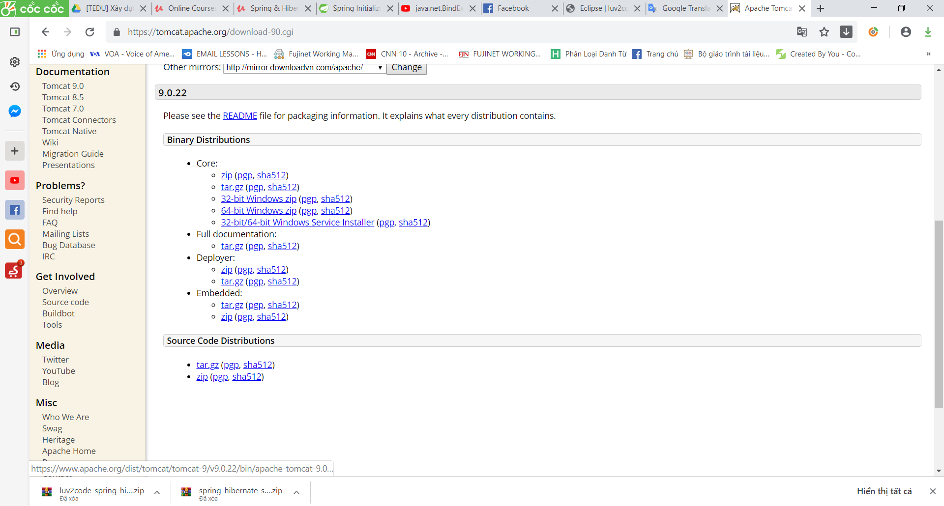

Chọn version **Tomcat9/ Chọn 32-bit/64-bit Windows Service Installer**

Sau đó cài đặt Apache :

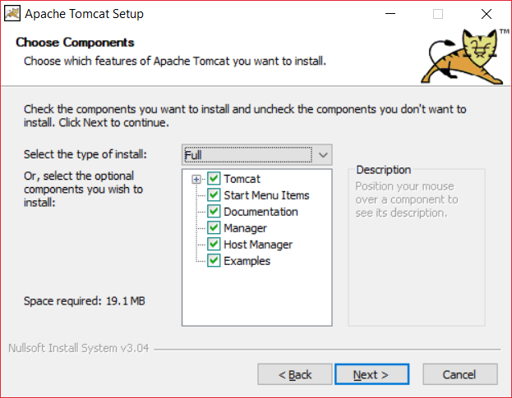

**Lưu ý :** phải chọn full, và nhập tên và pass cho admin

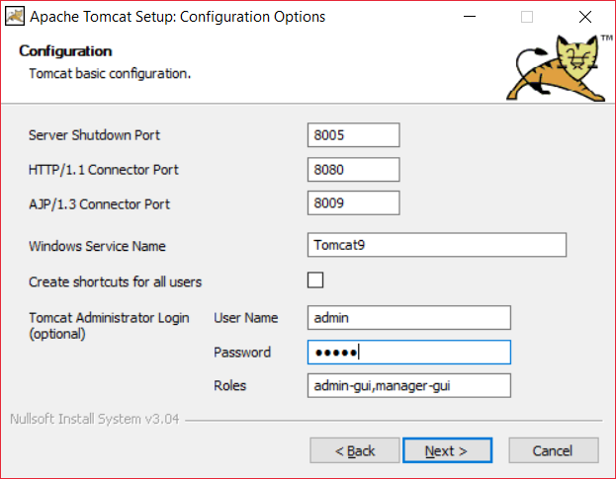

Bỏ chọn Show Readme và click Finish

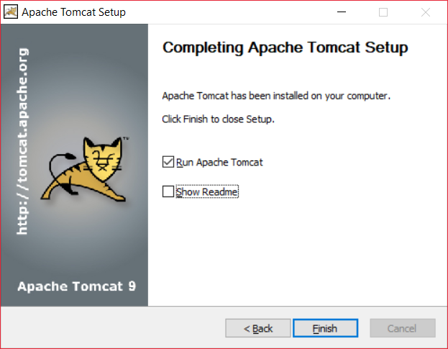

Verify install bằng cách vào link: <http://localhost:8080/>

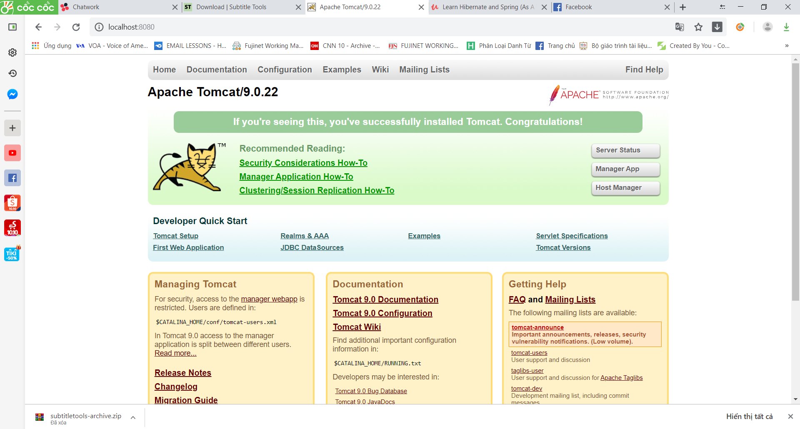

Như vậy bạn đã cài đặt thành công!

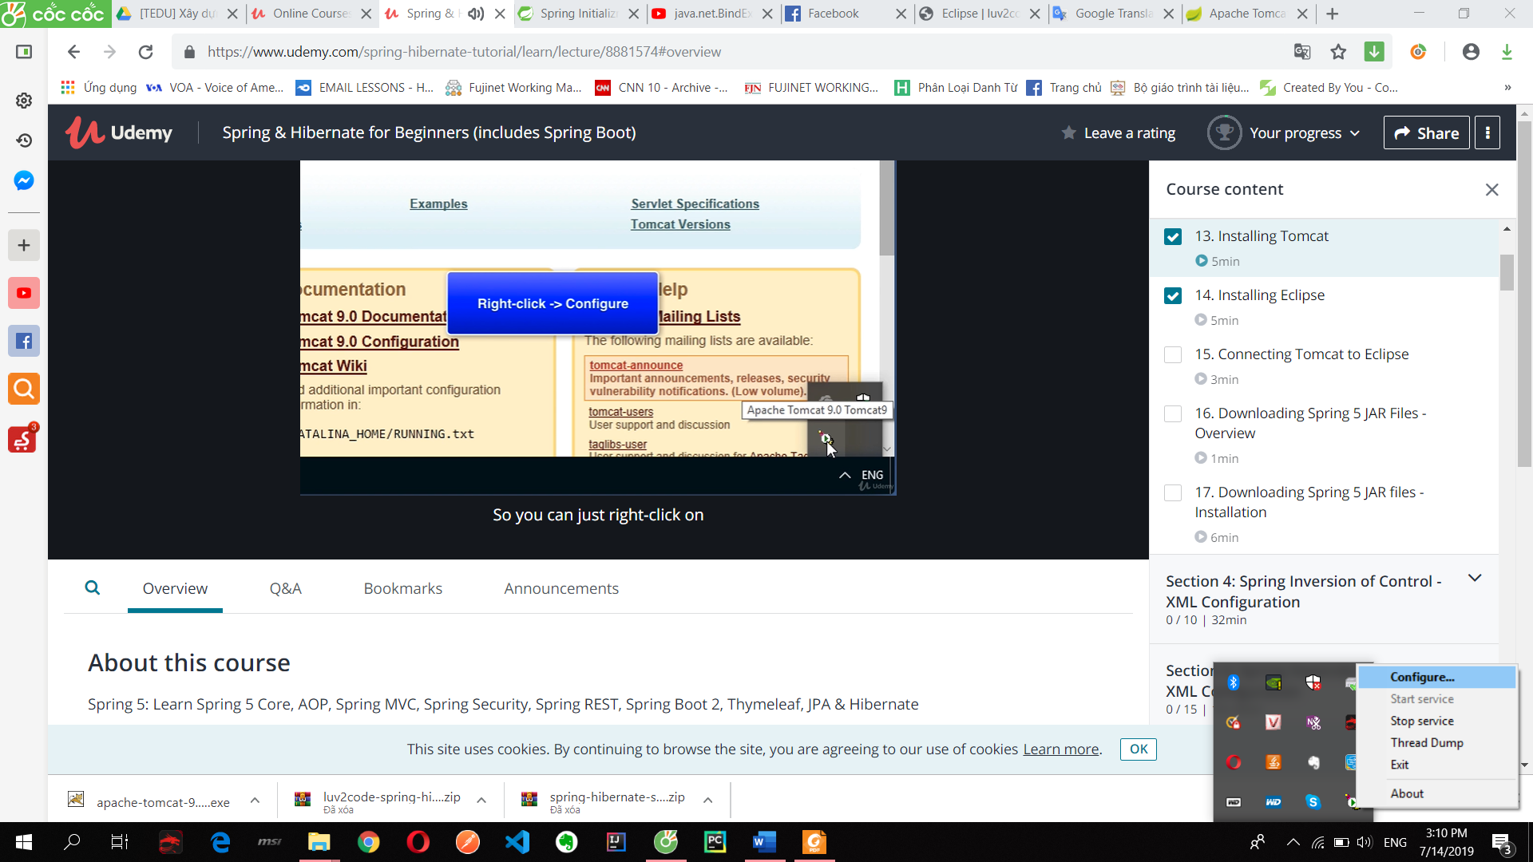

Vào windows gõ service:

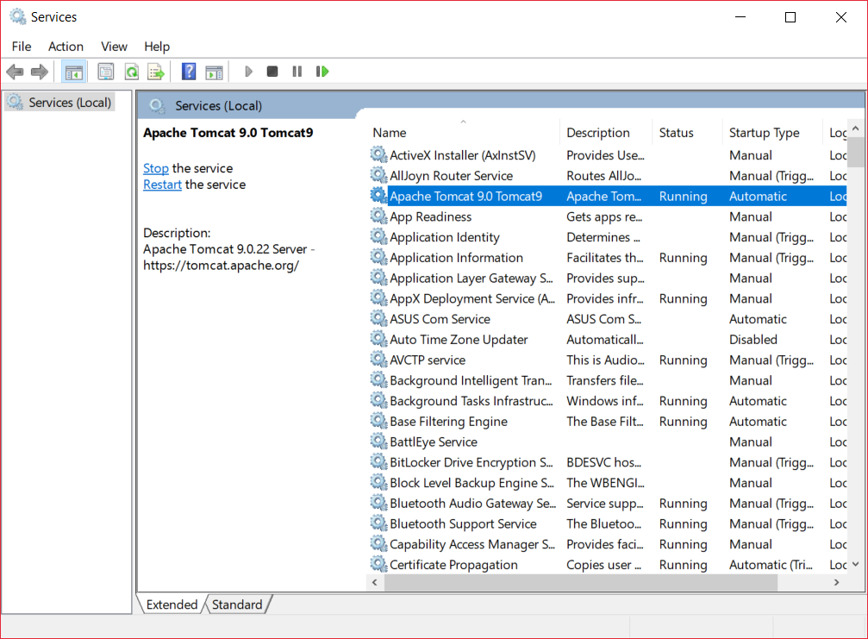

**Install eclipse:** chọn download packages => eclipse for

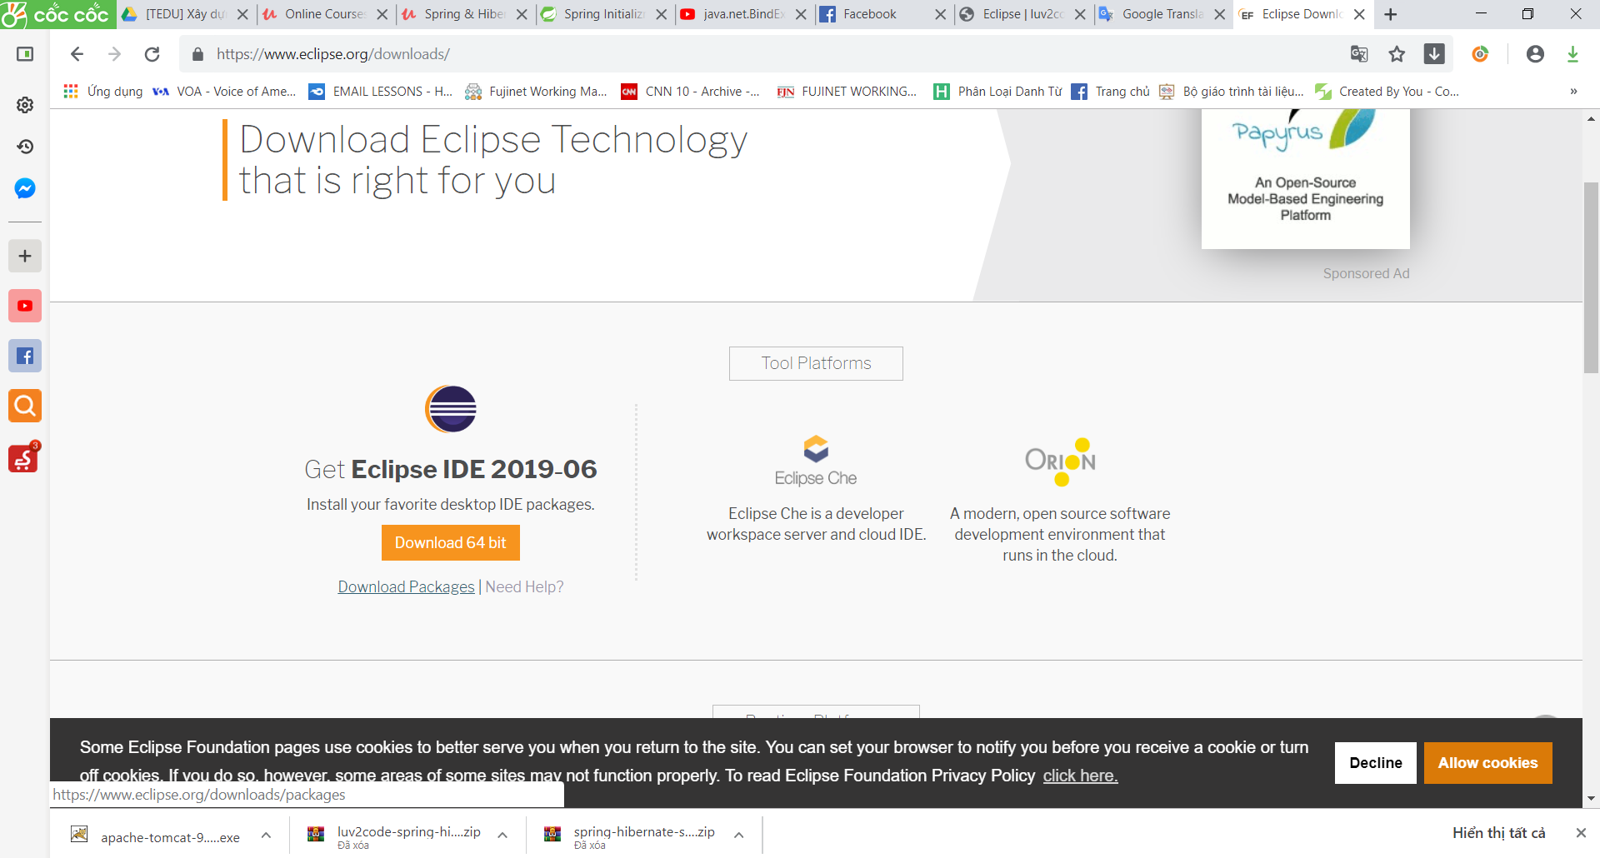

Try the Eclipse **Installer**2019‑06 R

The easiest way to install and update your Eclipse Development Environment.

4. Connecting Tomcat to Eclipse

**Connect apache to eclipse**

Vào tab server của eclipse/ chọn click link to add new server/ chọn Apache/ Tomcat 09/ rồi chọn đường link ở trong ổ C

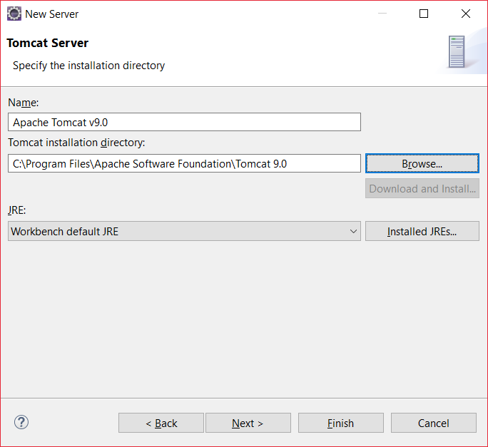

5. Downloading Spring 5 JAR Files – Overview

Open perspective:

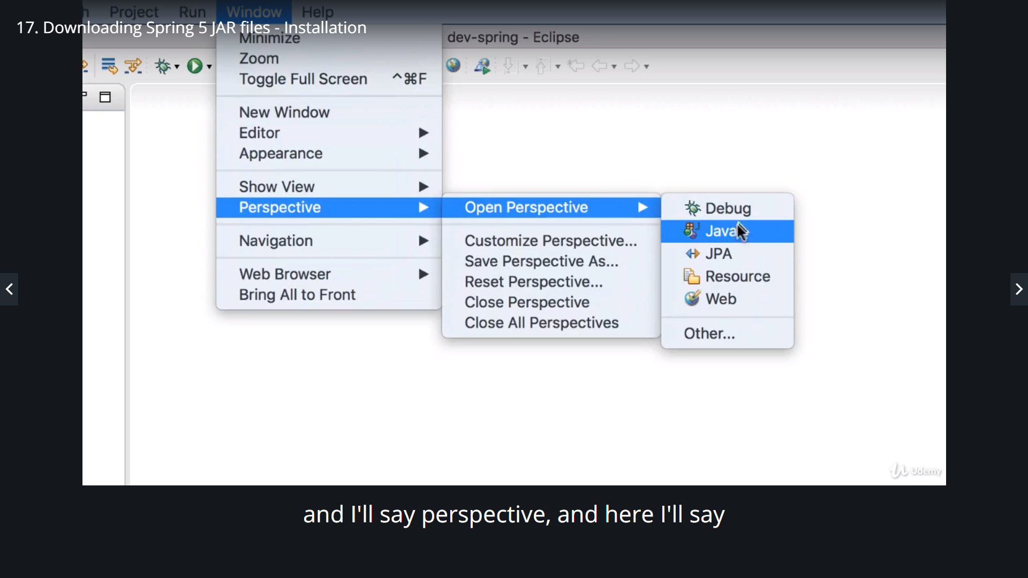

**Thêm thủ công vào** <http://www.luv2code.com/downloadspring> =>

<http://repo.spring.io/release/org/springframework/spring/>

chọn version release ở dưới cùng rồi chọn **spring-framework-5.1.8.RELEASE-dist.zip** để tải

Tạo project java bình thường, sau đó **tạo thư mục lib** rồi copy tất các các thư viện trong lib đã tải paste vào

**Right click/ properties/ Java build path/ libraries/ classpath/** ấn add jar rồi chon đến thư mục lib trong project mà ta vừa tạo chọn hết tất cả các file

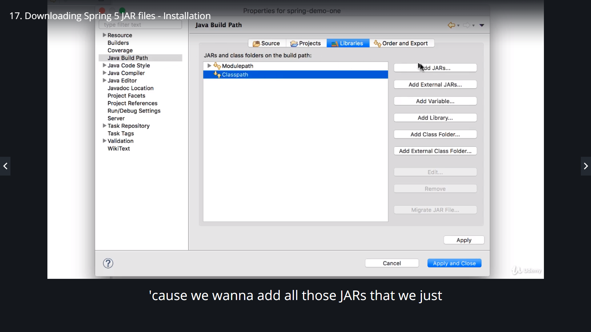

Nếu đúng sẽ xuất hiện **Referenced libraries**:

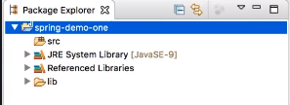

Mở **perspective**(ta project..): vào **windows/ perspective**

## 4. Spring Inversion of Control - XML Configuration

1. What is Inversion of Control

The approach of outsourcing the construction and management of objects

Kịch bản: pdf

2. Code Demo - Rough Prototype Part 1

Tạo interface để implement:

Spring Container

Primary functions

• Create and manage objects (Inversion of Control)

• Inject object’s dependencies (Dependency Injection)

IOC & XML Configuration

Ioc: tạo và quản lý object(xem pdf)

Tạo interface Coach(HLV) và các môn thể thao tương ứng => làm sao để dễ dàng chuyển đổi giữa các môn thể thao và không phải code cứng mà chỉ dùng file config

Xem tiếp file 12-spring-ioc-basics-overview

Spring Development Process

1. Configure your Spring Beans

2. Create a Spring Container

3. Retrieve Beans from Spring Container

3 ways to config Spring container: 12-spring-ioc-basics-overview.pdf

**FAQ: What is a Spring Bean?**

A "Spring Bean" is simply a Java object.

When Java objects are created by the Spring Container, then Spring refers to them as "Spring Beans".

Spring Beans are created from normal Java classes .... just like Java objects.

Here's a blurb from the Spring Reference Manual

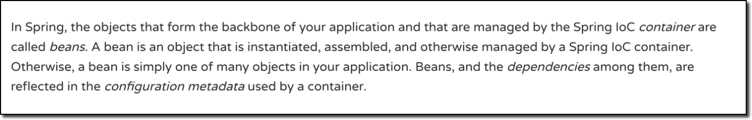

Source: <https://docs.spring.io/spring/docs/current/spring-framework-reference/core.html#beans-introduction>

Source: spring-hibernate-source-code-v26\01-spring-core-5\spring-demo-one\starter-files copy file applicationContext.xml để bắt đầu project ioc

**Why do we specify the Coach interface in getBean()?**

For example:

Coach theCoach = context.getBean("myCoach", Coach.class);

**Answer**

When we pass the interface to the method, behind the scenes Spring will cast the object for you.

context.getBean("myCoach", Coach.class)

Practice Activity #1 - Inversion of Control with XML Configuration

**Practice Activity #1 - Inversion of Control with XML Configuration**

1. Define a new implementation for the Coach interface. You can use whatever sport you would like.
2. Reference your new implementation in the Spring config file.
3. Test your application to verify you are retrieving information from your new Coach implementation.

You can check your code against the solution. The solution is available here:

<http://www.luv2code.com/downloads/udemy-spring-hibernate/solution-practice-activities.zip>

Nếu scope là prototype thì nó trỏ cùng 1 object khi get nhiều lần từ bean

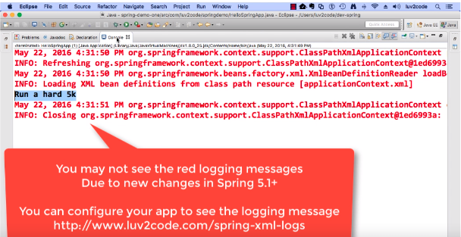

Add logging

HEADS UP - Add Logging Messages in Spring 5.1

**The Problem**

In Spring 5.1, the Spring Development team changed the logging levels internally. As a result, by default you will no longer see the red logging messages at the INFO level. This is different than in the videos.

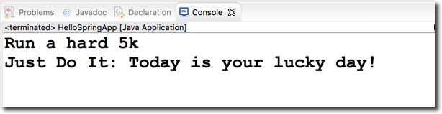

**The Solution**

If you would like to configure your app to show similar logging messages as in the video, you can make the following updates listed below. Note, you will not see the EXACT same messages, since the Spring team periodically changes the text of the internal logging messages. However, this should give you some additional logging data.

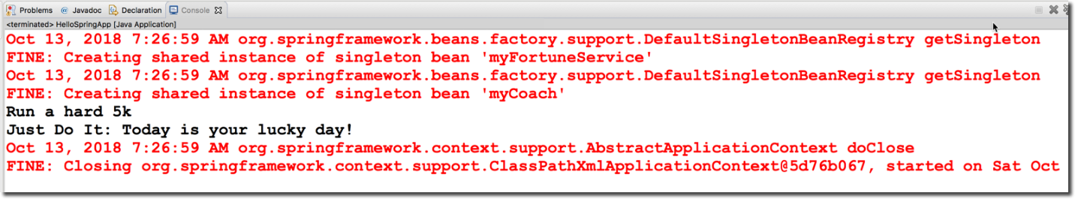

**Overview of the steps**

1. Create a bean to configure the parent logger and console handler

2. Configure the bean in the Spring XML config file

**Detailed Steps**

1. Create a bean to configure the parent logger and console handler

This class will set the parent logger level for the application context. It will also set the logging level for console handler. It sets the logger level to FINE. For more detailed logging info, you can set the logging level to level to FINEST.  You can read more about the logging levels at <http://www.vogella.com/tutorials/Logging/article.html>

This class also has an init method to handle the actual configuration. The init method is executed after the bean has been created and dependencies injected.

**File: MyLoggerConfig.java**

1. package com.luv2code.springdemo;
3. import java.util.logging.ConsoleHandler;
4. import java.util.logging.Level;
5. import java.util.logging.Logger;
6. import java.util.logging.SimpleFormatter;
8. import org.springframework.context.annotation.AnnotationConfigApplicationContext;
10. public class MyLoggerConfig {
12. private String rootLoggerLevel;
13. private String printedLoggerLevel;
15. public void setRootLoggerLevel(String rootLoggerLevel) {
16. this.rootLoggerLevel = rootLoggerLevel;
17. }
19. public void setPrintedLoggerLevel(String printedLoggerLevel) {
20. this.printedLoggerLevel = printedLoggerLevel;
21. }
23. public void initLogger() {
25. // parse levels
26. Level rootLevel = Level.parse(rootLoggerLevel);
27. Level printedLevel = Level.parse(printedLoggerLevel);
29. // get logger for app context
30. Logger applicationContextLogger = Logger.getLogger(AnnotationConfigApplicationContext.class.getName());
32. // get parent logger
33. Logger loggerParent = applicationContextLogger.getParent();
35. // set root logging level
36. loggerParent.setLevel(rootLevel);
38. // set up console handler
39. ConsoleHandler consoleHandler = new ConsoleHandler();
40. consoleHandler.setLevel(printedLevel);
41. consoleHandler.setFormatter(new SimpleFormatter());
43. // add handler to the logger
44. loggerParent.addHandler(consoleHandler);
45. }
47. }

---

2. Configure the bean in the Spring XML config file

In your XML config file, add the following bean entry. Make sure to list this as the first bean so that it is initialized first. Since the bean is initialized first, then you will get all of the logging traffic. If you move it later in the config file after the other beans, then you will miss out on some of the initial logging messages.

**File: applicationContext.xml (snippet)**

1. <!--
2. Add a logger config to see logging messages.
3. - For more detailed logs, set values to "FINEST"
4. - For info on logging levels, see: http://www.vogella.com/tutorials/Logging/article.html
5. -->
6. <bean id="myLoggerConfig" class="com.luv2code.springdemo.MyLoggerConfig" init-method="initLogger">
7. <property name="rootLoggerLevel" value="FINE" />
8. <property name="printedLoggerLevel" value="FINE"/>
9. </bean>

---

[Source code is available here](https://gist.github.com/darbyluv2code/cfb16c2fd1825a947d8faca3724b47a9). : <https://gist.github.com/darbyluv2code/cfb16c2fd1825a947d8faca3724b47a9>

Run config: maven clean, install

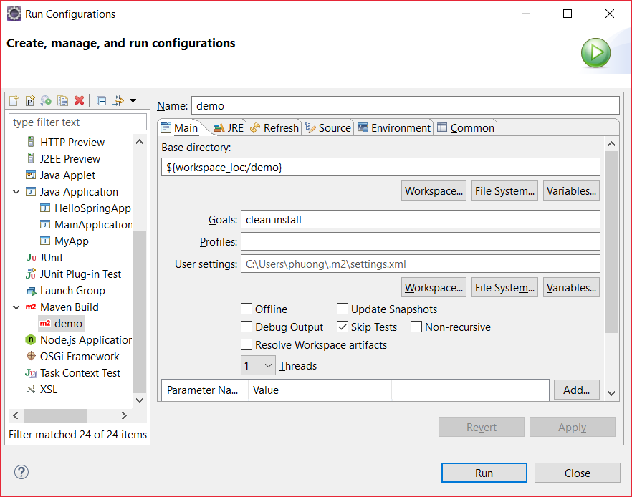

Sau đó run application

## 5. Spring Dependency Injection - XML Configuration

Các nguyên tắc đảo ngược phụ thuộc.

Client ủy quyền để gọi cho đối tượng khác có trách nhiệm cung cấp các phụ thuộc của nó

Ví dụ như request car thì car factory sẽ inject các component của nó vào để tạo thành object

Spring Injection Types(pdf)

• Constructor Injection

• Setter Injection(Phải có hàm khởi tạo không tham số)

Injecting Literal Values

Development Process - Constructor Injection

1. Define the dependency interface and class

2. Create a constructor in your class for injections

3. Configure the dependency injection in Spring config file

FAQ: What is the purpose for the no arg constructor?

***Question:****I was wondering why you created a no arg constructor? I thought that they are implied by Java and only required when you also have an overloaded constructor. Or is this a Spring specific thing?*

*---*

***Answered by: Oleksandr Palamarchuk***

*When you don’t define any constructor in your class, compiler defines default one for you, however when you declare any constructor (in your example you have already defined a parameterized constructor), compiler doesn’t do it for you.*

*Since you have defined a constructor in class code, compiler didn’t create default one. While creating object you are invoking default one, which doesn’t exist in class code. Then the code gives an compilation error.*

Development Process - Setter Injection

1. Create setter method(s) in your class for injections**( must create no-arg constructor)**

2. Configure the dependency injection in Spring config file

Injecting Literal Values

Development Process

1. Create setter method(s) in your class for injections

2. Configure the injection in Spring config file

**Question:**

For the CricketCoach example with Setter Injection, why do we use the CricketCoach class instead of the Coach interface?

**Answer:**

The getTeam() method is only defined in the CricketCoach class. It is not part of the Coach interface.

As a result, you would need the following code:

    CricketCoach theCricketCoach = context.getBean("myCricketCoach", CricketCoach.class);

---

The Coach interface has two methods: getDailyWorkout and getDailyFortune

The CricketCoach class has four methods: getDailyWorkout, getDailyFortune, getTeam and setTeam

---

When you retrieve a bean from the Spring container using the Coach interface:

    Coach theCricketCoach = context.getBean("myCricketCoach", Coach.class);

You only have access to the methods defined in the Coach interface: getDailyWorkout and getDailyFortune. Even though the actual implementation has additional methods, you only have visibility to methods that are defined at the Coach interface level.

---

When you retrieve a bean from the Spring container using the CricketCoach class:

    CricketCoach theCricketCoach = context.getBean("myCricketCoach", CricketCoach.class);

You have access to the methods defined in the Coach interface: getDailyWorkout and getDailyFortune.

ALSO, you have access to the additional methods defined in the CricketCoach class: getTeam, setTeam.

---

The bottom line is it depends on how you retrieve the object and assign it ... that determines the visibility you have to the methods.

Injecting Values from a Properties File

1. Create Properties File in src

2. Load Properties File in Spring config file

3. Reference values from Properties File

**Practice Activity #2 - Dependency Injection with XML Configuration**

1. Define a new implementation for the FortuneService.

    a. When the getFortune() method is called it should return a random fortune from the array.

    b. Your fortune service should define three fortunes in an array.

2. Inject your new dependency into your Coach implementation.

3. Test your application to verify you are retrieving random fortunes.

Compare your code to the solution. The solution is available here:  
- http://www.luv2code.com/downloads/udemy-spring-hibernate/solution-practice-activities.zip

## 6. Spring Bean Scopes and Lifecycle

Spring Container creates only one instance of the bean, by default

• It is cached in memory

• All requests for the bean

• will return a SHARED reference to the SAME bean

Explicitly Specify Bean Scope and type - pdf

4. Bean Lifecycle

1. Define your methods for init and destroy

2. Configure the method names in Spring config file

Bean Lifecycle Methods / Hooks

• You can add custom code during bean initialization

• Calling custom business logic methods

• Setting up handles to resources (db, sockets, file etc)

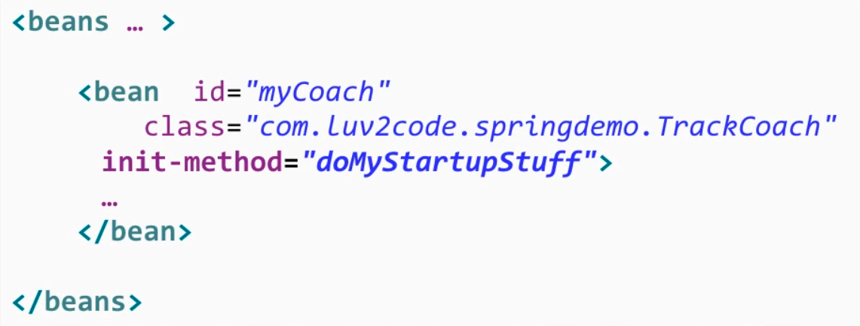

• You can add custom code during bean destruction

• Calling custom business logic method

• Clean up handles to resources (db, sockets, files etc)

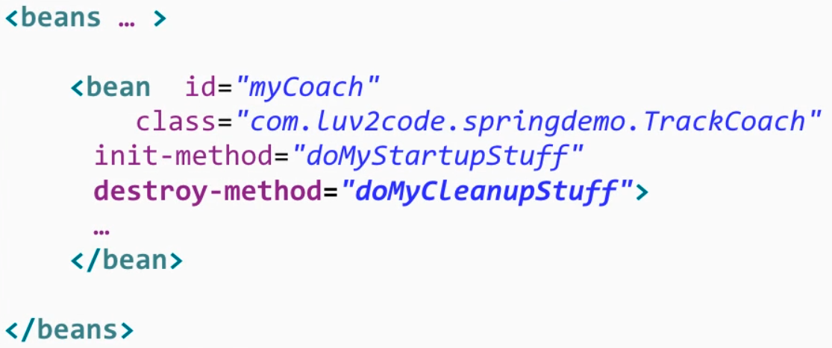

**Special Note about init and destroy Method Signatures**

When using XML configuration, I want to provide additional details regarding the method signatures of the init-method  and destroy-method .

**Access modifier**  
The method can have any access modifier (public, protected, private)

**Return type**  
The method can have any return type. However, "void' is most commonly used. If you give a return type just note that you will not be able to capture the return value. As a result, "void" is commonly used.

**Method name**  
The method can have any method name.

**Arguments**  
The method can not accept any arguments. The method should be no-arg.

There is a subtle point you need to be aware of with "prototype" scoped beans.

**For "prototype" scoped beans, Spring does not call the destroy method.  Gasp!**

---

***In contrast to the other scopes, Spring does not manage the complete lifecycle of a prototype bean****: the container instantiates, configures, and otherwise assembles a prototype object, and hands it to the client, with no further record of that prototype instance.*

*Thus, although initialization lifecycle callback methods are called on all objects regardless of scope,****in the case of prototypes, configured destruction lifecycle callbacks are not called****. The client code must clean up prototype-scoped objects and release expensive resources that the prototype bean(s) are holding.*

*---*

This also applies to both XML configuration and Annotation-based configuration.

## 7. Spring Configuration with Java Annotations - Inversion of Control

1. Annotations Overview - Component Scanning

Development Process

1. Enable component scanning in Spring config file

2. Add the @Component Annotation to your Java classes

3. Retrieve bean from Spring container

@Component(“beanID”)

5. Default Component Names - Overview

## 8. Spring Configuration with Java Annotations - Dependency Injection

1. Constructor Injection - Overview

For dependency injection, Spring can use auto wiring

• Spring will look for a class that matches the property

• matches by type: class or interface

• Spring will inject it automatically … hence it is autowired

Autowiring Injection Types

• Constructor Injection

• Setter Injection

• Field Injections

**AUTOWIRING**

**FAQ: What if there are multiple FortuneService implementations?**

When using autowiring, what if there are multiple FortuneService implementations? Like in the image below?  
  
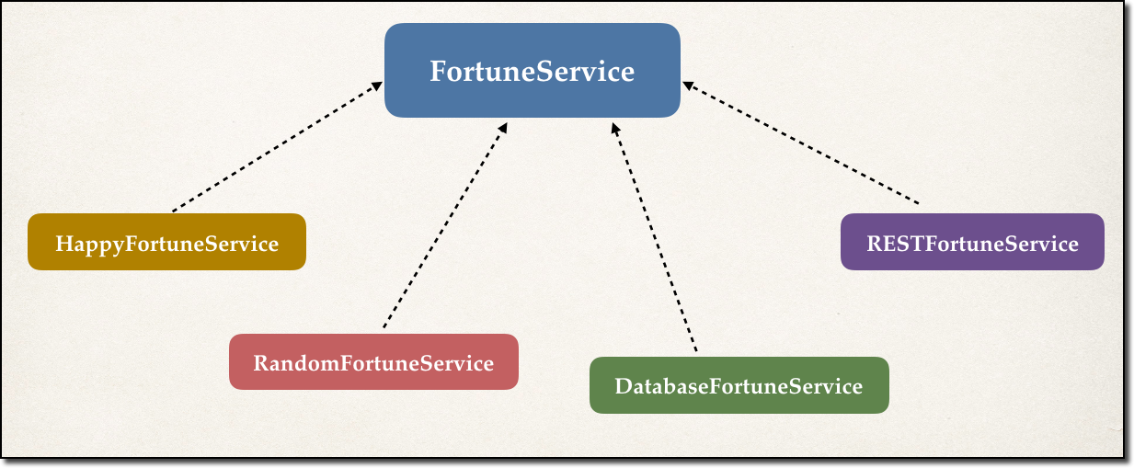

---

**ANSWER**

Spring has special support to handle this case. Use the **@Qualifier** annotation. We'll cover this later in the course with slides and code examples. But don't worry, we will address all scenarios :-)

**Development Process - Constructor Injection**1. Define the dependency interface and class  
2. Create a constructor in your class for injections  
3. Configure the dependency injection with **@Autowired** Annotation

**Question**

I have finished the video "Constructor Injection - Writing Code part2".

I have commented the Autowired annotation. But still it worked. How did it work?

//@Autowired

public TennisCoach(FortuneService theFortuneService) {

System.out.println(" theFortuneService " + theFortuneService);

fortuneService = theFortuneService;

}

===

**Answer**

This is a new feature of Spring 4.3.

Here is the snippet from the Spring Docs.

**Section 1.9.2: Autowired**

As of Spring Framework 4.3, an *@Autowired* annotation on such a constructor is no longer necessary if the target bean only defines one constructor to begin with. However, if several constructors are available, at least one must be annotated to teach the container which one to use.

I personally prefer to use the @Autowired annotation because it makes the code more readable. But as mentioned, the @Autowired is not required for this scenario.

---

See link to the docs.

<https://docs.spring.io/spring/docs/current/spring-framework-reference/core.html#beans-autowired-annotation>

link

<https://docs.spring.io/spring/docs/current/spring-framework-reference/core.html#beans-autowired-annotation>

6. Setter Injection - Overview

1. Create setter method(s) in your class for injections (có constructor)  
2. Configure the dependency injection with **@Autowired** Annotation

8. Method Injection

Giống như setter injection

9. Field Injection - Overview

Configure the dependency injection with Autowired Annotation

✤ Applied directly to the field(hàm tạo)

✤ No need for setter methods

11. Which Injection Type Should You Use

12. Qualifiers for Dependency Injection - Overview

Nếu có nhiều interface

**Annotations - Default Bean Names ... and the Special Case**

In general, when using Annotations, for the default bean name, Spring uses the following rule.

If the annotation's value doesn't indicate a bean name, an appropriate name will be built based on the short name of the class (with the first letter lower-cased).

For example:

HappyFortuneService --> happyFortuneService

---

However, for the **special case of when BOTH the first and second characters of the class name are upper case**, then the **name is NOT converted**.

For the case of RESTFortuneService

RESTFortuneService --> RESTFortuneService

No conversion since the first two characters are upper case.

Behind the scenes, Spring uses the **Java Beans Introspector** to generate the default bean name. Here's a screenshot of the documentation for the key method.

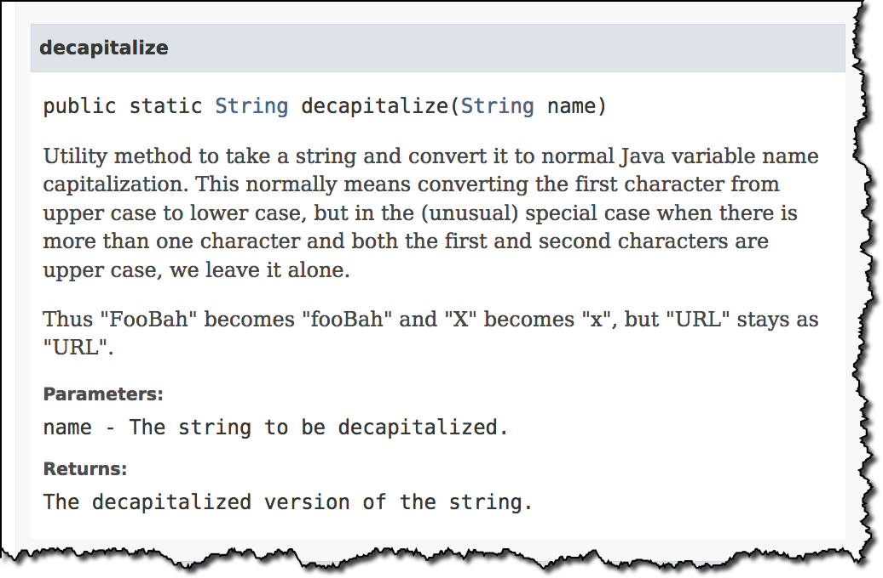

Also, here's a link to the documentation.

- <https://docs.oracle.com/javase/8/docs/api/java/beans/Introspector.html#decapitalize(java.lang.String)>

---

As always, you can give explicity names to your beans.

@Component("foo")  
public class RESTFortuneService .... {  
      
}

Then you can access it using the name of "foo". Nothing tricky to worry about :-)

Hope this helps. Happy Coding! :-)

16. Using @Qualifier with Constructors

**@Qualifier** is a nice feature, but it is tricky when used with Constructors.

The syntax is much different from other examples and not exactly intuitive.  Consider this the "deep end of the pool" when it comes to Spring configuration LOL :-)

 You have to place the @Qualifier annotation inside of the constructor arguments.

Here's an example from our classroom example. I updated it to make use of constructor injection, with @Autowired and @Qualifier. Make note of the code in bold below:

---  
package com.luv2code.springdemo;

import org.springframework.beans.factory.annotation.Autowired;

import org.springframework.beans.factory.annotation.Qualifier;  
import org.springframework.stereotype.Component;

@Component  
public class TennisCoach implements Coach {

    private FortuneService fortuneService;

    // define a default constructor  
    public TennisCoach() {  
        System.out.println(">> TennisCoach: inside default constructor");  
    }  
      
**@Autowired  
    public TennisCoach(@Qualifier("randomFortuneService") FortuneService theFortuneService) {**

**System.out.println(">> TennisCoach: inside constructor using @autowired and @qualifier");  
          
        fortuneService = theFortuneService;  
    }**         
      
    /*  
    @Autowired  
    public void doSomeCrazyStuff(FortuneService theFortuneService) {  
        System.out.println(">> TennisCoach: inside doSomeCrazyStuff() method");  
        fortuneService = theFortuneService;  
    }  
    */  
      
    /*  
    @Autowired  
    public TennisCoach(FortuneService theFortuneService) {  
        fortuneService = theFortuneService;  
    }  
    */  
      
    @Override  
    public String getDailyWorkout() {  
        return "Practice your backhand volley";  
    }

    @Override  
    public String getDailyFortune() {  
        return fortuneService.getFortune();  
    }

}

---

For detailed documentation on using @Qualified with Constructors, see this link in the Spring Reference Manual

<https://docs.spring.io/spring/docs/current/spring-framework-reference/core.html#beans-autowired-annotation-qualifiers>

**FAQ: How to inject properties file using Java annotations**

**Answer:**

This solution will show you how inject values from a properties file using annotatons. The values will no longer be hard coded in the Java code.

**1. Create a properties file to hold your properties. It will be a name value pair.**

New text file:  src/sport.properties

foo.email=myeasycoach@luv2code.com

foo.team=Silly Java Coders

Note the location of the properties file is very important. It must be stored in src/sport.properties

**2. Load the properties file in the XML config file.**

File: applicationContext.xml

Add the following lines:

    <context:property-placeholder location="classpath:sport.properties"/>

This should appear just after the <context:component-scan .../> line

**3. Inject the properties values into your Swim Coach: SwimCoach.java**

@Value("${foo.email}")

private String email;

@Value("${foo.team}")

private String team;

---

**DOWNLOAD FULL SOURCE CODE**

You can download entire code from here:

- <http://www.luv2code.com/downloads/spring-hibernate/spring-props-annotation-demo.zip>

## 9. Spring Configuration with Java Annotations - Bean Scopes and Lifecycle Methods

1. @Scope Annotation – Overview

Default scope is singleton

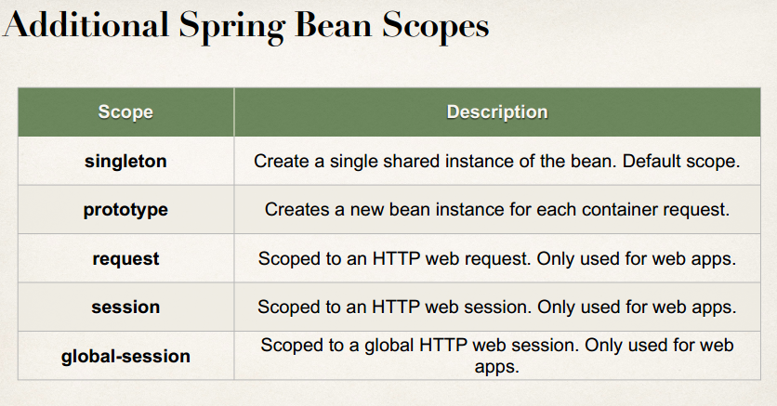

2. @Scope Annotation - Write Some Code

Here is a subtle point you need to be aware of with "prototype" scoped beans.

**For "prototype" scoped beans, Spring does not call the @PreDestroy method.  Gasp!**

I didn't know this either until I dug through the Spring reference manual researching a student's question.

Here is the answer from the Spring reference manual. Section 7.5.2

<https://docs.spring.io/spring/docs/current/spring-framework-reference/core.html#beans-factory-scopes-prototype>

---

***In contrast to the other scopes, Spring does not manage the complete lifecycle of a  
prototype bean***: the container instantiates, configures, and otherwise assembles aprototype object, and hands it to the client, with no further record of that prototypeinstance.

Thus, although initialization lifecycle callback methods are called on all objects regardless of scope, ***in the case of prototypes, configured destruction lifecycle callbacks are not called***. The client code must clean up prototype-scoped objects and release expensive resources that the prototype bean(s) are holding.

To get the Spring container to release resources held by prototype-scoped beans, try using a custom [*bean post-processor*](https://docs.spring.io/spring/docs/current/spring-framework-reference/core.html#beans-factory-extension-bpp), which holds a reference to beans that need to be cleaned up.

---

This also applies to XML configuration.

3. Bean Lifecycle Method Annotations – Overview

Development Process

1. Define your methods for init and destroy

2. Add annotations: @PostConstruct and @PreDestroy

***Special Note about @PostConstruct and @PreDestroy Method Signatures***

I want to provide additional details regarding the method signatures of @PostContruct and @PreDestroy methods.

**Access modifier**

The method can have any access modifier (public, protected, private)

**Return type**The method can have any return type. However, "void' is most commonly used. If you give a return type just note that you will not be able to capture the return value. As a result, "void" is commonly used.

**Method name**The method can have any method name.

**Arguments**The method can not accept any arguments. The method should be no-arg.

**HEADS UP - FOR JAVA 9, 10 and 11 USERS - @PostConstruct and @PreDestroy**

If you are using Java 9, 10 or 11, then you will encounter an error when using @PostConstruct and @PreDestroy in your code.

These are the steps to resolve it. Come back to the lecture if you hit the error.

***Error***

Eclipse is unable to import @PostConstruct or @PreDestroy

This happens because of Java 9 and higher.

When using Java 9 and higher, javax.annotation has been removed from its default classpath. That's why we Eclipse can't find it.

---

***Solution***

1. Download the javax.annotation-api-1.2.jar from

<http://central.maven.org/maven2/javax/annotation/javax.annotation-api/1.2/javax.annotation-api-1.2.jar>

2. Copy the JAR file to the **lib** folder of your project

---

Use the following steps to add it to your Java Build Path.

3. Right-click your project, select **Properties**

4. On left-hand side, click **Java Build Path**

5. In top-center of dialog, click **Libraries**

6. Click **Classpath** and then Click **Add JARs ...**

7. Navigate to the JAR file **<your-project>/lib/javax.annotation-api-1.2.jar**

8. Click **OK**then click **Apply and Close**

Eclipse will perform a rebuild of your project and it will resolve the related build errors.

Here is a subtle point you need to be aware of with "prototype" scoped beans.

**For "prototype" scoped beans, Spring does not call the @PreDestroy method.  Gasp!**

I didn't know this either until I dug through the Spring reference manual researching a student's question.

Here is the answer from the Spring reference manual. Section 7.5.2

<https://docs.spring.io/spring/docs/current/spring-framework-reference/core.html#beans-factory-scopes-prototype>

---

***In contrast to the other scopes, Spring does not manage the complete lifecycle of a  
prototype bean***: the container instantiates, configures, and otherwise assembles aprototype object, and hands it to the client, with no further record of that prototypeinstance.

Thus, although initialization lifecycle callback methods are called on all objects regardless of scope, ***in the case of prototypes, configured destruction lifecycle callbacks are not called***. The client code must clean up prototype-scoped objects and release expensive resources that the prototype bean(s) are holding.

To get the Spring container to release resources held by prototype-scoped beans, try using a custom [*bean post-processor*](https://docs.spring.io/spring/docs/current/spring-framework-reference/core.html#beans-factory-extension-bpp), which holds a reference to beans that need to be cleaned up.

---

This also applies to XML configuration.

## 10. Spring Configuration with Java Code (no xml)

1. Spring Configuration with Java Code (no xml) – Overview

Instead of configuring Spring container using XML

Configure the Spring container with Java code

Development Process

1. Create a Java class and annotate as @Configuration

2. Add component scanning support: @ComponentScan (optional)

3. Read Spring Java configuration class

4. Retrieve bean from Spring container

1. Defining Spring Beans with Java Code (no xml) - Overview

**Question:**

During All Java Configuration, how does the @Bean annotation work in the background?

**Answer**

This is an advanced concept. But I'll walk through the code line-by-line.

For this code:

@Bean

public Coach swimCoach() {

SwimCoach mySwimCoach = new SwimCoach();

return mySwimCoach;

}

At a high-level, Spring creates a bean component manually. By default the scope is singleton. So any request for a "swimCoach" bean, will get the same instance of the bean since singleton is the default scope.

However, let's break it down line-by-line

@Bean

The @Bean annotation tells Spring that we are creating a bean component manually. We didn't specify a scope so the default scope is singleton.

public Coach swimCoach(){

This specifies that the bean will bean id of "swimCoach". The method name determines the bean id. The return type is the Coach interface. This is useful for dependency injection. This can help Spring find any dependencies that implement the Coach interface.

The @Bean annotation will intercept any requests for "swimCoach" bean. Since we didn't specify a scope, the bean scope is singleton. As a result, it will give the same instance of the bean for any requests.

SwimCoach mySwimCoach = new SwimCoach();

This code will create a new instance of the SwimCoach.

return mySwimCoach;

This code returns an instance of the swimCoach.

----

Now let's step back and look at the method in it's entirety.

@Bean

public Coach swimCoach() {

SwimCoach mySwimCoach = new SwimCoach();

return mySwimCoach;

}

It is important to note that this method has the @Bean annotation. The annotation will intercept ALL calls to the method "swimCoach()". Since no scope is specified the @Bean annotation uses singleton scope. Behind the scenes, during the @Bean interception, it will check in memory of the Spring container (applicationContext) and see if this given bean has already been created.

If this is the first time the bean has been created then it will execute the method as normal. It will also register the bean in the application context. So that is knows that the bean has already been created before. Effectively setting a flag.

The next time this method is called, the @Bean annotation will check in memory of the Spring container (applicationContext) and see if this given bean has already been created. Since the bean has already been created (previous paragraph) then it will immediately return the instance from memory. It will not execute the code inside of the method. Hence this is a singleton bean.

The code for

SwimCoach mySwimCoach = new SwimCoach();

return mySwimCoach;

is not executed for subsequent requests to the method public Coach swimCoach() . This code is only executed once during the initial bean creation since it is singleton scope.

That explains how @Bean annotation works for the swimCoach example.

====

Now let's take it one step further.

Here's your other question

***>> Please explain in detail whats happening behind the scene for this statement.***

return new SwimCoach(sadFortuneService())

The code for this question is slightly different. It is injecting a dependency.

In this example, we are creating a SwimCoach and injecting the sadFortuneService().

// define bean for our sad fortune service

@Bean

public FortuneService sadFortuneService() {

return new SadFortuneService();

}

// define bean for our swim coach AND inject dependency

@Bean

public Coach swimCoach() {

SwimCoach mySwimCoach = new SwimCoach(sadFortuneService());

return mySwimCoach;

}

Using the same information presented earlier

The code

// define bean for our sad fortune service

@Bean

public FortuneService sadFortuneService() {

return new SadFortuneService();

}

In the code above, we define a bean for the sad fortune service. Since the bean scope is not specified, it defaults to singleton.

Any calls for sadFortuneService, the @Bean annotation intercepts the call and checks to see if an instance has been created. First time through, no instance is created so the code executes as desired. For subsequent calls, the singleton has been created so @Bean will immediately return with the singleton instance.

Now to the main code based on your question.

return new SwimCoach(sadFortuneService())

This code creates an instance of SwimCoach. Note the call to the method sadFortuneService(). We are calling the annotated method above. The @Bean will intercept and return a singleton instance of sadFortuneService. The sadFortuneService is then injected into the swim coach instance.

This is effectively dependency injection. It is accomplished using all Java configuration (no xml).

---

This concludes the line-by-line discussion of the source code. All of the behind the scenes work.

I hope this clears your doubt. :-)

8. Injecting Values from Properties File – Overview

**FAQ: Problems with Injecting Values - Value not returning from ${foo.email}**

**Question**

I am running the code for Java Configuration and injecting values from props file. However, I'm getting:

${foo.email}  
${foo.team}

Instead of the actual property values. How can I resolve this?

**Answer**

This is an issue with Spring versions.

If you are using Spring 4.2 and lower, you will need to add the code in bold.

---

package com.luv2code.springdemo;

import org.springframework.context.annotation.Bean;  
import org.springframework.context.annotation.Configuration;  
import org.springframework.context.annotation.PropertySource;  
import org.springframework.context.support.PropertySourcesPlaceholderConfigurer;

@Configuration  
// @ComponentScan("com.luv2code.springdemo")  
@PropertySource("classpath:sport.properties")  
public class SportConfig {  
      
**// add support to resolve ${...} properties  
    @Bean  
    public static PropertySourcesPlaceholderConfigurer  
                    propertySourcesPlaceHolderConfigurer() {  
          
        return new PropertySourcesPlaceholderConfigurer();  
    }**      
    // define bean for our sad fortune service  
    @Bean  
    public FortuneService sadFortuneService() {  
        return new SadFortuneService();  
    }  
      
    // define bean for our swim coach AND inject dependency  
    @Bean  
    public Coach swimCoach() {  
        SwimCoach mySwimCoach = new SwimCoach(sadFortuneService());  
          
        return mySwimCoach;  
    }  
      
}  
----

In Spring 4.3 and higher, they removed this requirement. As a result, you don't need this code.

In the video, I show Spring 4.3, that's why this code is not displayed.

Let me know if that clears it up.

:-)

## 11. Spring MVC - Building Spring Web Apps

<https://docs.spring.io/spring/docs/current/spring-framework-reference/web.html>

1. Spring MVC Overview

<http://luv2code.com/spring-mvc-docs>

<https://docs.spring.io/spring/docs/current/spring-framework-reference/web.html>

2. Spring MVC - Behind the Scenes

<https://docs.spring.io/spring/docs/current/spring-framework-reference/web.html#mvc-view>

<http://luv2code.com/spring-mvc-views>

3. Development Environment Checkpoint

In the following videos for Spring MVC, I provide a collection of starter files.

Download these files from the link below.

<http://www.luv2code.com/downloads/udemy-spring-hibernate/solution-code-spring-mvc-config-files.zip>

You will need these in the following videos.

Cheers :-)

5. Spring MVC Configuration - Overview

6. Spring MVC Configuration - JAR Files

File/ New/ Dynamic web project/Finish

Copy jar files vào thư mục WebContent/ WEB-INF/ lib

Copy thêm 2 file jstl(Nằm trong starter file)

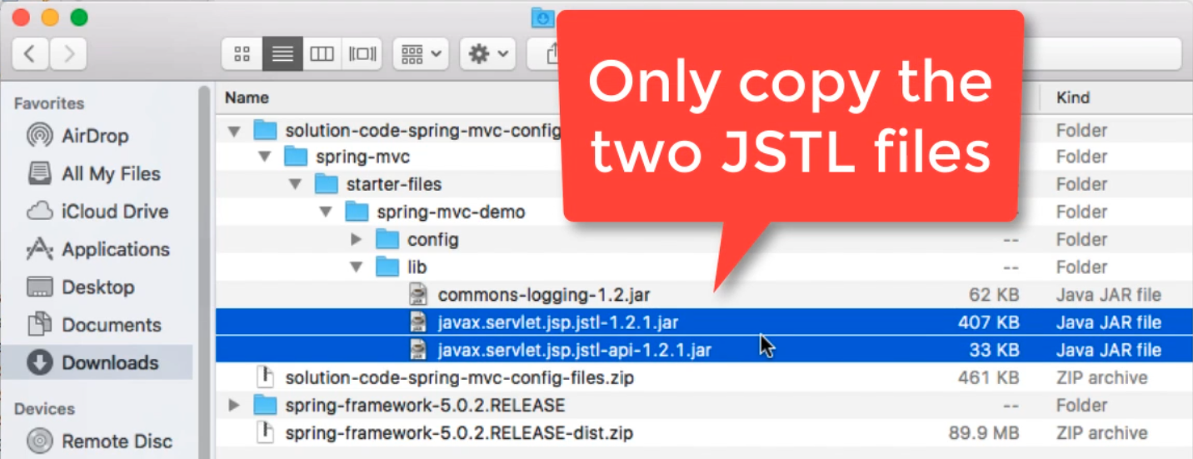

7. Spring MVC Configuration - Config Files

Paste 2 file .xml vào WEB-INF

Tạo folder view trong WEB-INF

**Question:**

How to configure the Spring Dispatcher Servlet using all Java Code (no xml)?

**Answer:**

Good question!

For Spring MVC, we cover all Java config (no xml) later in the course, complete with videos/explanation and everything.

However, if you just need the code, here are the steps

1. Delete the files: web.xml file and spring-mvc-demo-servlet.xml files

2. Create a new Java package: com.luv2code.springdemo.config

3. Add the following Java files in your package

**File: DemoAppConfig.java**

package com.luv2code.springdemo.config;

import org.springframework.context.annotation.Bean;

import org.springframework.context.annotation.ComponentScan;

import org.springframework.context.annotation.Configuration;

import org.springframework.web.servlet.ViewResolver;

import org.springframework.web.servlet.config.annotation.EnableWebMvc;

import org.springframework.web.servlet.view.InternalResourceViewResolver;

@Configuration

@EnableWebMvc

@ComponentScan(basePackages="com.luv2code.springdemo")

public class DemoAppConfig {

// define a bean for ViewResolver

@Bean

public ViewResolver viewResolver() {

InternalResourceViewResolver viewResolver = new InternalResourceViewResolver();

viewResolver.setPrefix("/WEB-INF/view/");

viewResolver.setSuffix(".jsp");

return viewResolver;

}

}

---

**File: MySpringMvcDispatcherServletInitializer.java**

package com.luv2code.springdemo.config;

import org.springframework.web.servlet.support.AbstractAnnotationConfigDispatcherServletInitializer;

public class MySpringMvcDispatcherServletInitializer extends AbstractAnnotationConfigDispatcherServletInitializer {

@Override

protected Class<?>[] getRootConfigClasses() {

// TODO Auto-generated method stub

return null;

}

@Override

protected Class<?>[] getServletConfigClasses() {

return new Class[] { DemoAppConfig.class };

}

@Override

protected String[] getServletMappings() {

return new String[] { "/" };

}

}

4. Test your app

Your app should work as desired.

---

I also uploaded a full project implementation with code here

<https://drive.google.com/open?id=1_5__2SggzgFHt7Rs2YYsv5JHRVX5Orq3>

---

For a discussion on how this code works, you can skip ahead to the following video

**Video 403 - Spring MVC All Java Config**

<https://www.udemy.com/spring-hibernate-tutorial/learn/v4/t/lecture/8355870?start=148>

Skip ahead to time marker [02:28]

---

let me know if you need anything else.

:-)

## 12. Spring MVC - Creating Controllers and Views

1. Creating a Spring Home Controller and View – Overview

Development Process

1. Create Controller class

2. Define Controller method

3. Add Request Mapping to Controller method

4. Return View Name

5. Develop View Page

- Khi chạy vào run as/ run on server/ chọn server Tomcat/ tick Always use this server….

If get error 404

<http://luv2code.com/spring-mvc-helps>

4. FAQ HELP! My Spring MVC Controller is not working. What to do.html

JUST A HEADS UP ...

IN THE VIDEOS YOUR SPRING MVC CONTROLLER CODE MAY NOT WORK

THIS IS AN ECLIPSE CACHING BUG

IF YOUR CONTROLLER DOESN'T WORK THEN TRY THE STEPS BELOW

----  
**Question:**HELP! My Spring MVC Controller is not working. What to do?

**Answer:**

***Debug Tip #0: Make sure you are accessing the correct URL***

You need to access the correct URL, localhost:8080/spring-mvc-demo/

Note: Do not attempt to run the JSP files directly. This will not work due to MVC.

---

***Debug Tip #1: Make Sure your Package Names is consistent***

The Spring configuration file used in the videos expects for your controller to be in the package:

***package com.luv2code.springdemo.mvc;***

*Make sure your controller is this package.*

***----***

***Debug Tip #2:  Reimport Project into Eclipse***

Sometimes the Eclipse project settings can become corrupted. One possible solution is to remove the Eclipse project  and reimport into Eclipse.

Here are the steps.

1. Remove the project from Eclipse.

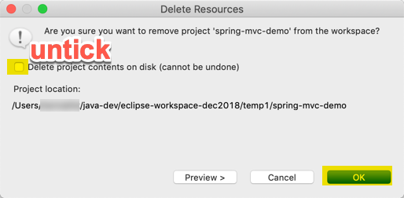

2. Open the project in file system and remove the files/ folders except src and WebContent.

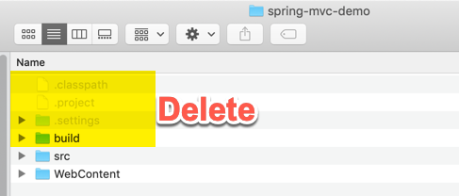

3. Open the project in Eclipse again using **File > Import ... > General > Existing Projects into Workspace**

4.  Check the project properties(Right click on the project and click on Properties),

5. Check the Java Build Path, Java Compiler and Project Facets and make sure that the Java version is same in all the windows.

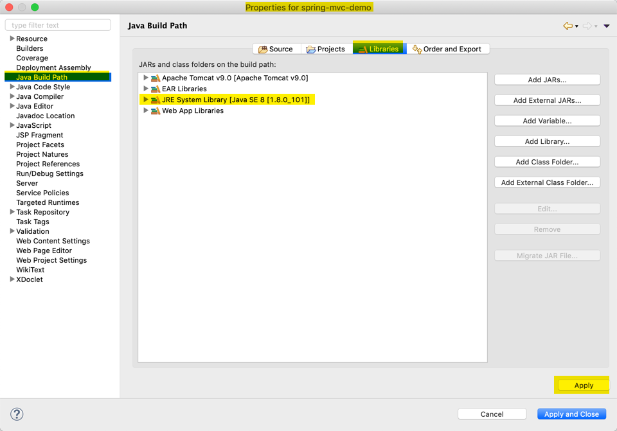

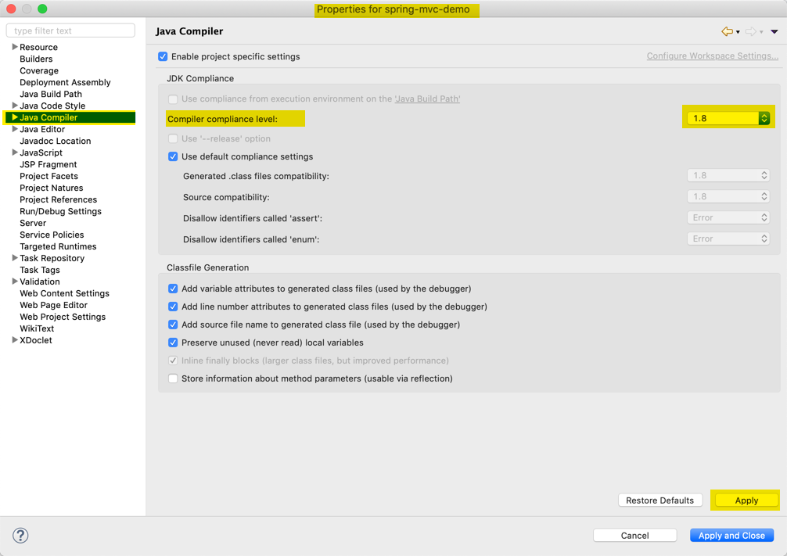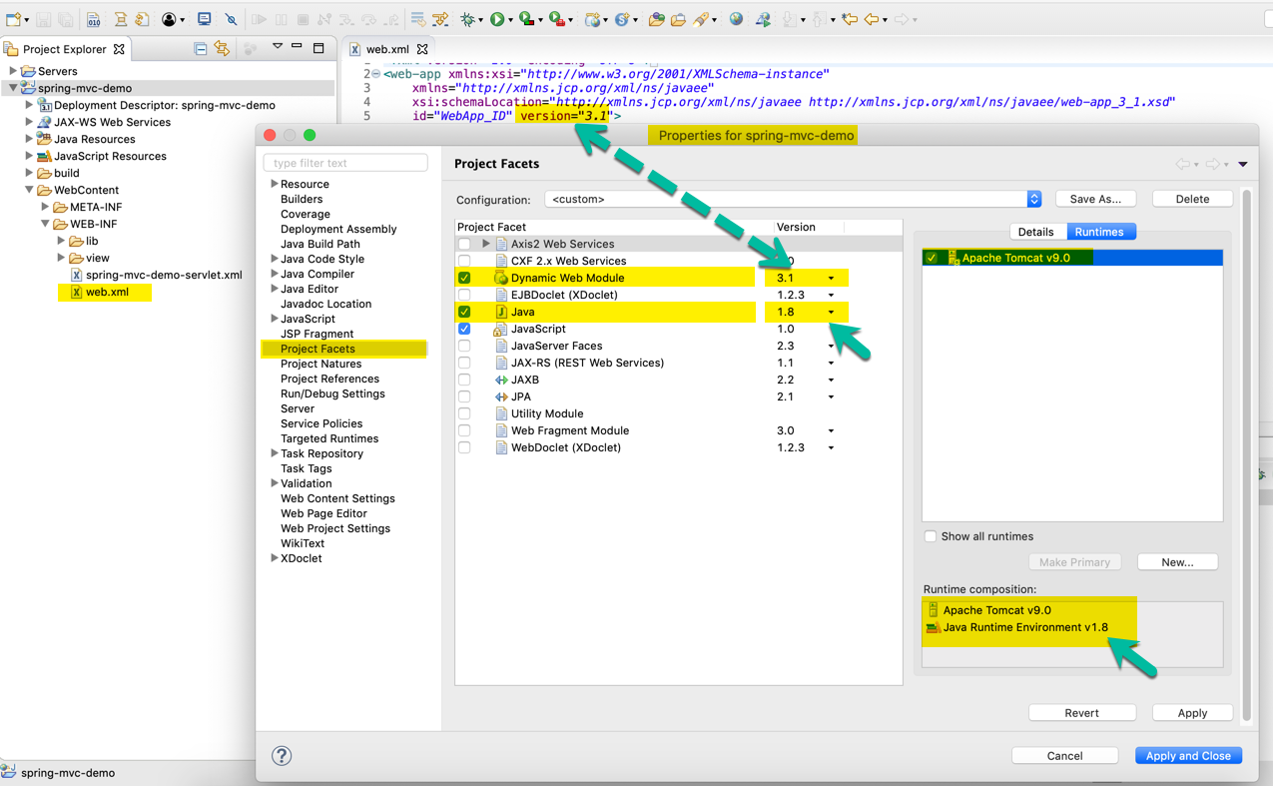

5. Build the project and try again.

***----***

***Debug Tip #3: Clear Tomcat Cache***This is normally a caching issue with the cache.

Here are some steps to clear the Eclipse cache and Tomcat cache.

1. In the Server's tab in Eclipse, Stop the Tomcat server

2. Right-click the server and select "Clean..."

3. Right-click the server again and select "Clean Tomcat Work Directory..."

---

4. In the Eclipse, select the top-level menu option, Project > Clean ...

5. Be sure your project is selected and click Ok

6. Restart Eclipse

Retest your application. If you continue to have problems try Debug Tip #2

---

***Debug Tip #4: Import the Project in  a new workspace***

1. Copy your project to a new directory on your computer like, c:\foobar

2. In Eclipse, open a new workspace: Create a new workspace in Eclipse: File > Switch Workspace > Other ... > give any name

3. In Eclipse, import the project

3a. Use File > Import > General > Existing Projects into Workspace

3b. Browse to directory: c:\foobar

4. In your new workspace, add a reference to the Tomcat server

5. Test your app in the new workspace

---

If you still have problems, then post your code to the classroom discussion forum.

Be sure to include the following files:  
- spring-mvc-demo-servlet.xml  
- your controller .java  
- your view page .jsp

5. FAQ HELP! - Can't Start Tomcat - Ports are in Use!.html

Can't Start Tomcat - Ports are in Use

You may have a problem starting Tomcat. You may see this ugly error message about ports in use.

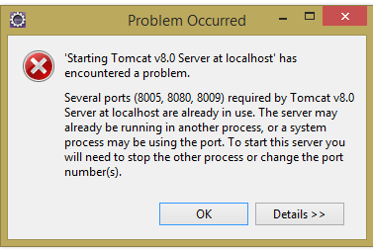

**Solution**

You can use the troubleshooting tips below.

***Troubleshooting Tip #1***

1. Exit Eclipse

2. Open a web web browser and visit, http://localhost:8080

3. If you see a "Tomcat" web page then that means Tomcat is running as a Windows service. To stop Tomcat running as a Windows services, open your Windows Control Panel. Find the service "Apache Tomcat" and stop it.

4. If you don't see a "Tomcat" web page, then stop the appropriate process displayed.

--  
***Troubleshooting Tip #2 - GUI Option***

Steps to free port which is already used to run Tomcat server in Eclipse

1. On MS Windows, select *Start > All Programs  > Accessories > System Tools >Resource Monitor*

2. Expand the **Network Tab**

3. Move to the section for **Listening Ports**

4. Look in the Port column and scroll to find entry for port 8080

5. Select the given process and delete/kill the process

6. Return back to Eclipse and start the Tomcat Server, it should start up now.

---

***Troubleshooting Tip #3 - Command-Line Option***

Steps to free port which is already used to run Tomcat server in Eclipse

For example , suppose 8080 port is used , we need to make free 8080 to run tomcat

Step 1: (open the CMD command)

C:\Users\username>netstat -o -n -a | findstr 0.0:8080

TCP    0.0.0.0:3000      0.0.0.0:0              LISTENING       3116

Now , we can see that LISTENING port is 3116 for 8080 ,

We need to kill 3116 now

Step 2:

C:\Users\username>taskkill /F /PID 3116

Step 3:  Return back to Eclipse and start the Tomcat Server, it should start up now.

====

**Mac/Linux SOLUTION**

Step 0: Exit Eclipse

Step 1: Open a terminal window

Step 2: Enter the following command to find the process id

lsof -i :8080

This will give output of the application that is running on port 8080

Step 3: Enter the following command to kill the process

kill $(lsof -t -i :8080)

Step 4:  Return back to Eclipse and start the Tomcat Server, it should start up now.

6. FAQ How Does Component Scan Work - Your Package Names are Different!.html

How Does Component Scan Work - Your Package Names are Different!

**Question**

How does component scan work in this example? You have different package names.

You listed the component scan package as: com.luv2code.springdemo

But the our MVC controllers are defined in com.luv2code.springdemo.mvc

**Answer**  
For the Spring attribute:  base-package="com.luv2code.springdemo"

Spring will recursively scan for components starting at the base package: "com.luv2code.springdemo"

When I say "recursive", it means that Spring will start at the base package and scan all sub packages.

The package com.luv2code.springdemo.mvc is a sub package because of naming structure, just like folders on a file system.

As a result, it will be included in the scan.

7. Reading HTML Form Data – Overview

11. Adding Data to the Spring Model - Overview

**Question**

14. How do I use CSS, JavaScript and Images in a Spring MVC Web App?

**Answer**

Here are the steps on how to access static resources in a Spring MVC. For example, you can use this to access images, css, JavaScript files etc.

Any static resource is processed as a URL Mapping in Spring MVC. You can configure references to static resources in the spring-mvc-demo-servlet.xml.

In my example, I'm going to have the following directory structure:

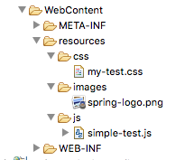

I chose to put everything in the "resources" directory. But you can use any name for "resources", such as "assets", "foobar" etc. Also, you can give any name that you want for the subdirectories under "resources".

---

**Step 1:** Add the following entry to your Spring MVC configuration file: **spring-mvc-demo-servlet.xml**

You can place this entry anywhere in your Spring MVC config file.

<mvc:resources mapping="/resources/**" location="/resources/"></mvc:resources>

**Step 2:** Now in your view pages, you can access the static files using this syntax:

<img src="${pageContext.request.contextPath}/resources/images/spring-logo.png">

You need to use the JSP expression **${pageContext.request.contextPath}** to access the correct root directory for your web application.

Apply the same technique for reading CSS and JavaScript.

---

Here's a full example that reads CSS, JavaScript and images.

<!DOCTYPE html> <html>

<head>

**<link rel="stylesheet" type="text/css"**

**href="${pageContext.request.contextPath}/resources/css/my-test.css">**

**<script src="${pageContext.request.contextPath}/resources/js/simple-test.js"></script>**

</head>

<body>

<h2>Spring MVC Demo - Home Page</h2>

<a href="showForm">Plain Hello World</a>

<br><br>

**<img src="${pageContext.request.contextPath}/resources/images/spring-logo.png" />**

<br><br>

<input type="button" onclick="doSomeWork()" value="Click Me"/>

</body>

</html>

---

Source code for this example are available here:

- <https://gist.github.com/darbyluv2code/9a09543a226baeedc04b9a5037ca52ec>

****15. Bonus: Deploying your App to Tomcat as a Web Application Archive (WAR) file****

When you deploy your Java web apps, you can make use of a Web Application Archive (WAR) file.

The Web Application Archive (WAR) file is a compressed version of your web application. It uses the zip file format but the file has the .war extension.

If you are using Eclipse, then the best way to visualize it is think of your "WebContent" directory being compressed as a zip file with the .war extension.

This includes all of your web pages, images, css etc. It also includes the WEB-INF directory which includes your classes in WEB-INF/classes and supporting JAR files in WEB-INF/lib.

The WAR file format is part of the Java EE / Servlet specification. As a result, all Java EE servers support this format (ie jboss, weblogic, websphere, glassfish and tomcat).

Below, I provide steps on how to create a WAR file in Eclipse. I also show how to deploy the WAR file on Tomcat.

---

1. In Eclipse, stop Tomcat

2. Right-click your project and select Export > WAR File

3. In the Destination field, enter: <any-directory>/mycoolapp.war

4. Outside of Eclipse, start Tomcat  
- If you are using MS Windows, then you should find it on the Start menu

5. Make sure Tomcat is up and running by visiting: http://localhost:8080

6. Deploy your new WAR file by copying it to <tomcat-install-directory>\webapps

Give it about 10-15 seconds to make the deployment. You'll know the deployment is over because you'll see a new folder created in webapps ... with your WAR file name.

7. Visit your new app. If your war file was: mycoolapp.war then you can access it with:  http://localhost:8080/mycoolapp/

## 13. Spring MVC - Request Params and Request Mappings

1. Binding Request Params – Override

2. Binding Request Params - Write Some Code

3. Controller Level Request Mapping – Overview

6. FAQ How does processForm work for hello.html

**FAQ:**

**Question: Can you please clarify how /hello is getting appended to the jsp file action for "processForm"?**

**Answer**

You can use "processForm" because it is a relative path to the controller "/hello" request mapping. Here is how it works.

1. When you wish to view the form, the HTML link points to "hello/showForm". This calls the controller and it displays the form.

2. At this point the browser URL/path is: http://localhost:8080/spring-mvc-demo/hello

3. The HTML form uses "processForm" for the form action. Notice that it does not have a forward slash, as a result, this will be relative to the current browser URL. Since the current browser URL is

http://localhost:8080/spring-mvc-demo/hello

Then the actual form URL submission will send it to

http://localhost:8080/spring-mvc-demo/hello/processForm

The part in bold with map to the controller with top-level request mapping "/hello" and then map to request mapping in that class "/processForm"

The key here is relative path of showing the form and then submitting to relative path.

## 14. Spring MVC - Form Tags and Data Binding

1. Spring MVC Form Tags Overview

<http://luv2code.com/spring-mvc-form-tags>

**Spring MVC Form Tags**• Form tags will generate HTML for you :-)

|  |
| --- |
| **Form Tags** form:form => main form container |
| form:input | text field |
| form:textarea | multi-line text field |
| form:checkbox | check box |
| form:radiobutton | radio buttons |
| form:select | drop down list |
| *more ….* |  |

**How To Reference Spring MVC Form Tags**• Specify the Spring namespace at beginning of JSP file  
**<%@ taglib prefix=*"form"* uri=*"http://www.springframework.org/tags/form"* %>**

2. Text Fields - Overview

6. Drop-Down Lists – Overview

9. FAQ Use properties file to load country options.html

**Question:**

How to use properties file to load country options

**Answer:**

This solution will show you how to place the country options in a properties file. The values will no longer be hard coded in the Java code.

**1. Create a properties file to hold the countries. It will be a name value pair.  Country code is name. Country name is the value.**

New text file:  WEB-INF/countries.properties

BR=Brazil

FR=France

CO=Colombia

IN=India

Note the location of the properties file is very important. It must be stored in WEB-INF/countries.properties

**2. Update header section for Spring config file**

We are going to use a new set of Spring tags for <util>. As a result, you need to update the header information in the Spring config file.

File: spring-mvc-dmo-servlet.xml

Remove the previous header and add this.

<?xml version="1.0" encoding="UTF-8"?>

<beans xmlns="http://www.springframework.org/schema/beans"

xmlns:context="http://www.springframework.org/schema/context"

xmlns:mvc="http://www.springframework.org/schema/mvc"

xmlns:util="http://www.springframework.org/schema/util"

xmlns:xsi="http://www.w3.org/2001/XMLSchema-instance"

xsi:schemaLocation="

http://www.springframework.org/schema/beans

http://www.springframework.org/schema/beans/spring-beans.xsd

http://www.springframework.org/schema/context

http://www.springframework.org/schema/context/spring-context.xsd

http://www.springframework.org/schema/mvc

http://www.springframework.org/schema/mvc/spring-mvc.xsd

http://www.springframework.org/schema/util

http://www.springframework.org/schema/util/spring-util.xsd">

**3. Load the country options properties file in the Spring config file. Bean id: countryOptions**

File: spring-mvc-dmo-servlet.xml

Add the following lines:

<util:properties id="countryOptions" location="classpath:../countries.properties" />

**4. Inject the properties values into your Spring Controller: StudentController.java**

@Value("#{countryOptions}")

private Map<String, String> countryOptions;

**5. Add the country options to the Spring MVC model. Attribute name: theCountryOptions**

@RequestMapping("/showForm")

public String showForm(Model theModel) {

// create a student object Student

Student theStudent = new Student();

// add student object to the model

theModel.addAttribute("student", theStudent);

// add the country options to the model

theModel.addAttribute("theCountryOptions", countryOptions);

return "student-form";

}

**6. Update the JSP page, student-form.jsp, to use the new model attribute for the drop-down list: theCountryOptions**

<form:select path="country">

<form:options items="${theCountryOptions}" />

</form:select>

**7. Remove all references to country option from your Student.java.**

---

**DOWNLOAD FULL SOURCE CODE**

You can download entire code from here:

- <http://www.luv2code.com/downloads/spring-hibernate/spring-props-mvc-demo.zip>

1. Radio Buttons – Overview
2. FAQ How to populate radiobuttons with items from Java class.html

**FAQ: How to populate radiobuttons with items from Java class like we did with selectlist?**

You can follow a similar approach that we used for the drop-down list.

Here are the steps

1. Set up the data in your Student class

Add a new field

    private LinkedHashMap<String, String> favoriteLanguageOptions;

In your constructor, populate the data

        // populate favorite language options  
        favoriteLanguageOptions = new LinkedHashMap<>();

        // parameter order: value, display label  
        //  
        favoriteLanguageOptions.put("Java", "Java");  
        favoriteLanguageOptions.put("C#", "C#");  
        favoriteLanguageOptions.put("PHP", "PHP");  
        favoriteLanguageOptions.put("Ruby", "Ruby");

Add getter method

    public LinkedHashMap<String, String> getFavoriteLanguageOptions() {  
        return favoriteLanguageOptions;  
    }

2. Reference the data in your form

        Favorite Language:  
          
        <form:radiobuttons path="favoriteLanguage" items="${student.favoriteLanguageOptions}"  />

Source code is available here:  
- <https://gist.github.com/darbyluv2code/debb69b1bf8010d84d50e0542e809ffb>

13. Checkboxes – Overview

## 15. Spring MVC Form Validation - Applying Built-In Validation Rules

1. Spring MVC Form Validation Overview

Bean validation

Tải file zip từ trang chủ hibernate

<https://beanvalidation.org/>

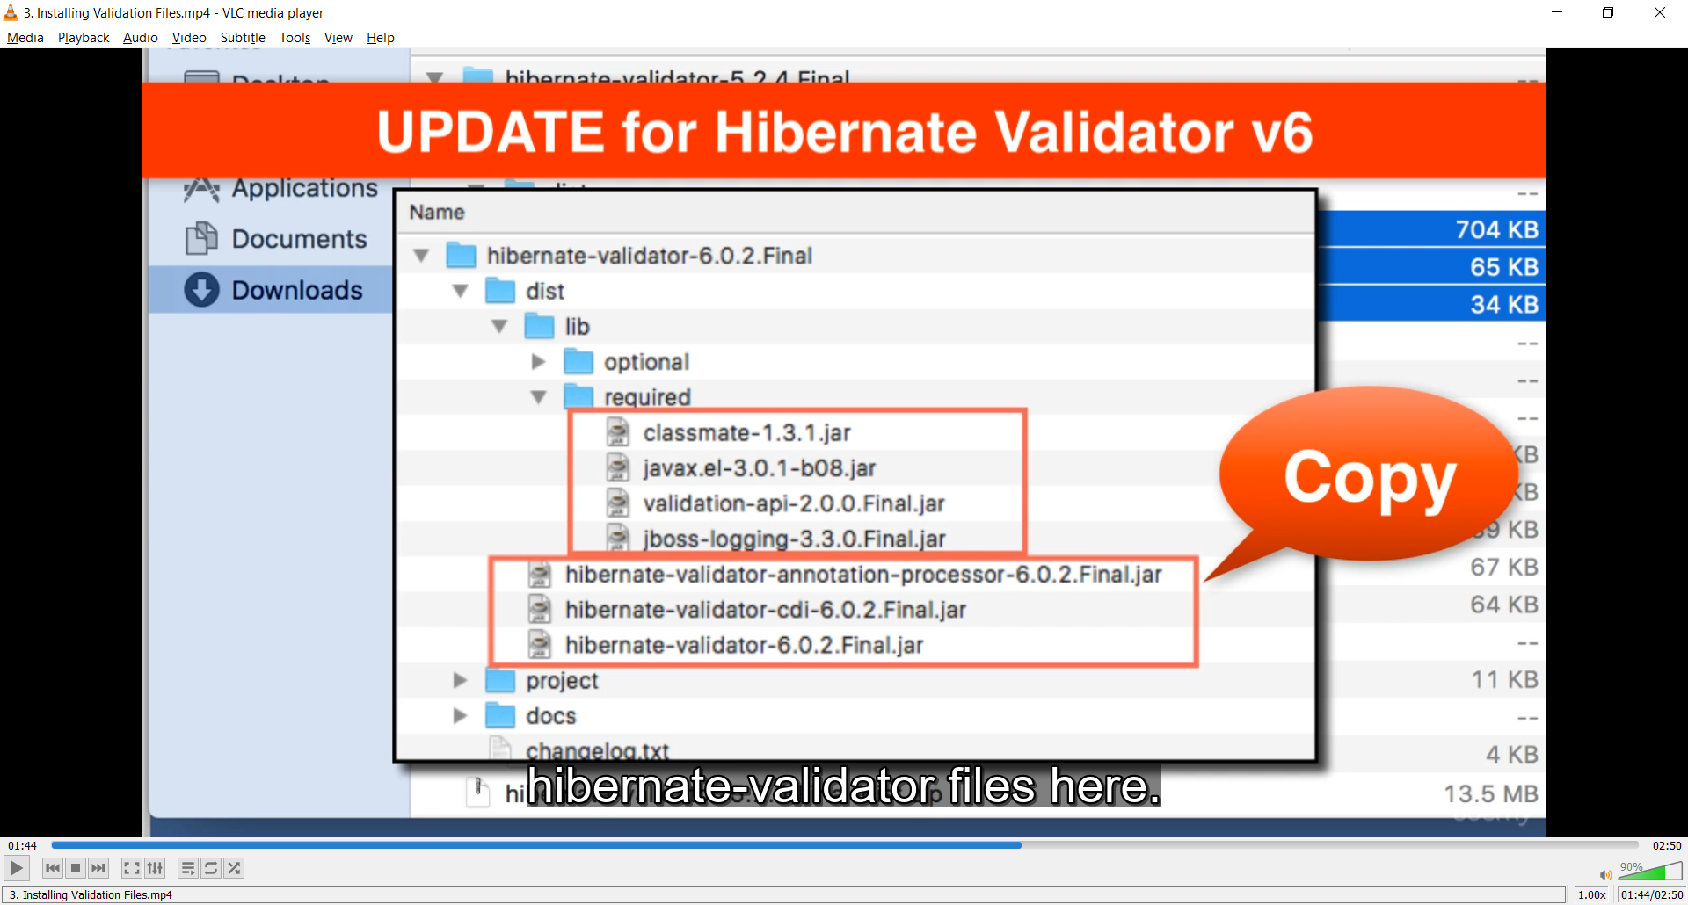

<http://hibernate.org/validator/>

Kiểu dữ liệu khi validate phải là object và có đầy đủ get set

2. Setting Up Dev Environment for Form Validation

3. Installing Validation Files

4. Checking for Required Fields Overview

When performing Spring MVC validation, the location of the BindingResult parameter is very important. In the method signature, **the BindingResult parameter must appear immediately after the model attribute**.

If you place it in any other location, Spring MVC validation will not work as desired. In fact, your validation rules will be ignored.

@RequestMapping("/processForm")

public String processForm(

@Valid @ModelAttribute("customer") Customer theCustomer,

BindingResult theBindingResult) {

...

}

Here is the relevant section from the Spring Reference Manual

---

***Defining @RequestMapping methods***

*@RequestMapping handler methods have a flexible signature and can choose from a range of supported controller method arguments and return values.  
...*

*The Errors or BindingResult parameters have to follow the model object that is being  
bound immediately ...*

*Source:*[*https://docs.spring.io/spring/docs/current/spring-framework-reference/web.html#mvc-ann-methods*](https://docs.spring.io/spring/docs/current/spring-framework-reference/web.html#mvc-ann-methods)

6. Add Validation Rule to Customer Class

7. Display Validation Error Messages on HTML Form

10. Update Confirmation Page

11. Test the Validation Rule for Required Fields

12. Add Pre-processing Code with @InitBinder - Overview

## 16. Spring MVC Form Validation - Validating Number Ranges and Regular Expressions

1. Validating a Number Range - Overview

2. Validating a Number Range - Write Some Code

3. Applying Regular Expressions - Overview

4. Applying Regular Expressions - Write Some Code

5. How to make Integer Field Required freePasses

6. How to Handle String input for Integer Fields - Custom Message

7. How to Handle String input for Integer Fields - Configure Resource Bundle

Thêm:

<bean id="messageSource"   
 class="org.springframework.context.support.ResourceBundleMessageSource">  
 <property name="basenames" value="resources/messages" />  
</bean>

Tạo file messages.properties trong src/resources

8. How to Handle String input for Integer Fields - Deep Dive

**FAQ: How to Make Integer field required and handle Strings: freePasses?**

***Question:***

I am getting the following error when i submit the form with an empty value for customer "freePasses". I am  using @NotNull on the field "freePasses". It is not throwing "is required" after validation after submit.

How to fix this? Please help.

Also, how do I handle validation if the user enters String input for the integer field?

-----

***Answer:***

Great question!

The root cause is the freePasses field is using a primitive type: int. In order to check for null we must use the appropriate wrapper class: **Integer**.

To resolve this, In Customer.java, replace "int" with "Integer"

@NotNull(message="is required")       
@Min(value=0, message="must be greater than or equal to zero")       
@Max(value=10, message="must be less than or equal to 10")       
private **Integer** freePasses;

Then update your getter/setter methods to use "Integer"

    public **Integer** getFreePasses() {  
        return freePasses;  
    }

    public void setFreePasses(**Integer** freePasses) {  
        this.freePasses = freePasses;  
    }

Save everything and retest.

=====

Here is the full source code.

package com.luv2code.springdemo.mvc;

import javax.validation.constraints.Max;

import javax.validation.constraints.Min;

import javax.validation.constraints.NotNull;

import javax.validation.constraints.Pattern;

import javax.validation.constraints.Size;

public class Customer {

private String firstName;

@NotNull(message="is required")

@Size(min=1, message="is required")

private String lastName;

@NotNull(message="is required")

@Min(value=0, message="must be greater than or equal to zero")

@Max(value=10, message="must be less than or equal to 10")

private Integer freePasses;

@Pattern(regexp="^[a-zA-Z0-9]{5}", message="only 5 chars/digits")

private String postalCode;

public String getPostalCode() {

return postalCode;

}

public void setPostalCode(String postalCode) {

this.postalCode = postalCode;

}

public String getFirstName() {

return firstName;

}

public void setFirstName(String firstName) {

this.firstName = firstName;

}

public String getLastName() {

return lastName;

}

public void setLastName(String lastName) {

this.lastName = lastName;

}

public Integer getFreePasses() {

return freePasses;

}

public void setFreePasses(Integer freePasses) {

this.freePasses = freePasses;

}

}

====

**Handle String Input for Integer Fields**

If the user enters String input such as "abcde" for the Free Passes integer field, we'd like to give a descriptive error message.

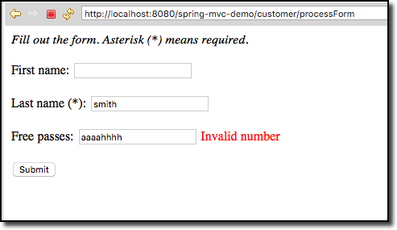

We basically need to override the default Spring MVC validation messages.

Follow these steps.

1. In your Eclipse project, expand the node: **Java Resources**

2. Right-click the **src** directory and create a new sub-directory: **resources**

3. Right-click the **resources** sub-directory and create a new file named: **messages.properties**

Your directory structure should look like this:

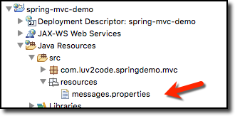

4. Add the following entry to the **messages.properties** file

typeMismatch.customer.freePasses=Invalid number

5. Save file

---

This file contains key/value pairs for the error message type

For a basic example:

  typeMismatch.customer.freePasses=Invalid number

The format of the error key is:   code + "." + object name + "." + field

To find out the given error code, in your Spring controller, you can log the details of the binding result

 System.out.println("Binding result: " + theBindingResult);

For details, see the docs here

- <http://docs.spring.io/spring/docs/current/javadoc-api/org/springframework/validation/DefaultMessageCodesResolver.html>

---

6. Edit your config file: **WEB-INF/spring-mvc-demo-servlet.xml**

Add the following:

<bean id="messageSource"

class="org.springframework.context.support.ResourceBundleMessageSource">

<property name="basenames" value="resources/messages" />

</bean>

7. Save the file. Restart the Tomcat server

8. Run your app and add bad data for the "Free Passes" field. You will see the error message from our properties file.



## 17. Spring MVC Form Validation - Creating Custom Validation Rules

1. Custom Form Validation - Overview - Part 1

2. Custom Form Validation - Overview - Part 2

3. Creating a Custom Java Annotation - Part 1

4. Creating a Custom Java Annotation - Part 2

5. Developing the ConstraintValidator

6. Adding Validation Rule to the Entity and Form

7. Testing the Custom Validation Rule

**Spring MVC Custom Validation - FAQ: Is it possible to integrate multiple validation string in one annotation?**

**Question:**

Is it possible to integrate multiple validation string in one annotation? For example, validate against both LUV and TOPS.

**Answer:**

Yes, you can do this. In your validation, you will make use of an array of strings.

Here's an overview of the steps.

1. Update CourseCode.java to use an array of strings

2. Update CourseCodeConstraintValidator.java to validate against array of strings

3. Update Customer.java to validate using array of strings

---

**Detailed Steps**

**1. Update CourseCode.java to use an array of strings**

Change the value entry to an array of Strings:

// define default course code

public String[] value() default {"LUV"};

Note the use of square brackets for the array of Strings. Also, the initialized value uses curley-braces for array data.

**2. Update CourseCodeConstraintValidator.java to validate against array of strings**

Change the field for coursePrefixes to an array

private String[] coursePrefixes;

Update the isValid(...) method to loop through the course prefixes. In the loop, check to see if the code matches any of the course prefixes.

@Override

public boolean isValid(String theCode,

ConstraintValidatorContext theConstraintValidatorContext) {

boolean result = false;

if (theCode != null) {

//

// loop thru course prefixes

//

// check to see if code matches any of the course prefixes

//

for (String tempPrefix : coursePrefixes) {

result = theCode.startsWith(tempPrefix);

// if we found a match then break out of the loop

if (result) {

break;

}

}

}

else {

result = true;

}

return result;

}

**3. Update Customer.java to validate using array of strings**

@CourseCode(value={"TOPS", "LUV"}, message="must start with TOPS or LUV")

private String courseCode;

Note the use of curley braces.

---

Complete Source Code:

<https://gist.github.com/darbyluv2code/0275ddb6e70e085a10fd464e36a42739>

---

That's it. This provides a solution to integrate multiple validation string in one annotation. In this example, the code validates against both LUV and TOPS.

## 18. Introduction to Hibernate

1. Hibernate Overview

This course uses Hibernate 5.2.

Hibernate 5.2 requires Java 8.

In order to run the examples in this course, you will need have Java 8 installed.

2. Hibernate and JDBC

Java 8

**Official MySQL Installation instructions for MAC**

<http://dev.mysql.com/doc/refman/5.7/en/osx-installation.html>

## 19. Setting Up Hibernate Development Environment

2. Hibernate Development Environment Overview

3. Installing MySQL on MS Windows

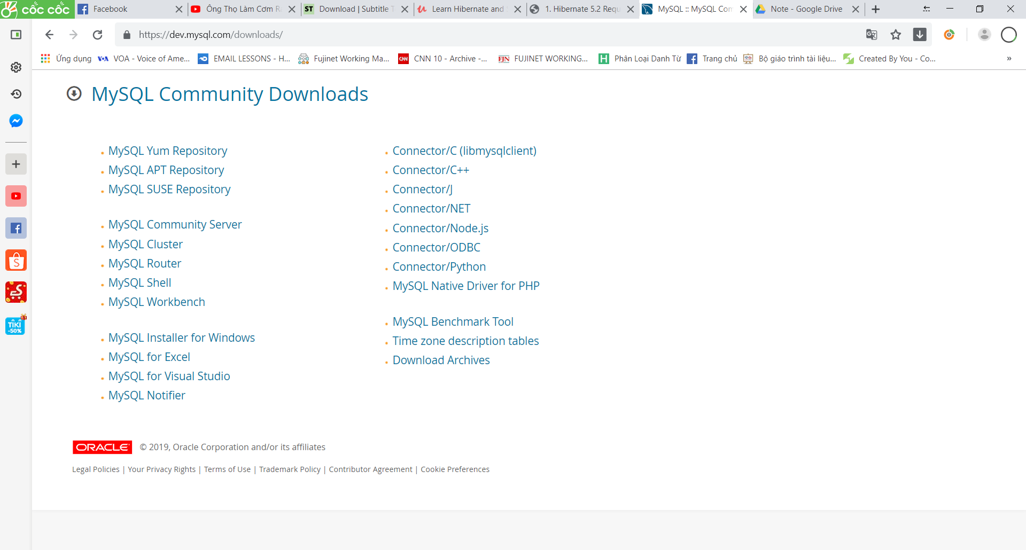

mysql-installer-community-8.0.16.0

pass: 1234

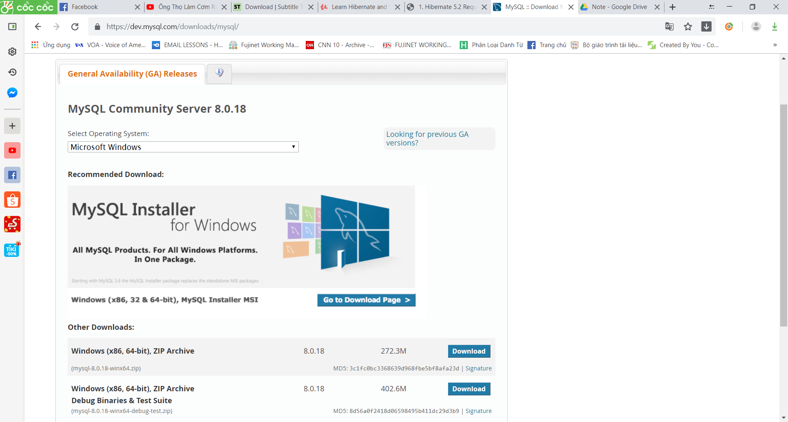

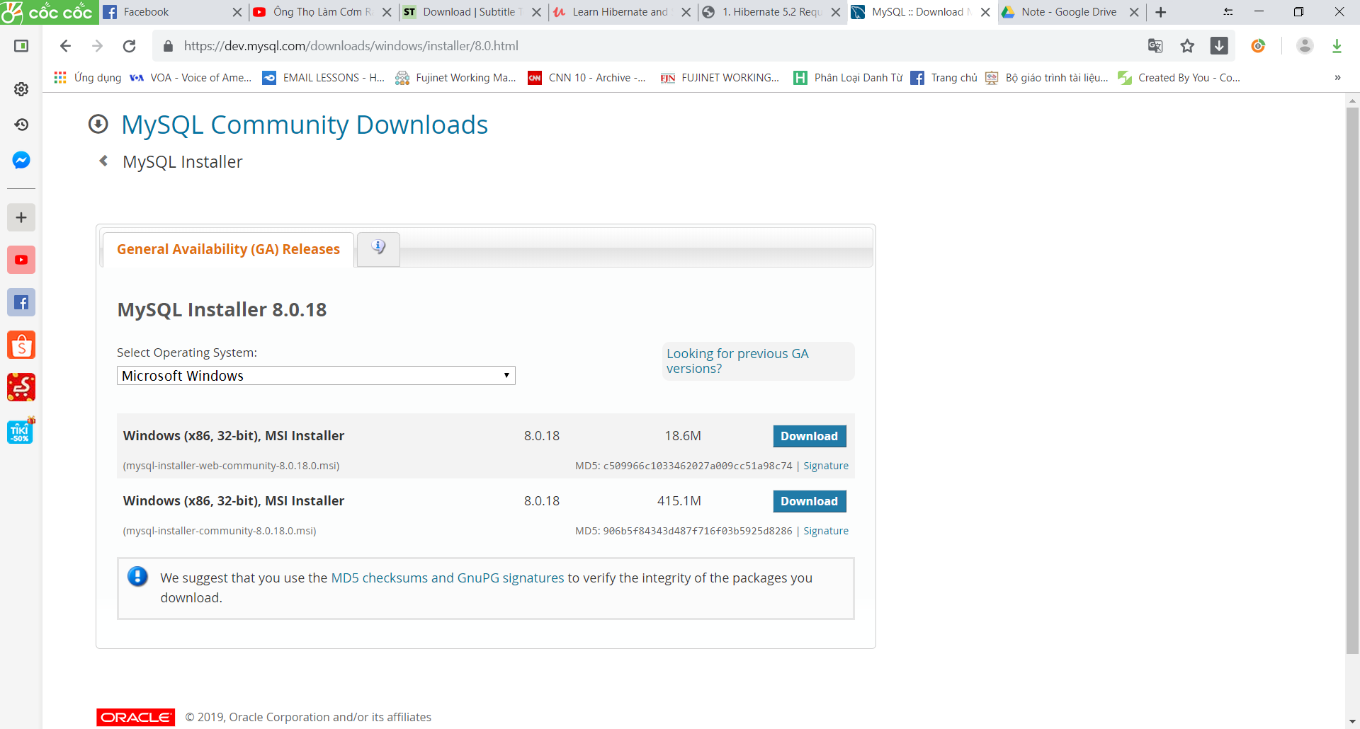

Chọn [**No thanks, just start my download.**](https://dev.mysql.com/get/Downloads/MySQLInstaller/mysql-installer-web-community-8.0.18.0.msi)

5. Setting Up Database Table

1. Folder: sql-scripts

01-create-user.sql

02-student-tracker.sql

1. Create a new MySQL user for our application  
user id: **hbstudent**password: **hbstudent**

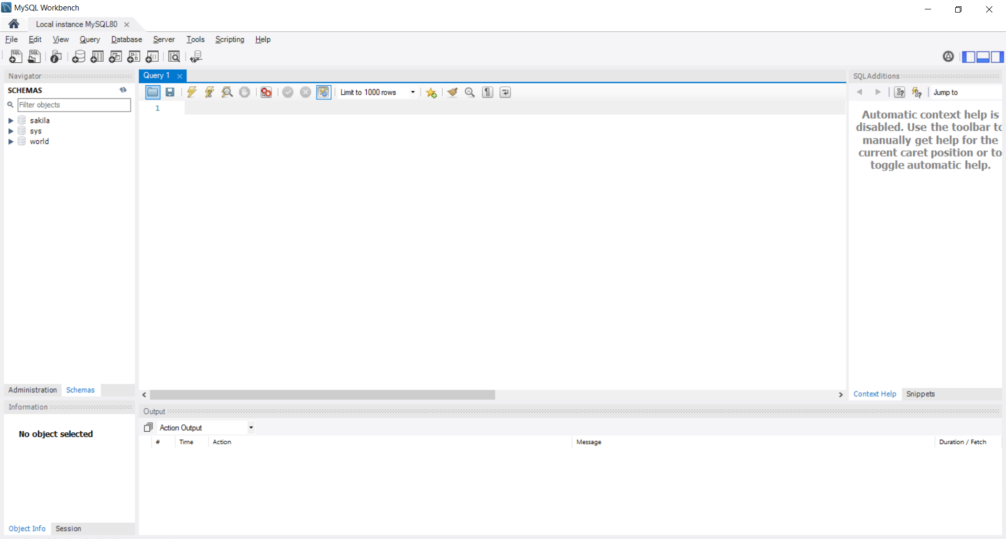

Chọn vào icon folder

Import file 01-create-user.sql để tạo user mới

CREATE USER 'hbstudent'@'localhost' IDENTIFIED BY 'hbstudent';  
  
GRANT ALL PRIVILEGES ON * . * TO 'hbstudent'@'localhost';  
  
#  
# Starting with MySQL 8.0.4, the MySQL team changed the   
# default authentication plugin for MySQL server   
# from mysql_native_password to caching_sha2_password.  
#  
# The command below will make the appropriate updates for your user account.  
#  
# See the MySQL Reference Manual for details:   
# https://dev.mysql.com/doc/refman/8.0/en/caching-sha2-pluggable-authentication.html  
#  
ALTER USER 'hbstudent'@'localhost' IDENTIFIED WITH mysql_native_password BY 'hbstudent';

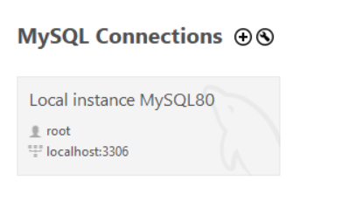

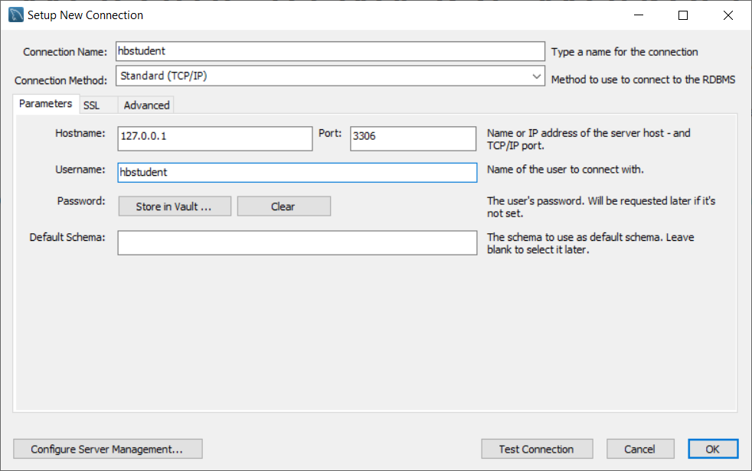

Pass: hbstudent

6. Setting up Hibernate in Eclipse

<https://hibernate.org/orm/>

Tải version 5.4

Copy tất cả file trong \hibernate-release-5.4.6.Final\lib\required

Tải jdbc connector: <https://dev.mysql.com/downloads/connector/j/5.1.html>

Rồi copy 1 file jar đó vào eclipse

7. Testing Your JDBC Connection

Tạo file TestJdbc

useSLL: get rid of Mysql SSL warning

import java.sql.Connection;  
import java.sql.DriverManager;

public static void main(String[] args) {  
  
 String jdbcUrl = "jdbc:mysql://localhost:3306/hb_student_tracker?useSSL=false&serverTimezone=UTC";  
 String user = "hbstudent";  
 String pass = "hbstudent";  
   
 try {  
 System.out.println("Connecting to database: " + jdbcUrl);  
   
 Connection myConn =  
 DriverManager.getConnection(jdbcUrl, user, pass);  
   
 System.out.println("Connection successful!!!");  
   
 }  
 catch (Exception exc) {  
 exc.printStackTrace();  
 }  
   
}

## 20. Hibernate Configuration with Annotations

1. Hibernate Development Process Overview

Xem pdf

<http://luv2code.com/hibernate-tutorial>

2. Creating the Hibernate Configuration File

3. Hibernate Annotations - Part 1

@Id đánh dấu là primary key

**JUST A HEADS UP - FOR JAVA 9, 10 and 11 USERS**

**If you are using Java 9, 10 or 11, then you will encounter an error when you run your Hibernate program.**

**These are the steps to resolve it. Come back to the lecture if you hit the error.**

----

**Error: Exception in thread "main" java.lang.NoClassDefFoundError: javax/xml/bind/JAXBException**

This happens because of Java 9 and higher.

Java 9 and higher has removed java.xml.bind from its default classpath. That's why we get the class not found exception.  We have to explicitly add JAR files to the build path.

---

***Solution***

For Java 9 and higher, you need to additional JAR files.

You need to download the following JAR files:

javax.activation-1.2.0.jar  
jaxb-api-2.3.0.jar  
jaxb-core-2.3.0.jar  
jaxb-impl-2.3.0.jar

---

1. Download the files using links below:

[javax.activation-1.2.0.jar](http://search.maven.org/remotecontent?filepath=com/sun/activation/javax.activation/1.2.0/javax.activation-1.2.0.jar)

[jaxb-api-2.3.0.jar](http://search.maven.org/remotecontent?filepath=javax/xml/bind/jaxb-api/2.3.0/jaxb-api-2.3.0.jar)

[jaxb-core-2.3.0.jar](http://search.maven.org/remotecontent?filepath=com/sun/xml/bind/jaxb-core/2.3.0/jaxb-core-2.3.0.jar)

[jaxb-impl-2.3.0.jar](http://search.maven.org/remotecontent?filepath=com/sun/xml/bind/jaxb-impl/2.3.0/jaxb-impl-2.3.0.jar)

---

2. Copy the JAR files to the **lib** folder of your project

javax.activation-1.2.0.jar  
jaxb-api-2.3.0.jar  
jaxb-core-2.3.0.jar  
jaxb-impl-2.3.0.jar

---

Use the following steps to add the JAR files to your Java Build Path.

3. Right-click your project, select **Properties**

4. On left-hand side, click **Java Build Path**

5. In top-center of dialog, click **Libraries**

6. Click **Classpath** and then **Click Add JARs ...**

7. Navigate to the JAR files **<your-project>/lib**

Select the files:  
javax.activation-1.2.0.jar  
jaxb-api-2.3.0.jar  
jaxb-core-2.3.0.jar  
jaxb-impl-2.3.0.jar

8. Click OK then click Apply and Close

Eclipse will perform a rebuild of your project and it will resolve the related build/runtime errors.

====

**Error: import of the javax.persistance.GenerationType saying its not accessible**

You may still encounter problems for "import of the javax.persistance.GenerationType saying its not accessible"

To resolve this, apply the following steps

1. Right Click on the Project -> Properties - > Java Build Path.

2. Follow the steps as showed in the images below.

3. In Module Properties -> Select All in Available modules and move to Explicitly included modules.

4. Project->Clean... and Rebuild the Project and try again.

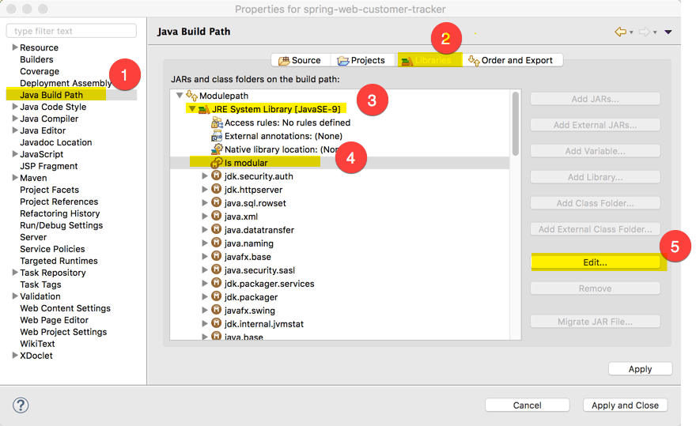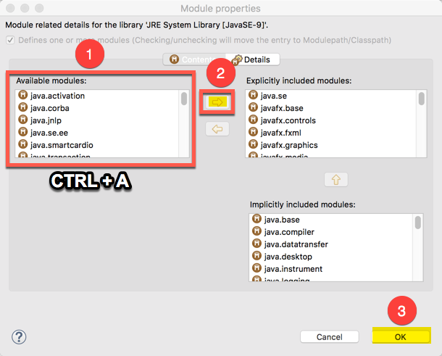

====

Note, if you are using Maven then you can add this to your POM file

<dependency>  
   <groupId>javax.xml.bind</groupId>  
   <artifactId>jaxb-api</artifactId>  
   <version>2.2.8</version>  
</dependency>  
  
<dependency>  
   <groupId>com.sun.xml.bind</groupId>  
   <artifactId>jaxb-core</artifactId>  
   <version>2.2.8</version>  
</dependency>  
  
<dependency>  
   <groupId>com.sun.xml.bind</groupId>  
   <artifactId>jaxb-impl</artifactId>  
   <version>2.2.8</version>  
</dependency>

<dependency>  
   <groupId>com.sun.activation</groupId>  
   <artifactId>javax.activation</artifactId>  
   <version>1.2.0</version>  
</dependency>

---

**HEADS UP - JAVA 9 USERS - Eclipse Generate toString() fails**

**Problem:**

The Generate toString() process fails in Eclipse with Java 9.

When clicking on Generate toString() an error message pops up saying:-

Cannot Create method Implementations

Reason:

C:\Program Files\Java\jre 9.04\lib\jrt-fs.jar\java.base[java.base is not in project's build path]

====

**Answer**

This is a bug in Eclipse when using Java 9.

It is a known issue and logged here by the Eclipse team.

Bug link: <https://bugs.eclipse.org/bugs/show_bug.cgi?id=521995>

---

As a work around, you will need to manually write the code for toString(). You can move ahead in the video and then pause the video where you see the toString() code.

**FAQ: Why we are using JPA Annotation instead of Hibernate ?**

**QUESTION:**Why we are using JPA Annotation instead of Hibernate ?

For example, why we are not using this org.hibernate.annotations.Entity?

**ANSWER:**JPA is a standard specification. Hibernate is an implementation of the JPA specification.

Hibernate implements all of the JPA annotations.

The Hibernate team recommends the use of JPA annotations as a best practice.

## 21. Hibernate CRUD Features Create, Read, Update and Delete

1. Creating and Saving Java Objects - Part 1

**SessionFactory**  
Reads the hibernate config file  
Creates Session objects  
Heavy-weight object  
Only create once in your app  
**Session**  
Wraps a JDBC connection  
Main object used to save/retrieve objects  
Short-lived object  
Retrieved from SessionFactory

Deault name: hibernate.cfg.xml

Sửa file config thành để chạy được:

<property name=*"connection.driver_class"*>com.mysql.jdbc.Driver

</property>

<https://o7planning.org/vi/10201/huong-dan-lap-trinh-java-hibernate-cho-nguoi-moi-bat-dau#a77418>

3. Primary Keys - Overview

Tạo file Demo

5. Primary Keys - Changing the Starting Index

ALERT TABLE hb.student AUTO_INCREMENT=200

Cách reset

Truncate hn.student

6. Reading Objects with Hibernate

7. Querying Objects with Hibernate – Overview

Tạo hàm nhanh

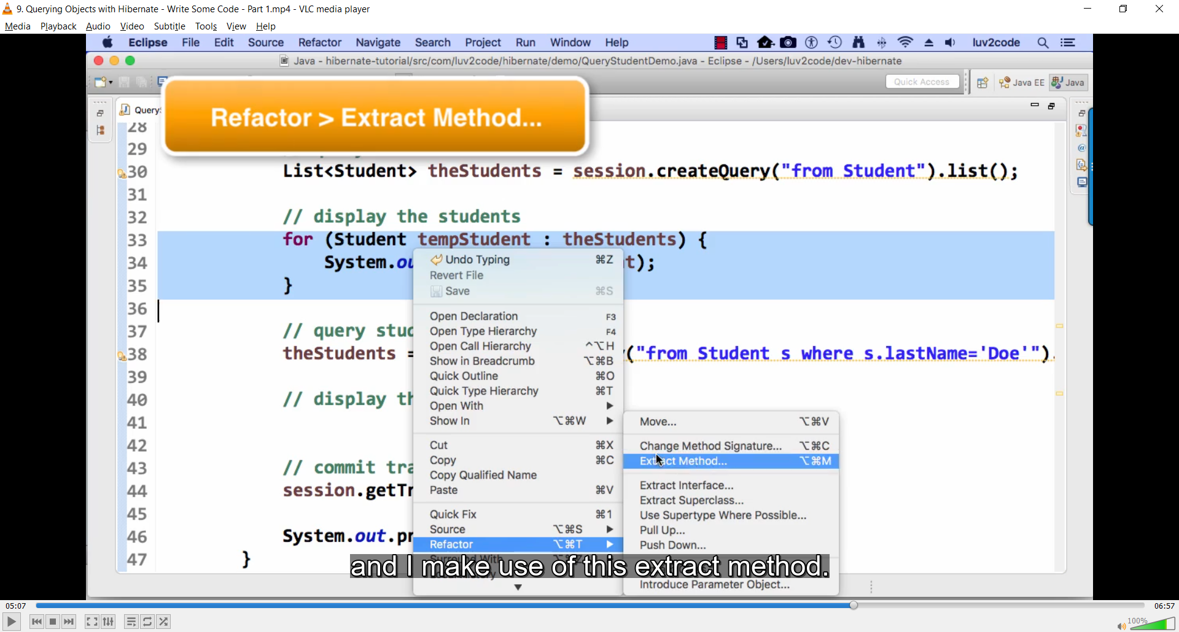

10. FAQ How To View Hibernate SQL Parameter Values.html

FAQ: How To View Hibernate SQL Parameter Values

**Question:**

I see hibernate printing out the query parameters as ? in the console.Is it possible to printout the value that was actually queried on thedatabase. Asking as this would help in the debugging purpose.

Answer:

When using Hibernate, if you log the Hibernate SQL statements, you will see this:

Hibernate: insert into student (email, first_name, last_name, id) values (?, ?, ?, ?)

However, for debugging your application, you want to see the actual parameter values in the Hibernate logs. Basically, you want to get rid of the question marks in the Hibernate logs.

You can view the actual parameters by viewing the low-level trace of the Hibernate logs. This is not set up by default. However, we can add log4j to allow us to see these low-level logs.

#### ****Here is an overview of the process:****

1. Add log4j to your project classpath

2. Add log4j.properties to your “src” directory

#### ****Here are the detailed steps:****

**1. Add log4j to your project classpath**

1a. Download log4j v1.2.17 from this link: – <http://central.maven.org/maven2/log4j/log4j/1.2.17/log4j-1.2.17.jar>

1b. Copy this file to your project’s lib directory

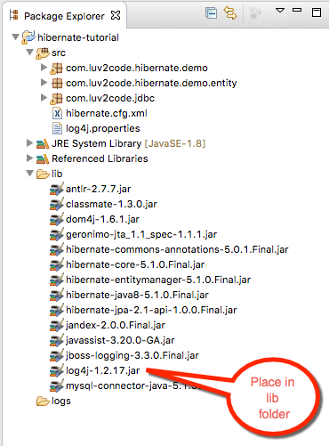

1c. Right-click your Eclipse project and select **Properties**

1d. Select**Build Path > Libraries > Add JARS…**

1e. Select the **log4j-1.2.17.jar** file from the **lib** directory

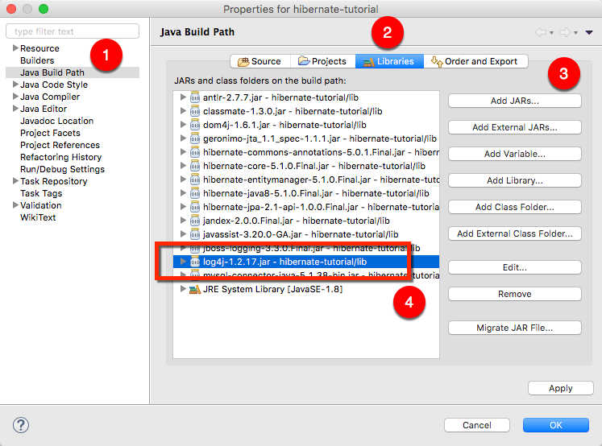

**2. Add log4j.properties to your “src” directory**

2a. Copy the text from below

# Root logger option

log4j.rootLogger=DEBUG, stdout

# Redirect log messages to console

log4j.appender.stdout=org.apache.log4j.ConsoleAppender

log4j.appender.stdout.Target=System.out

log4j.appender.stdout.layout=org.apache.log4j.PatternLayout

log4j.appender.stdout.layout.ConversionPattern=%d{yyyy-MM-dd HH:mm:ss} %-5p %c{1}:%L - %m%n

log4j.logger.org.hibernate=TRACE

2b. Save this file as "log4j.properties" in your “src” directory

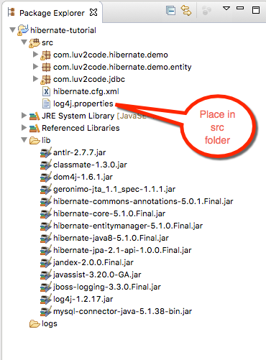

Note: This file has an important setting:

log4j.logger.org.hibernate=TRACE

This allows you see a low-level trace of Hibernate and this allows you see the real SQL parameter values.

Now run your application. You will see a lot of low-level TRACE logs in the Eclipse Console window.

Right-click in the Eclipse Console window and select **Find/Replace…**

Search for: **binding parameter**

or search for: **extracted value**

(the search string changes depending on which version of Hibernate you are using)

You will see the logs with the real parameter values. Congrats!

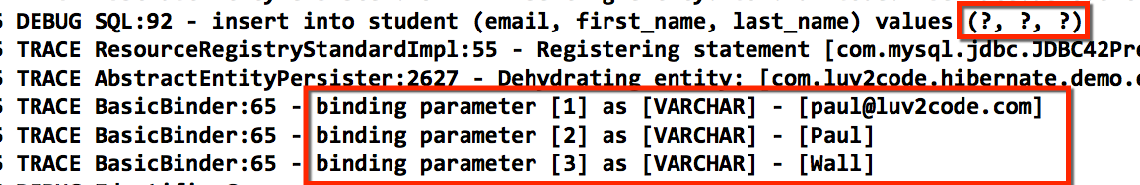

12. Updating Objects with Hibernate – Overview

**FAQ: Handling Dates with Hibernate**

How can I read date strings from the command-line and store them as dates in the database?

**Answer:**

You can make use of a combination of Java's date formatting class and Hibernate annotations.

Sample output:

Student [id=50, firstName=Paul, lastName=Doe, email=paul@luv2code.com, dateOfBirth=null]  
Student [id=51, firstName=Daffy, lastName=Duck, email=daffy@luv2code.com, dateOfBirth=null]  
Student [id=52, firstName=Paul, lastName=Doe, email=paul@luv.com, dateOfBirth=31/12/1998]

**Development Process Overview**

1. Alter database table for student  
2. Add a date utils class for parsing and formatting dates  
3. Add date field to Student class  
4. Add toString method to Student class  
5. Update CreateStudentDemo

----

**Detailed steps**

1. Alter database table for student

We need to alter the database table to add a new column for "date_of_birth".

Run the following SQL in your MySQL Workbench tool.

ALTER TABLE `hb_student_tracker`.`student`

ADD COLUMN `date_of_birth` DATETIME NULL AFTER `last_name`;

--

2. Add a date utils class for parsing and formatting dates

We need to add a DateUtils class to handle parsing and formatting dates. The source code is here. The class should be placed in the package: com.luv2code.hibernate.demo.

The date formatter uses special symbols for formatting/parsing.

-  dd:  day in month (number)  
-  MM:  month in year (number)  
- yyyy: year

See this link for details: https://docs.oracle.com/javase/tutorial/i18n/format/simpleDateFormat.html

package com.luv2code.hibernate.demo;

import java.text.ParseException;

import java.text.SimpleDateFormat;

import java.util.Date;

public class DateUtils {

// The date formatter

// - dd: day in month (number)

// - MM: month in year (number)

// - yyyy: year

//

// See this link for details: https://docs.oracle.com/javase/tutorial/i18n/format/simpleDateFormat.html

//

//

private static SimpleDateFormat formatter = new SimpleDateFormat("dd/MM/yyyy");

// read a date string and parse/convert to a date

public static Date parseDate(String dateStr) throws ParseException {

Date theDate = formatter.parse(dateStr);

return theDate;

}

// read a date and format/convert to a string

public static String formatDate(Date theDate) {

String result = null;

if (theDate != null) {

result = formatter.format(theDate);

}

return result;

}

}

---

3. Add date field to Student class

We need to add a date field to the Student class. We map this field to the database column, "date_of_birth". Also, we make use of the @Temporal annotation. This is a Java annotation for storing dates.

@Column(name="date_of_birth")

@Temporal(TemporalType.DATE)

private Date dateOfBirth;

Here's the full source code.

---

package com.luv2code.hibernate.demo.entity;

import java.util.Date;

import javax.persistence.Column;  
import javax.persistence.Entity;  
import javax.persistence.Id;  
import javax.persistence.Table;  
import javax.persistence.Temporal;  
import javax.persistence.TemporalType;

import com.luv2code.hibernate.demo.DateUtils;

@Entity  
@Table(name="student")  
public class Student {  
      
    @Id  
    @Column(name="id")  
    private int id;  
      
    @Column(name="first_name")  
    private String firstName;  
      
    @Column(name="last_name")  
    private String lastName;  
      
    @Column(name="email")  
    private String email;  
      
    @Column(name="date_of_birth")  
    @Temporal(TemporalType.DATE)      
    private Date dateOfBirth;  
      
    public Student() {  
          
    }

    public Student( String firstName, String lastName, String email, Date theDateOfBirth) {  
          
        this.firstName = firstName;  
        this.lastName = lastName;  
        this.email = email;  
        this.dateOfBirth = theDateOfBirth;  
          
    }

    public int getId() {  
        return id;  
    }

    public void setId(int id) {  
        this.id = id;  
    }

    public String getFirstName() {  
        return firstName;  
    }

    public void setFirstName(String firstName) {  
        this.firstName = firstName;  
    }

    public String getLastName() {  
        return lastName;  
    }

    public void setLastName(String lastName) {  
        this.lastName = lastName;  
    }

    public String getEmail() {  
        return email;  
    }

    public void setEmail(String email) {  
        this.email = email;  
    }

    public Date getDateOfBirth() {  
        return dateOfBirth;  
    }

    public void setDateOfBirth(Date dateOfBirth) {  
        this.dateOfBirth = dateOfBirth;  
    }

    @Override  
    public String toString() {  
        return "Student [id=" + id + ", firstName=" + firstName + ", lastName=" + lastName + ", email=" + email  
                + ", dateOfBirth=" + DateUtils.formatDate(dateOfBirth) + "]";  
    }  
          
}

---

4. Add toString method to Student class

We will make an update to the toString method in our Student class.  It will use the formatter from our DateUtils.class. This code is already included in Student.java from the previous step. I'm just highlighting it here for clarity.

return "Student [id=" + id + ", firstName=" + firstName + ", lastName=" + lastName + ", email=" + email

+ ", dateOfBirth=" + DateUtils.formatDate(dateOfBirth) + "]";

Note the use of DateUtils above.

---

5. Update CreateStudentDemo

Now for the grand finale. In the main program, read the date as a String and parse/convert it to a date. Here's the snippet of code.

String theDateOfBirthStr = "31/12/1998";

Date theDateOfBirth = DateUtils.parseDate(theDateOfBirthStr);

Student temoStudent = new Student("Paully", "Doe", "paul@luv.com", theDateOfBirth);

Here's the full code:

package com.luv2code.hibernate.demo;

import java.text.ParseException;

import java.util.Date;

import org.hibernate.Session;

import org.hibernate.SessionFactory;

import org.hibernate.cfg.Configuration;

import com.luv2code.hibernate.demo.entity.Student;

public class CreateStudentDemo {

public static void main(String[] args) {

// create session factory

SessionFactory factory = new Configuration().configure("hibernate.cfg.xml").addAnnotatedClass(Student.class)

.buildSessionFactory();

// create a session

Session session = factory.getCurrentSession();

try {

// create a student object

System.out.println("creating a new student object ...");

String theDateOfBirthStr = "31/12/1998";

Date theDateOfBirth = DateUtils.parseDate(theDateOfBirthStr);

Student temoStudent = new Student("Paully", "Doe", "paul@luv.com", theDateOfBirth);

// start transaction

session.beginTransaction();

// save the student object

System.out.println("Saving the student ...");

session.save(temoStudent);

// commit transaction

session.getTransaction().commit();

System.out.println("Success!");

} catch (Exception exc) {

exc.printStackTrace();

} finally {

factory.close();

}

}

}

14. Deleting Objects with Hibernate - Overview

## 22. Hibernate Advanced Mappings

1. Advanced Mappings Overview

Xem file pdf

2. Database Concepts

## 23. Hibernate Advanced Mappings - @OneToOne

1. @OneToOne - Overview - Part 1

2. @OneToOne - Overview - Part 2

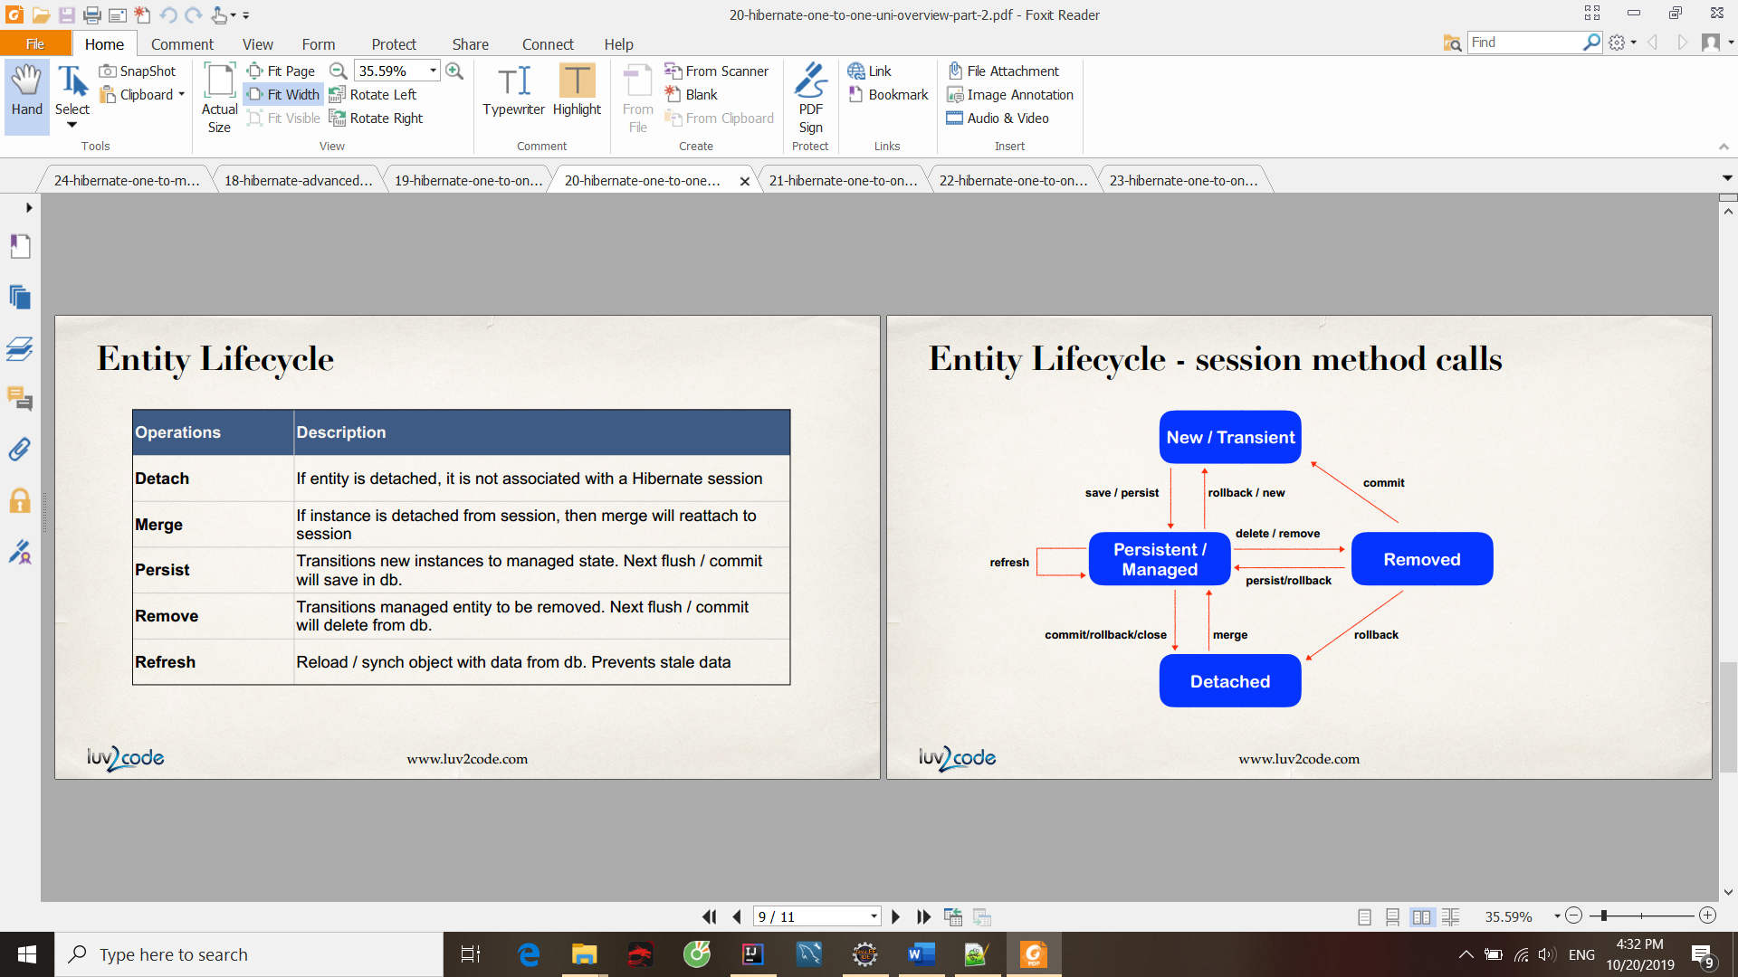

3. @OneToOne - Overview - Part 3

Nếu không chỉ rõ thì k có operation nào được cascaded

4. @OneToOne - Run Database Scripts



Xem diagram

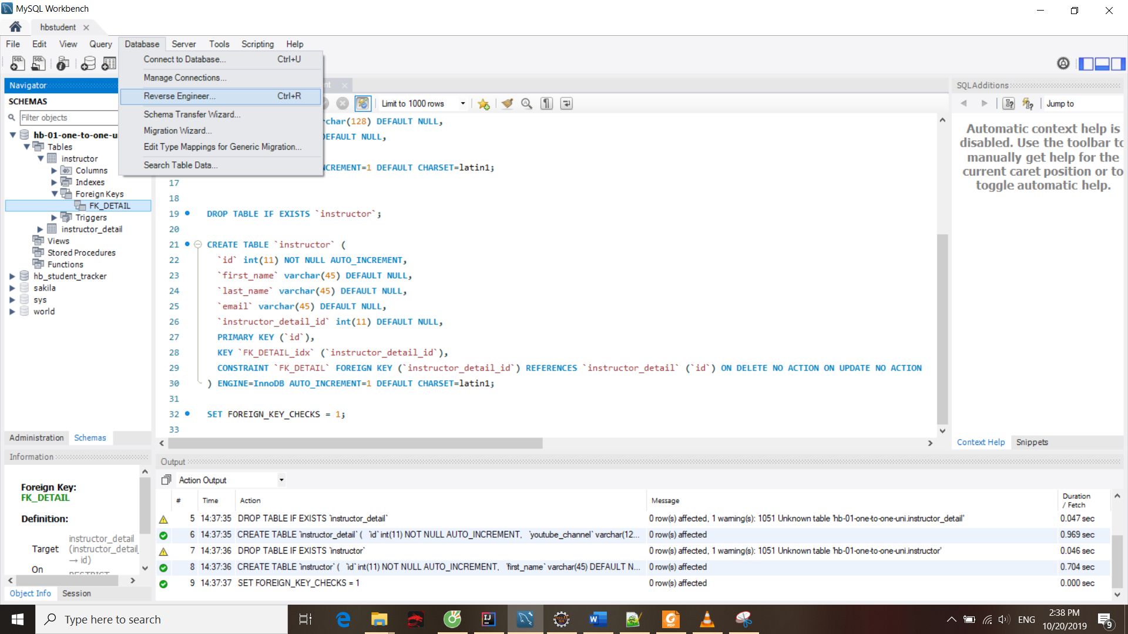

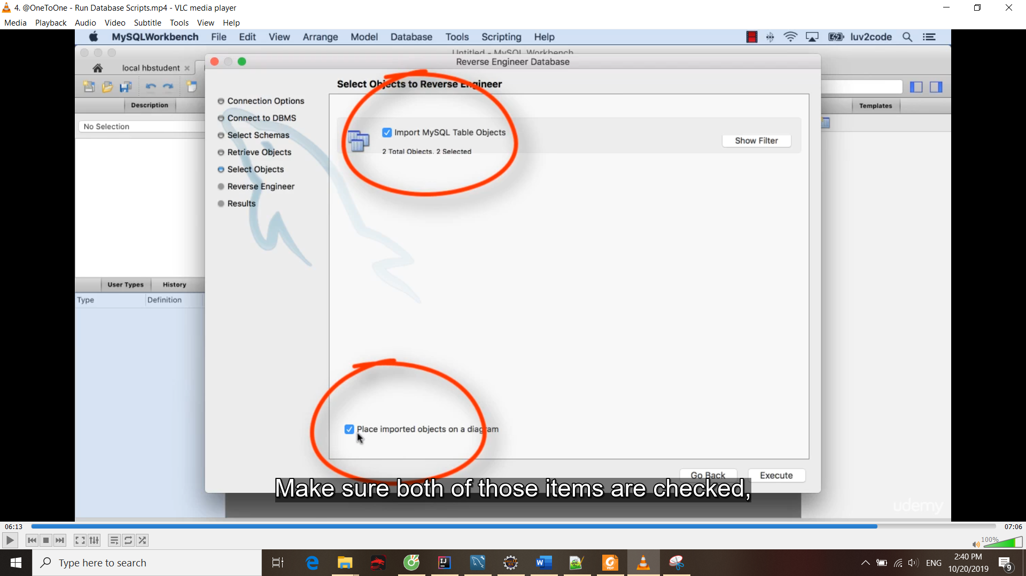

5. @OneToOne - Write Some Code - Prep Work

6. @OneToOne - Write Some Code - Create InstructorDetail class

7. @OneToOne - Write Some Code - Create Instructor class

Sửa file config

Tạo hàm tạo k cần bỏ id vào

10. @OneToOne - Delete an Entity

11. @OneToOne - Bi-Directional Overview

Mối quan hệ 2 chiều

12. @OneToOne - Bi-Directional - Create Relationship

13. @OneToOne - Bi-Directional - Develop Main App

14. @OneToOne - Refactoring and Exception Handling

15. @OneToOne - Bi-Directional - Cascade Delete

16. @OneToOne - Bi-Directional - Delete Only InstructorDetail - Part 1

Detail

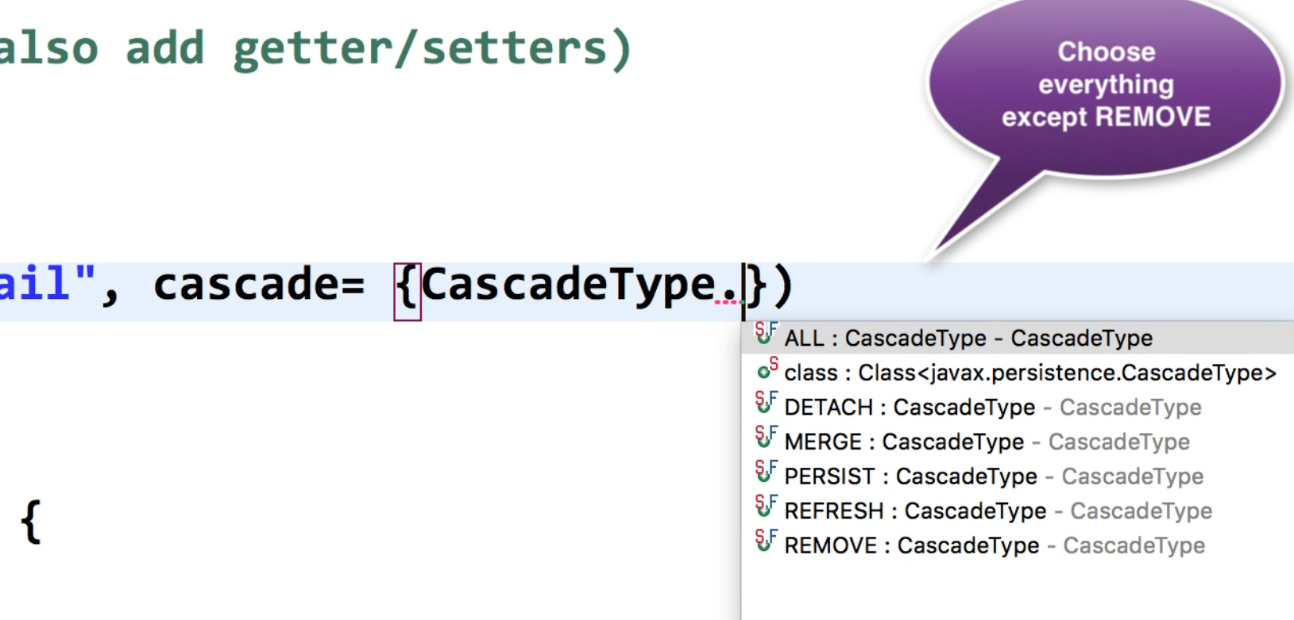

17. @OneToOne - Bi-Directional - Delete Only InstructorDetail - Part 2

tempInstructorDetail.getInstructor().setInstructorDetail(null);

## 24. Hibernate Advanced Mappings - @OneToMany

1. @OneToMany - Bi-Directional Overview - Part 1

2. @OneToMany - Bi-Directional Overview - Part 2

3. @OneToMany - Bi-Directional - Database Prep Work

<http://luv2code.com/hibernate-mapping-database-scripts>

Download db scripts

4. @OneToMany - Bi-Directional - Create Course Mapping

5. @OneToMany - Bi-Directional - Define Course Relationship

6. @OneToMany - Bi-Directional - Update Instructor

7. @OneToMany - Bi-Directional - Add Instructor to Database

8. @OneToMany - Bi-Directional - Create Courses for Instructor

9. @OneToMany - Bi-Directional - Retrieve Instructor Courses

10. @OneToMany - Bi-Directional - Delete a Course

## 25. Hibernate Advanced Mappings - Eager vs Lazy Loading

1. Eager vs Lazy Loading - Overview - Part 1

2. Eager vs Lazy Loading - Overview - Part 2

Pdf

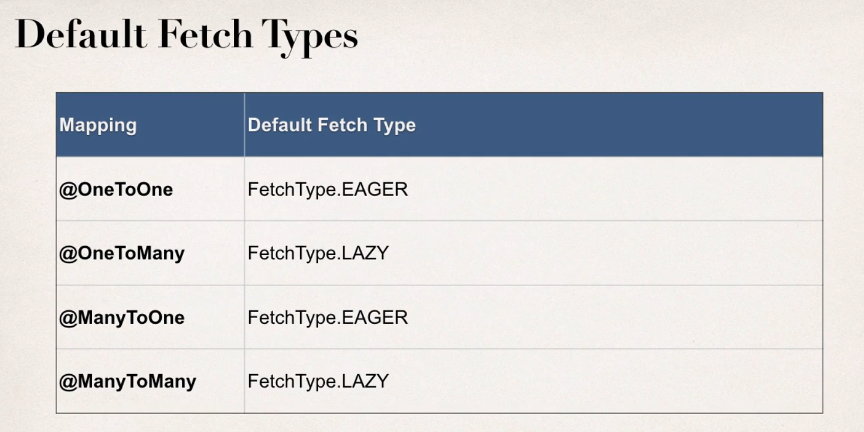

3. Eager vs Lazy Loading - Coding - Eager

4. Eager vs Lazy Loading - Coding - Lazy

5. Eager vs Lazy Loading - Coding - Closing the Session

6. Eager vs Lazy Loading - Coding - Resolve Lazy Loading Issue

Cách 1: gọi getter trước khi session close để tránh exception

Cách 2: HQL

7. Eager vs Lazy Loading - Coding - HQL JOIN FETCH

**FAQ: How load the courses at a later time in the application?**

**Question**I've watched your 2 solutions for loading related data after session closing. Both, either getting related courses before closing session and using JOIN FETCH seem to be negating of lazy loading (using those solutions we completely resign of lazy loading.

Is there any good solution to load these data somewhere else in the app? Should I open new session?

---

**Answer**Yes, you can load it later with using a new session, just make use of HQL

Here's the code snippet. Make note of HQL in bold

            session = factory.getCurrentSession();  
              
            session.beginTransaction();  
              
**// get courses for a given instructor  
            Query<Course> query = session.createQuery("select c from Course c "  
                                                    + "where c.instructor.id=:theInstructorId",      
                                                    Course.class);**              
            query.setParameter("theInstructorId", theId);  
              
            List<Course> tempCourses = query.getResultList();  
              
            System.out.println("tempCourses: " + tempCourses);  
---

Here's the full example.

:-)

---

package com.luv2code.hibernate.demo;

import java.util.List;

import org.hibernate.Session;  
import org.hibernate.SessionFactory;  
import org.hibernate.cfg.Configuration;  
import org.hibernate.query.Query;

import com.luv2code.hibernate.demo.entity.Course;  
import com.luv2code.hibernate.demo.entity.Instructor;  
import com.luv2code.hibernate.demo.entity.InstructorDetail;

public class GetCoursesLater {

    public static void main(String[] args) {

        // create session factory  
        SessionFactory factory = new Configuration()  
                                .configure("hibernate.cfg.xml")  
                                .addAnnotatedClass(Instructor.class)  
                                .addAnnotatedClass(InstructorDetail.class)  
                                .addAnnotatedClass(Course.class)  
                                .buildSessionFactory();  
          
        // create session  
        Session session = factory.getCurrentSession();  
          
        try {              
              
            // start a transaction  
            session.beginTransaction();  
                          
            // get the instructor from db  
            int theId = 1;  
            Instructor tempInstructor = session.get(Instructor.class, theId);                      
              
            System.out.println("luv2code: Instructor: " + tempInstructor);      
              
            // commit transaction  
            session.getTransaction().commit();  
              
            // close the session  
            session.close();

            System.out.println("\nluv2code: The session is now closed!\n");

            //  
            // THIS HAPPENS SOMEWHERE ELSE / LATER IN THE PROGRAM

            // YOU NEED TO GET A NEW SESSION  
            //  
              
            System.out.println("\n\nluv2code: Opening a NEW session \n");

            session = factory.getCurrentSession();  
              
            session.beginTransaction();  
              
            // get courses for a given instructor  
            Query<Course> query = session.createQuery("select c from Course c "  
                                                    + "where c.instructor.id=:theInstructorId",      
                                                    Course.class);  
              
            query.setParameter("theInstructorId", theId);  
              
            List<Course> tempCourses = query.getResultList();  
              
            System.out.println("tempCourses: " + tempCourses);  
              
            // now assign to instructor object in memory  
            tempInstructor.setCourses(tempCourses);  
              
            System.out.println("luv2code: Courses: " + tempInstructor.getCourses());  
              
            session.getTransaction().commit();  
              
            System.out.println("luv2code: Done!");  
        }  
        finally {  
              
            // add clean up code  
            session.close();  
              
            factory.close();  
        }  
    }

}

## 26. Hibernate Advanced Mappings - @OneToMany – Unidirectional

1. @OneToMany - Uni-Directional - Overview - Part 1

**@JoinColum ... where does it find the column?**

**Question**

In the Course class,we have OneToMany relation with reviews with join column course_id.

But in course table we do not have column course_id.

Ideally when we say @JoinColumn a new column should be created in course table ... isn't it?

How does @JoinColum know where to find the join column?

---

**Answer**

The JoinColumn is actually fairly complex and it goes through a number of advanced steps to find the desired column.

This info below is from the documentation

Source: http://docs.oracle.com/javaee/7/api/javax/persistence/JoinColumn.html#name--

---

The table in which it is found depends upon the context.

- If the join is for a OneToOne or ManyToOne mapping using a foreign key mapping strategy, the foreign key column is in the table of the source entity or embeddable.

- If the join is for a unidirectional OneToMany mapping using a foreign key mapping strategy, the foreign key is in the table of the target entity.

- If the join is for a ManyToMany mapping or for a OneToOne or bidirectional ManyToOne/OneToMany mapping using a join table, the foreign key is in a join table.

- If the join is for an element collection, the foreign key is in a collection table.

--

So as you can see, it depends on the context.

In our training video, we are using @OneToMany uni-directional (course has one-to-many reviews).

As a result, the join column / foreign key column is in the target entity. In this case, the target entity is the Review class. So, you will find the join column "course_id" in the "review" table.

4. @OneToMany - Uni-Directional - Set up database tables

5. @OneToMany - Uni-Directional - Create Review Class

6. @OneToMany - Uni-Directional - Configure Fetch Type

7. @OneToMany - Uni-Directional - Create Course Reviews

8. @OneToMany - Uni-Directional - Get Course Reviews

9. @OneToMany - Uni-Directional - Delete Course Reviews

## 27. Hibernate Advanced Mappings - @ManyToMany

1. @ManyToMany - Overview - Part 1

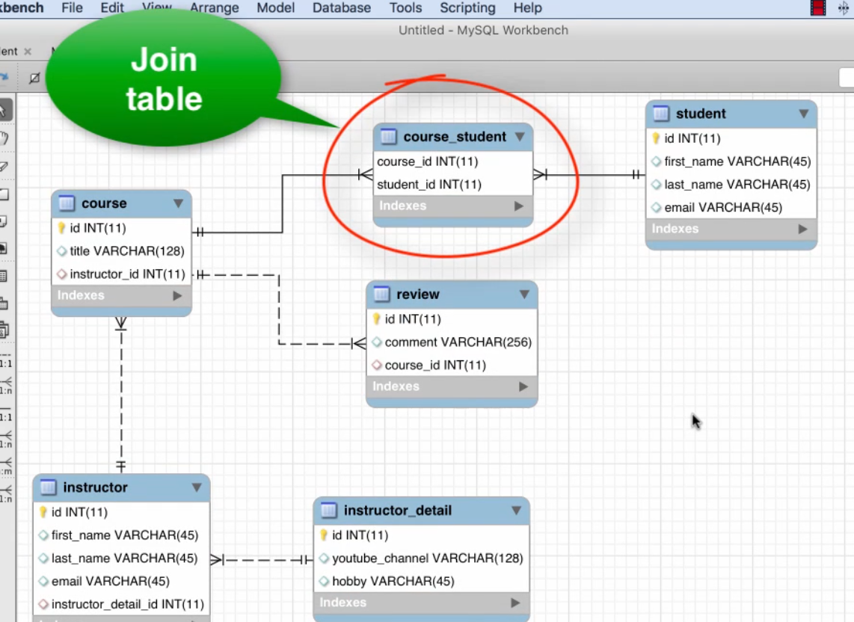

2. @ManyToMany - Overview - Part 2

3. @ManyToMany - Set up database tables

4. @ManyToMany - Update Course class

5. @ManyToMany - Configure Course for many-to-many

6. @ManyToMany - Configure Student for many-to-many

7. @ManyToMany - Create a Main App

8. @ManyToMany - Review app output

9. @ManyToMany - Add more courses for a student

10. @ManyToMany - Verify Data in Join Table

11. @ManyToMany - Get Courses for Student

12. @ManyToMany - Delete a Course

13. @ManyToMany - Delete a Student

## 28. Build a Database Web App - Spring MVC and Hibernate Project - Part 1

Source Files for Spring MVC + Hibernate Web App

In the following videos, you will need to use some starter files. The starter files include SQL scripts and JAR files.

The files are attached to each video. However, if you'd like, you can also download the entire bundle.

---

You can download the entire source code bundle from this link:

**Section 1, Lecture 5**  
<https://www.udemy.com/spring-hibernate-tutorial/learn/v4/t/lecture/5117038?start=0>

Once you upzip, then you'll have this directory structure.

---

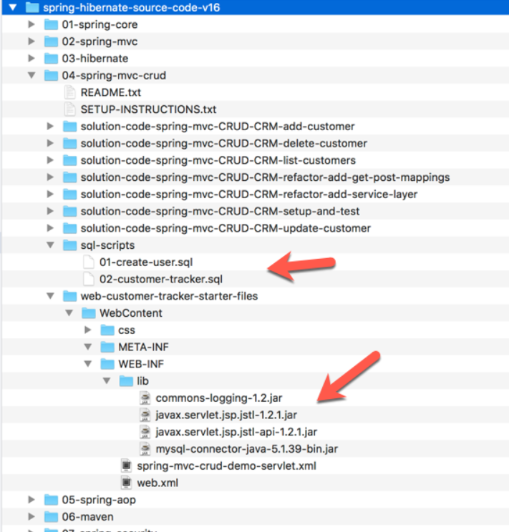

--

Then you can find the files that I use in this directory:

spring-hibernate-source-code-vXX/04-spring-mvc-crud/sql-scripts

and

spring-hibernate-source-code-vXX/04-spring-mvc-crud/web-customer-tracker-starter-files

Regarding the JAR files, they are in

spring-hibernate-source-code-vXX/04-spring-mvc-crud/web-customer-tracker-starter-files/WebContent/WEB-INF/lib

this directory includes commons-logging, jstl and mysql jdbc driver

---

You will still need to add the Spring and Hibernate files separately, but we'll cover that process in later videos. I'll walk you through the process.

3. Set up Sample Data for Database

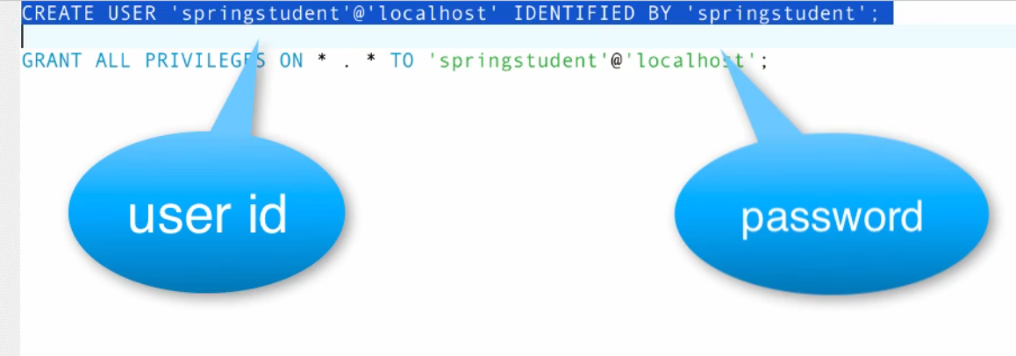

CREATE USER 'spstudent'@'localhost' IDENTIFIED BY 'spstudent';

GRANT ALL PRIVILEGES ON * . * TO 'spstudent'@'localhost';

To see which user you are, and whose permissions you have:

select user(), current_user();

To delete the pesky anonymous user:

drop user ''@'localhost';

This is something to do with user permissions. Giving proper grants will solve this issue.

Step [1]: Open terminal and run this command

$ mysql -uroot -p

Output [1]: This should give you mysql prompt shown below

[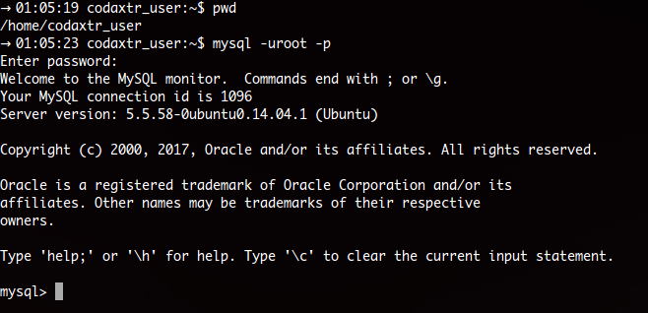](https://i.stack.imgur.com/MFbiL.png)

Step [2]:

mysql> CREATE USER 'parsa'@'localhost' IDENTIFIED BY 'your_password';

mysql> grant all privileges on *.* to 'parsa'@'localhost';

Syntax:

mysql> grant all privileges on `database_name`.`table_name` to 'user_name'@'hostname';

Note:

* hostname can be IP address, localhost, 127.0.0.1
* In database_name/table_name, * means all databases
* In hostname, to specify all hosts use '%'

Step [3]: Get out of current mysql prompt by either entering quit / exit command or press Ctrl+D.

Step [4]: Login to your new user

$ mysql -uparsa -pyour_password

Step [5]: Create the database

mysql> create database `database_name`;

4. Test Database Connection - Part 1

New dynamic web project(có server apache rồi)

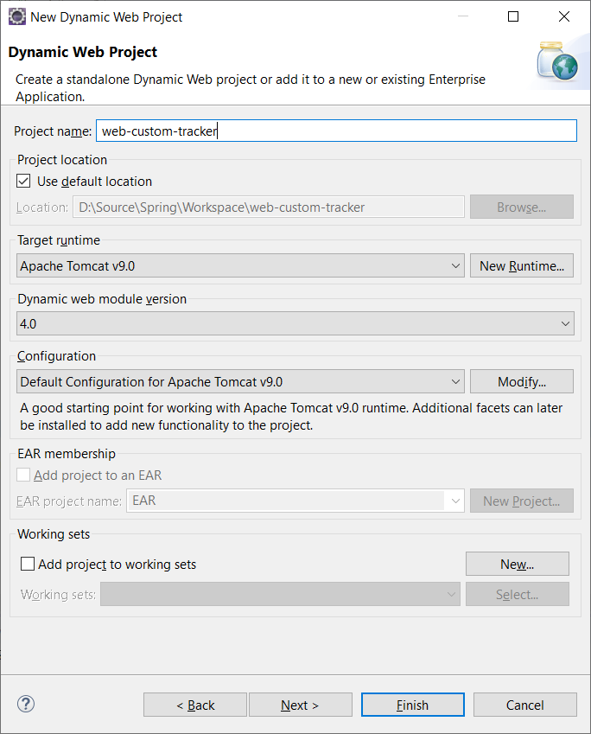

Bỏ thư viện **mysql-connector-java-5.1.48.jar** vào **lib/**

Tạo file servlet

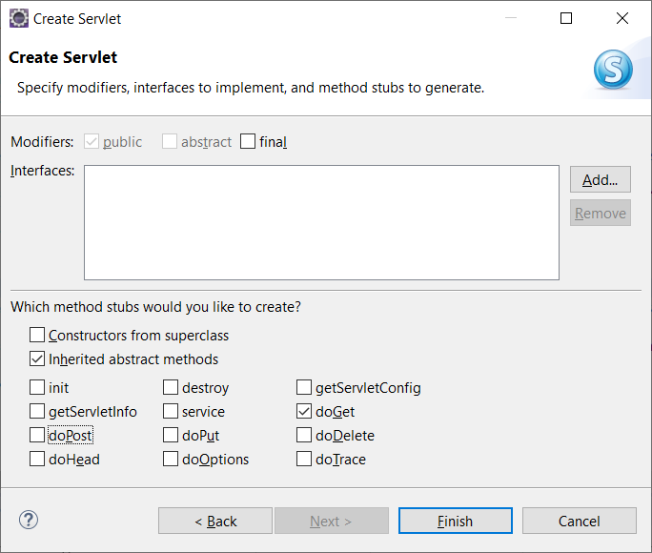

Stop nếu mới cài apache:

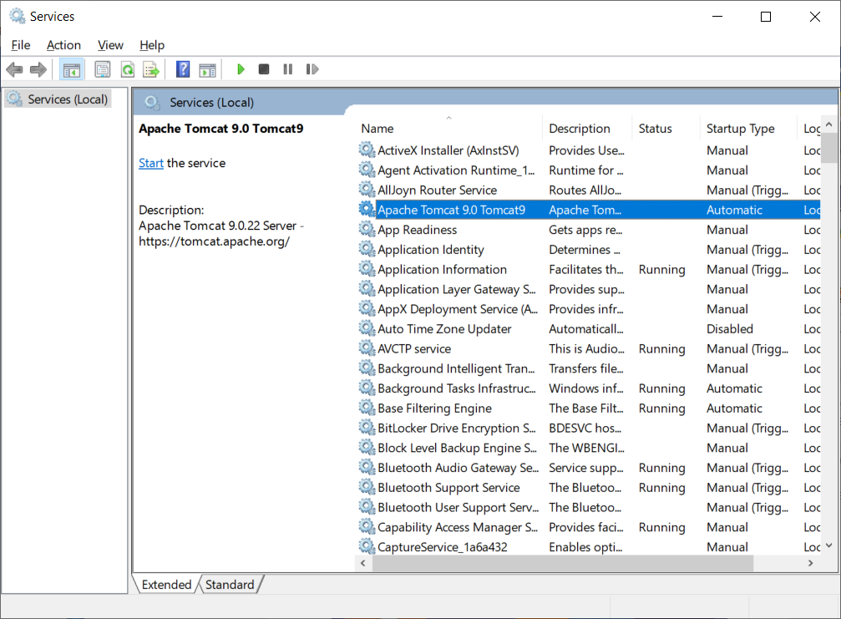

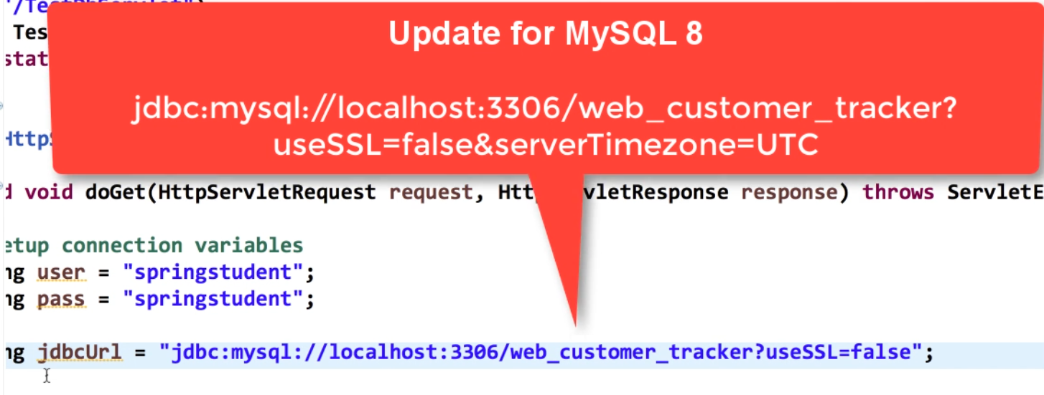

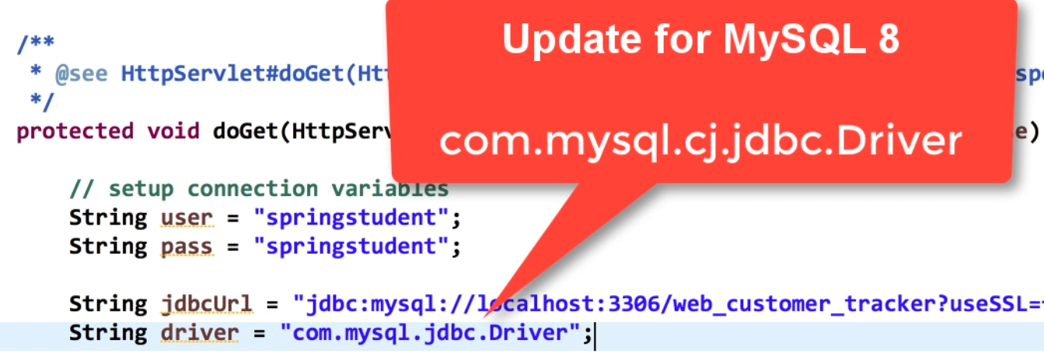

Run as/ run on server

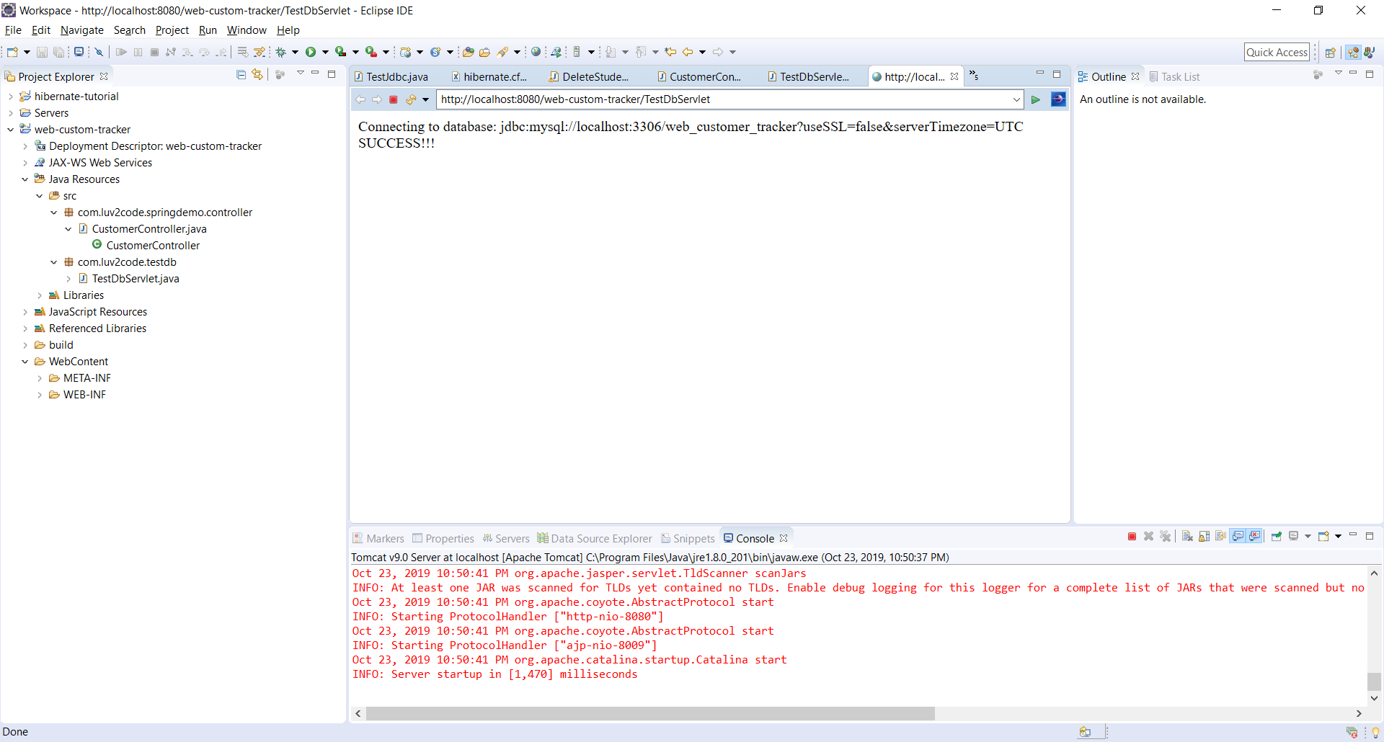

6. Set Up Dev Environment - Part 1

Copy 2 file xml vào folder WEB-INF

Copy 2 thư viện jstl:

**javax.servlet.jsp.jstl-api-1.2.1.jar và javax.servlet.jsp.jstl-1.2.1.jar**

Copy từ spring-framework-5.1.8.RELEASE\libs

Copy tất cả file hibernate trong require

Copy hibernate-release-5.4.6.Final\lib\optional\c3p0

=> database connection pool

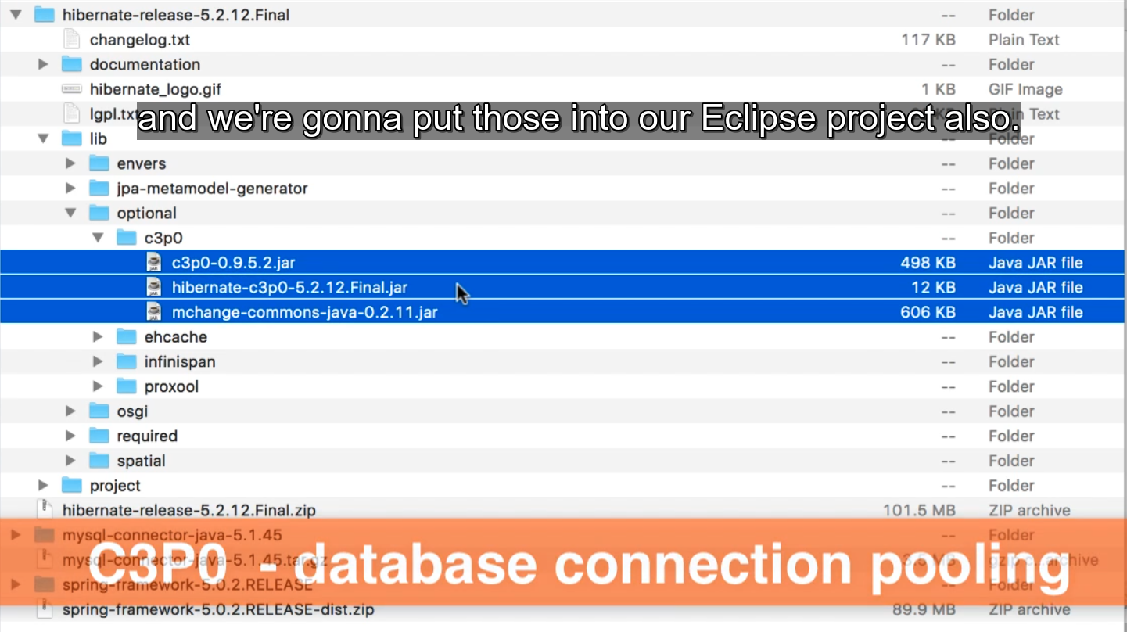

Configuration for Spring + Hibernate

1. Define database dataSource / connection pool

2. Setup Hibernate session factory

3. Setup Hibernate transaction manager

4. Enable configuration of transactional annotations

10. Test Spring MVC Controller - Part 1

**JAVA 9 and higher HEADS UP- SPRING MVC CRUD**

For Java 9 and higher, you need to additional JAR files.

You need to download the following JAR files:

javax.activation-1.2.0.jar

jaxb-api-2.3.0.jar

jaxb-core-2.3.0.jar

jaxb-impl-2.3.0.jar

---

1. Download the files using links below:

[javax.activation-1.2.0.jar](http://search.maven.org/remotecontent?filepath=com/sun/activation/javax.activation/1.2.0/javax.activation-1.2.0.jar)

[jaxb-api-2.3.0.jar](http://search.maven.org/remotecontent?filepath=javax/xml/bind/jaxb-api/2.3.0/jaxb-api-2.3.0.jar)

[jaxb-core-2.3.0.jar](http://search.maven.org/remotecontent?filepath=com/sun/xml/bind/jaxb-core/2.3.0/jaxb-core-2.3.0.jar)

[jaxb-impl-2.3.0.jar](http://search.maven.org/remotecontent?filepath=com/sun/xml/bind/jaxb-impl/2.3.0/jaxb-impl-2.3.0.jar)

---

2. Copy the JAR files to the **WEB-INF/lib** folder of your project

Clean project => start TOMCAT

Run: http://localhost:8080/web-custom-tracker/customer/list

## 29. Build a Database Web App - Spring MVC and Hibernate Project - Part 2

1. List Customers – Overview

<property name="packagesToScan" value="com.luv2code.springdemo.entity" />

Tìm kiếm những class có @Entity

2. List Customers - Overview of Development Process

3. List Customers - Creating Hibernate Entity - Part 1

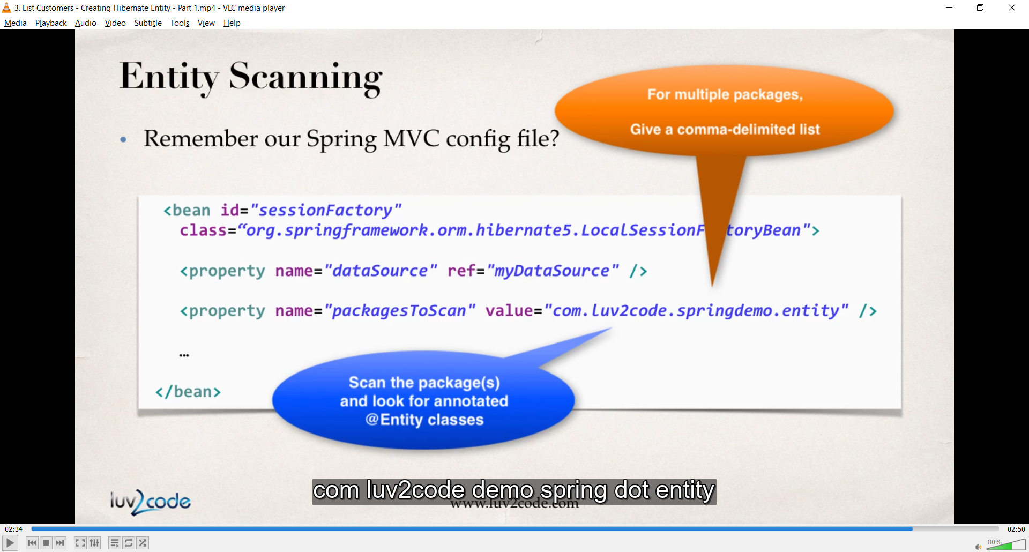

4. List Customers - Creating Hibernate Entity - Part 2

5. List Customers - Developing Hibernate DAO - Overview - Part 1

6. List Customers - Developing Hibernate DAO - Overview - Part 2

9. List Customers - Injecting DAO into Controller

10. List Customers - Developing JSP View Page

11. Making it Pretty with CSS - Overview

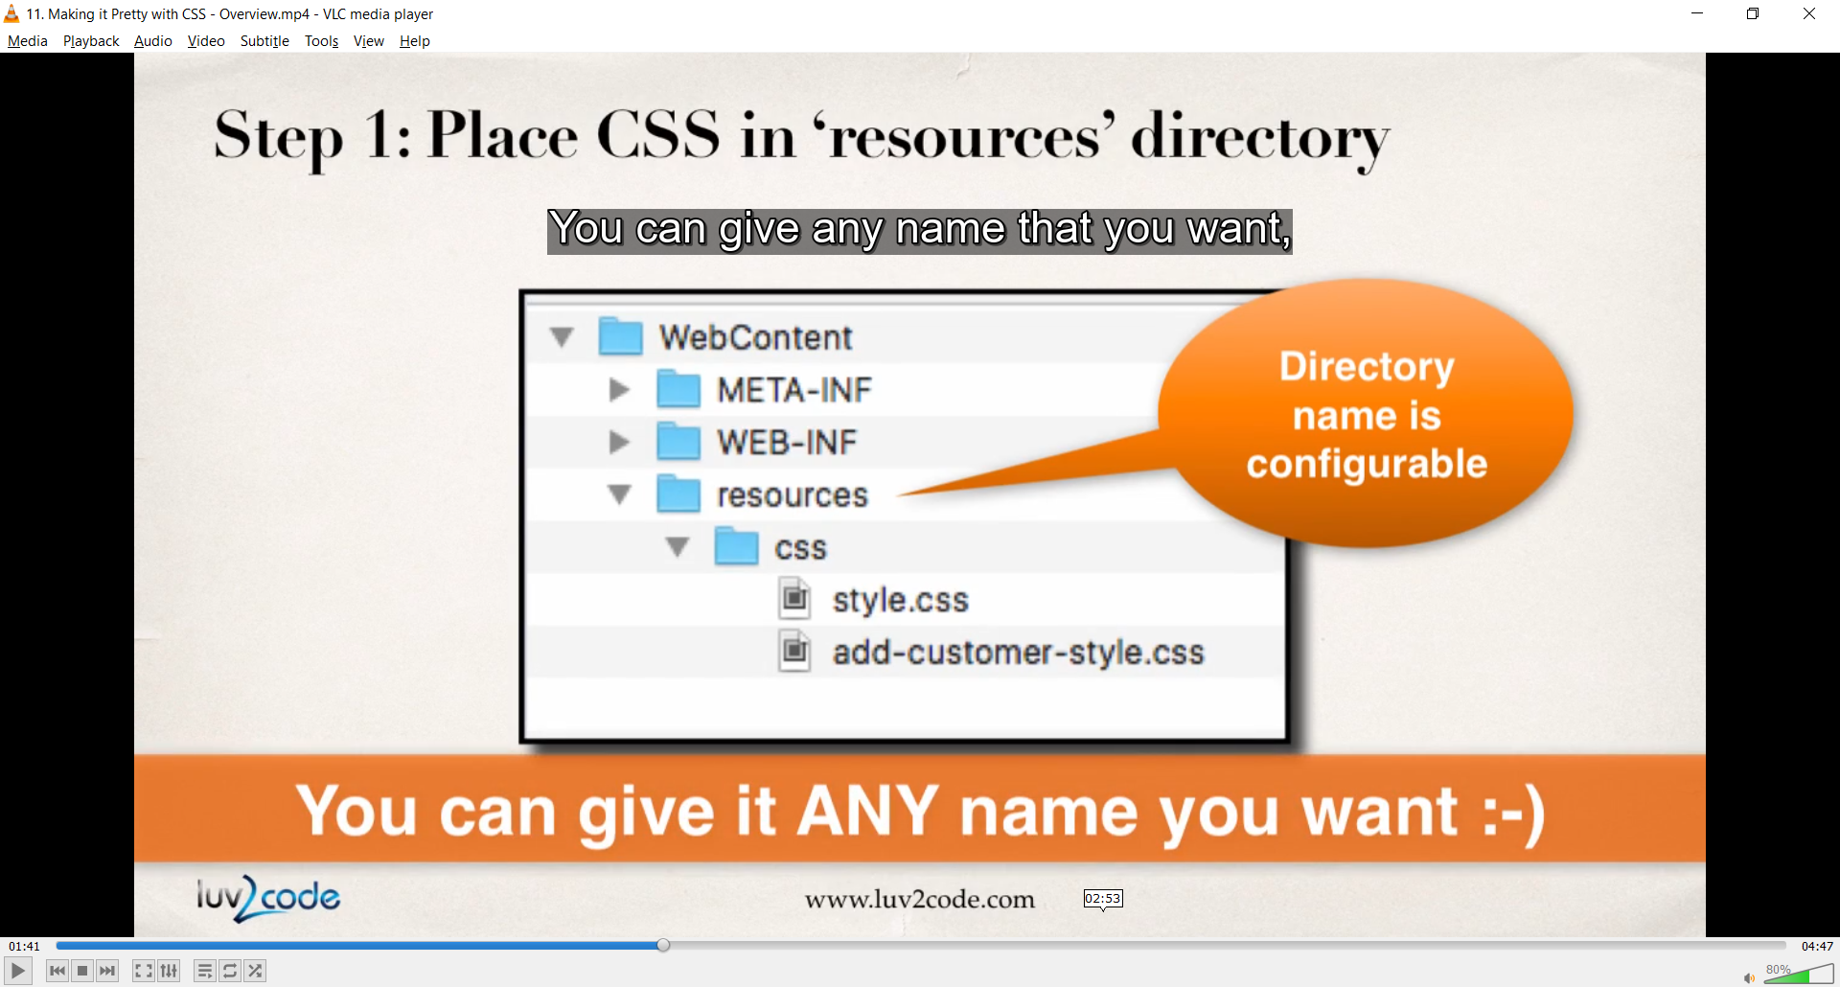

<!-- reference our style sheet -->  
  
<link type="text/css"  
 rel="stylesheet"  
 href="${pageContext.request.contextPath}/resources/css/style.css" />

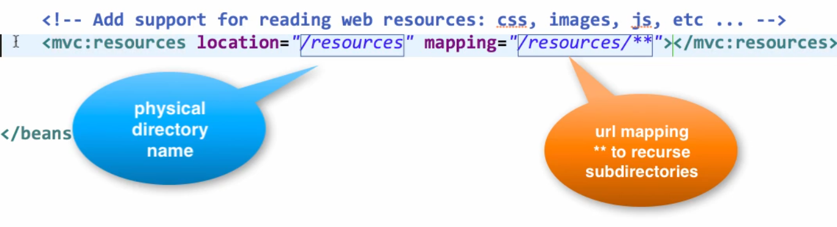

${pageContext.request.contextPath} : use proper app name

<mvc:resources location="/resources/" mapping="/resources/**"></mvc:resources>

14. Adding a Welcome File

<% response.sendRedirect("customer/list"); %>

## 30. Build a Database Web App - Spring MVC and Hibernate Project - Part 3

1. Refactor @GetMapping and @PostMapping - Overview

2. Refactor @GetMapping and @PostMapping - Write Some Code

3. Refactor Add a Service Layer - Overview

4. Refactor Add a Service Layer - Write Some Code - Part 1

5. Refactor Add a Service Layer - Write Some Code - Part 2

## 31. Build a Database Web App - Spring MVC and Hibernate Project - Part 4

1. Add Customer – Overview

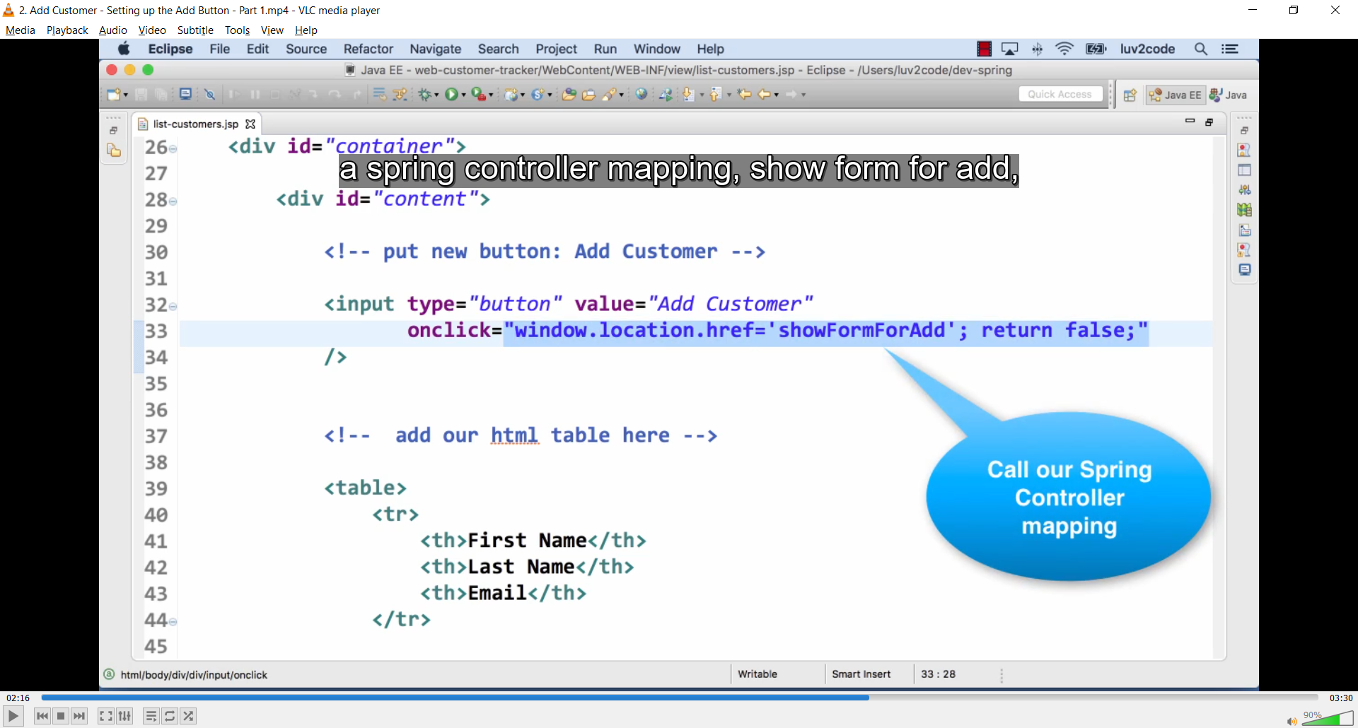

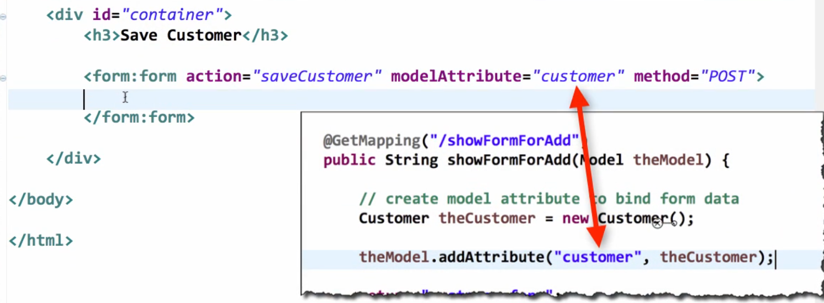

6. Add Customer - Creating the HTML Form - Part 3

<link type="text/css"  
 rel="stylesheet"  
 href="${pageContext.request.contextPath}/resources/css/style.css">

Link css

<div style="clear; both;"></div>  
  
<p>  
 <a href="${pageContext.request.contextPath}/customer/list">Back to List</a>  
</p>

7. Add Customer - Save to Database - Part 1

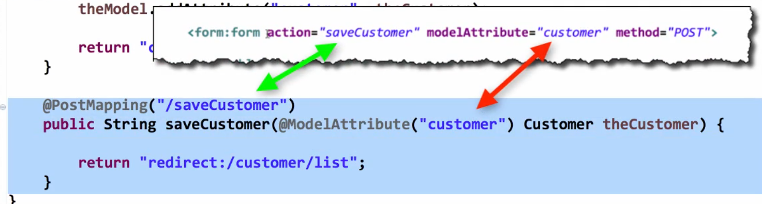

9. Sort Customer Data

## 32. Build a Database Web App - Spring MVC and Hibernate Project - Part 5

1. Update Customer - Overview

2. Update Customer - Creating Update Link

3. Update Customer - Prepopulating the Form - Part 1

<!-- need to associate this data with customer id -->  
<form:hidden path="id" />

6. Update Customer - Save Customer to Database - Part 1

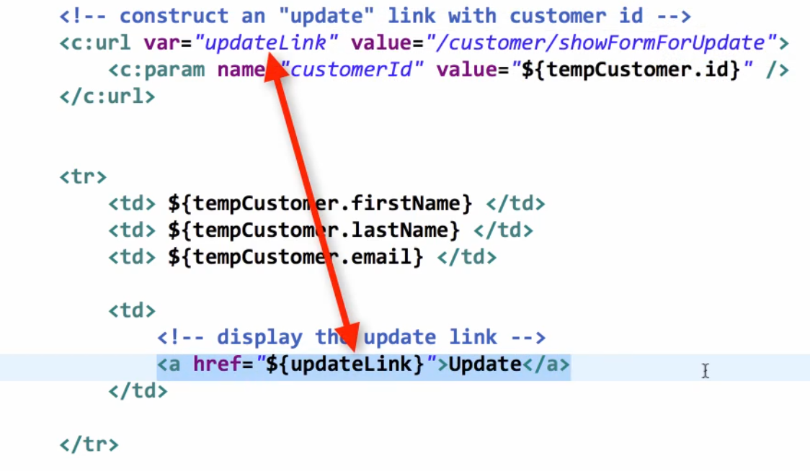

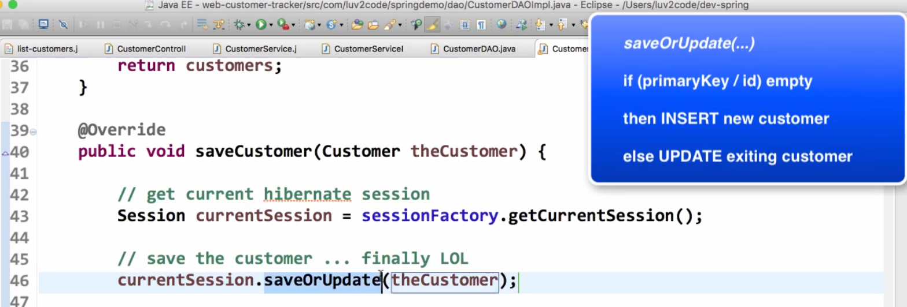

## 33. Build a Database Web App - Spring MVC and Hibernate Project - Part 6

7. FAQ How to Add Search support.html

**FAQ: How to add Search features to the App?**

A number of students have asked how to add search features to the app? I'll walk through this process.

Basically, we will allow the user to search for a customer by name. We'll add a search box at to the screen and the user can enter a name. On the backend, we'll compare this name to the customer's first name or last name.

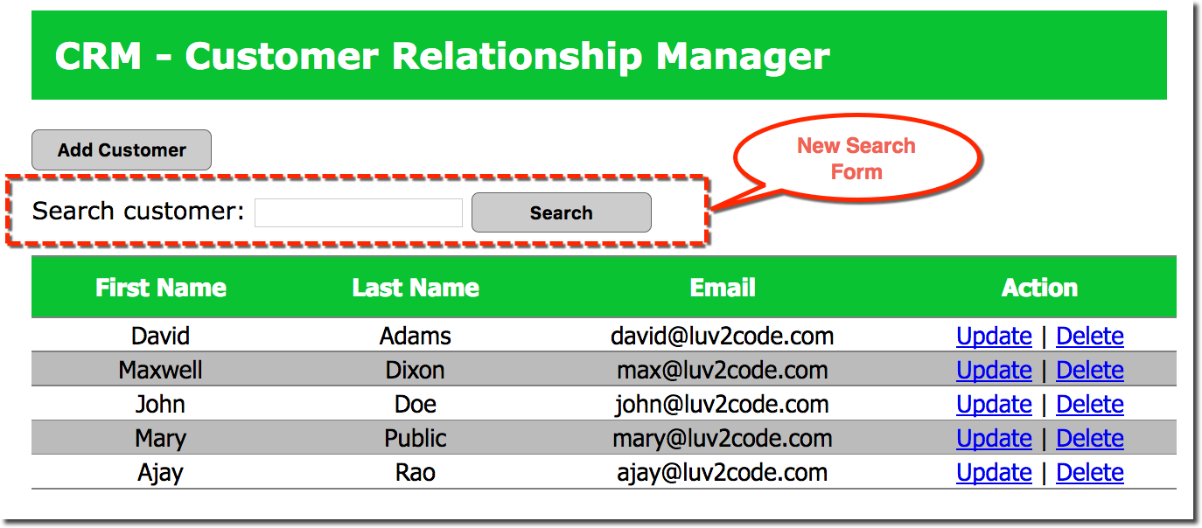

**Overview of Development Process**1. Create the HTML form  
2. Add mapping to the controller  
3. Add methods in the service layer to delegate to DAO  
4. Add method in the DAO to perfom search

**Download Source Code**All of the complete solution code is available for download here.

<http://www.luv2code.com/downloads/udemy-spring-hibernate/crm-tracker-bonus-search.zip>

I show you the detailed steps below so you can see what is added to each file.

**Detailed Steps**

**1. Create the HTML form**

You need to add a search form to read the user input and submit it to your Spring controller mapping

a. Edit the file: list-customers.jsp

b. We'll need to use Spring FORM tags, so at the  top of the file, add the following taglib reference

<%@ taglib prefix="form" uri="http://www.springframework.org/tags/form" %>

c. Now add a search form right after the search button

            <!--  add a search box -->  
            <form:form action="search" method="GET">  
                Search customer: <input type="text" name="theSearchName" />  
                  
                <input type="submit" value="Search" class="add-button" />  
            </form:form>

---

**2. Add mapping to the controller**

You need to add a mapping to handle the search form submission

a. Edit the file: CustomerController.java

b. Add the new mapping and method

    @GetMapping("/search")  
    public String searchCustomers(@RequestParam("theSearchName") String theSearchName,  
                                    Model theModel) {

        // search customers from the service  
        List<Customer> theCustomers = customerService.searchCustomers(theSearchName);  
                  
        // add the customers to the model  
        theModel.addAttribute("customers", theCustomers);

        return "list-customers";          
    }

c. You may have syntax errors on the customerService, but we'll resolve that in the next section.

---

**3. Add methods in the service layer to delegate to DAO**

You need to add methods in the service layer to delegate calls to the DAO

a. Edit the file: CustomerService.java

b. Add the method declaration

    public List<Customer> searchCustomers(String theSearchName);

c. Edit the file: CustomerServiceImpl.java

d. Add the method:

    @Override  
    @Transactional  
    public List<Customer> searchCustomers(String theSearchName) {

        return customerDAO.searchCustomers(theSearchName);  
    }

e. You may have syntax errors on the customerDAO, but we'll resolve that in the next section.

---

**4. Add method in the DAO to perfom search**

Now, we'll add methods in the DAO layer to search for a customer by first name or last name

a. Edit the file: CustomerDAO.java

b. Add the method declaration

    public List<Customer> searchCustomers(String theSearchName);

c. Edit the file: CustomerDAOImpl.java

d. Add the method:

    @Override  
    public List<Customer> searchCustomers(String theSearchName) {

        // get the current hibernate session  
        Session currentSession = sessionFactory.getCurrentSession();  
          
        Query theQuery = null;  
          
        //  
        // only search by name if theSearchName is not empty  
        //  
        if (theSearchName != null && theSearchName.trim().length() > 0) {

            // search for firstName or lastName ... case insensitive  
            theQuery =currentSession.createQuery("from Customer where lower(firstName) like :theName or lower(lastName) like :theName", Customer.class);  
            theQuery.setParameter("theName", "%" + theSearchName.toLowerCase() + "%");

        }  
        else {  
            // theSearchName is empty ... so just get all customers  
            theQuery =currentSession.createQuery("from Customer", Customer.class);              
        }  
          
        // execute query and get result list  
        List<Customer> customers = theQuery.getResultList();  
                  
        // return the results          
        return customers;  
          
    }

In this method, we need to check "theSearchName", this is the user input. We need to make sure it is not empty. If it is not empty then we will use it in the search query.  If it is empty, then we'll just ignore it and simply return all of the customers.

For the condition when "theSearchName" is not empty, then we use it to compare against the first name or last name. We also make use of the "like" clause and the "%" wildcard characters. This will allow us to search for substrings. For example, if we have customers with last name of "Patel", "Patterson" ... then we can search for "Pat" and it will match on those names.

Also, notice the query uses the lower case version of the values to make a case insensitive search. If you'd like to make a case sensitive search, then simply remove the lower references.

You can read more on the HQL "like" clause here:  
http://docs.jboss.org/hibernate/orm/5.2/userguide/html_single/Hibernate_User_Guide.html#hql-like-predicate

---

**5. Test the app**

Once you've made all of the updates then you can test your application.

The app will now have the search form at the top. You can enter a name to search and they app will give you the desired results.

Congrats!

## 34. AOP Aspect-Oriented Programming Overview

1. AOP - The Business Problem

2. AOP Solution and AOP Use Cases

3. Comparing Spring AOP and AspectJ

## 35. AOP @Before Advice Type

1. AOP @Before Advice Overview

2. AOP AOP Project Setup

Filter vào view

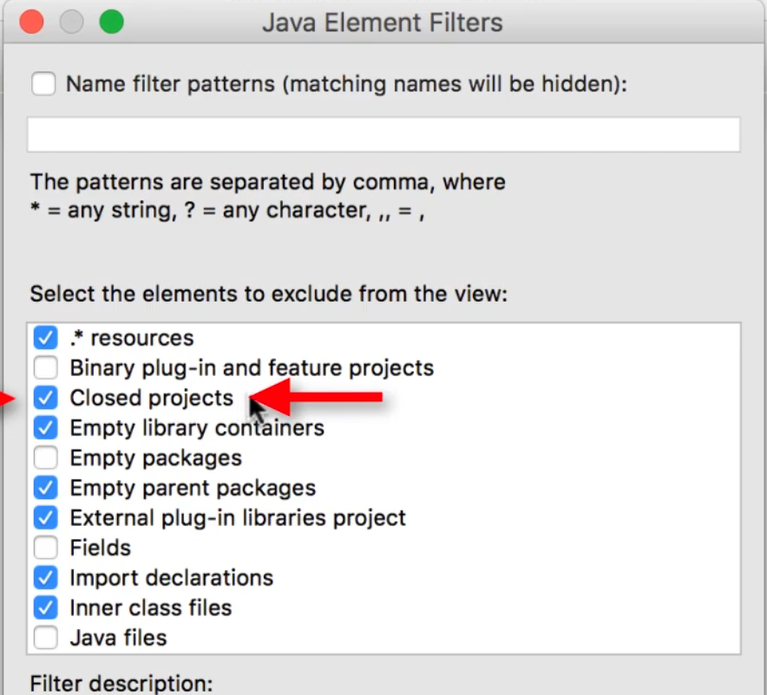

<http://luv2code.com/download-aspectjweaver>

<https://mvnrepository.com/artifact/org.aspectj/aspectjweaver>

Sau đó vào buildpath add

3. AOP @Before Advice - Write Some Code

4. AOP @Before Advice - Add and Test AOP Aspect

## 36. AOP Pointcut Expressions - Match Methods and Return Types

1. AOP - Pointcut Expressions Overview

2. AOP - Pointcut Expressions - Match any addAccount Method - Part 2

3. AOP - Pointcut Expressions - Match only DAO addAccount - Match any add Method

4. AOP - Pointcut Expressions - Match any Return Type

## 37. AOP Pointcut Expressions - Match Method Parameter Types

1. AOP Pointcut Expressions - Match Method Parameter Types Overview

2. AOP Pointcut Expressions - Match Method with Account and more Params

3. AOP Pointcut Expressions - Match Method Any Params - Match Method in a Package

## 38. AOP Pointcut Declarations

1. AOP Pointcut Declarations - Overview

2. AOP Pointcut Declarations - Write Some Code

3. AOP Combining Pointcuts - Overview

4. AOP Combining Pointcuts - Write Some Code - Part 1

5. AOP Combining Pointcuts - Write Some Code - Part 2

## 39. AOP Ordering Aspects

Thêm copy Qualify Name

## 40. AOP JoinPoints

## 41. AOP @AfterReturning Advice Type

Before => after => hàm main

## 42. AOP @AfterThrowing Advice Type

## 43. AOP @After Advice Type

## 44. AOP @Around Advice Type

## 45. AOP Add AOP Logging to Spring MVC App - Real-Time Project

## 46. Maven Crash Course

Free Maven Resources

Maven Reference Manual

• [www.luv2code.com/mavenreferencemanual](http://www.luv2code.com/mavenreferencemanual)

Maven eBooks

• [www.luv2code.com/mavenebooks](http://www.luv2code.com/mavenebooks)

Maven Cheat Sheet

• [www.luv2code.com/mavencheatsheet](http://www.luv2code.com/mavencheatsheet)

How to Install the m2eclipse Plugin.html

**How To Install Maven m2eclipse Plugin**

*Note: Recent releases of Eclipse (Mar, Neon, Oxygen) already have the m2eclipse plugin installed. Only follow these steps if you don't have the plugin installed.*

1. In Eclipse, select**Help > Install New Software**

This will display the Install dialog

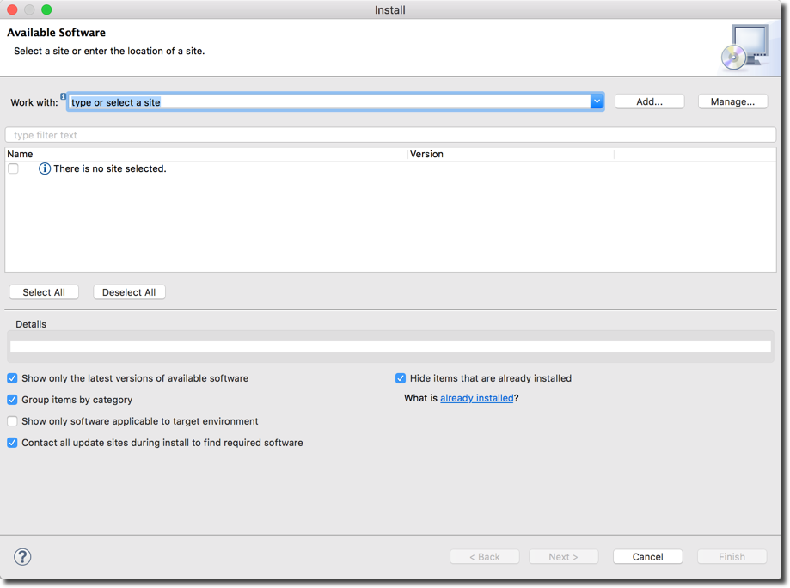

2. Click the **"Add..."** button.

3. In the dialog, enter the following from the screenshow below:

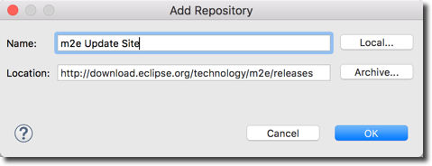

4. Wait for a couple of minutes while Eclipse fetches the files

5. In the dialog, check the box for**"Maven Integration for Eclipse"**

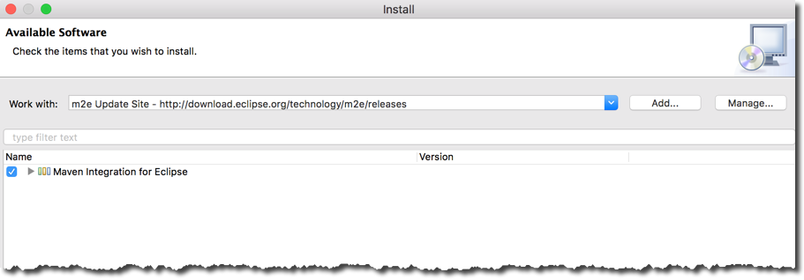

6. Click Next

7. It will show a dialog to review components, Click **Next**

8. Accept the License Agreement, Click **Finish**

9. Once installation is complete, restart Eclipse.

---

**Verify Installation**

10. In Eclipse, select **Help > Install New Software**

11. In bottom right of dialog, you will see a blue link: **What is already installed?**

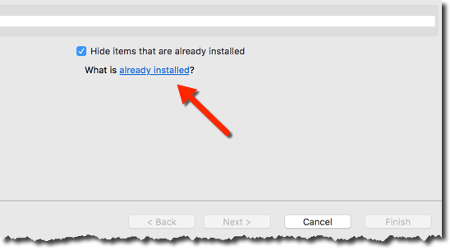

12. Click the link

13. In the dialog, filter on the text: **m2e**

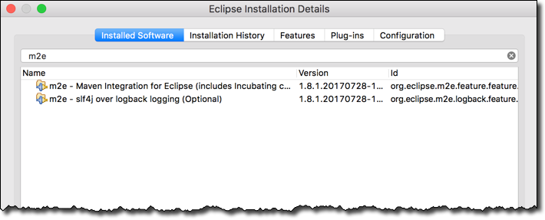  
  
14. If you see the m2e entries, then the plugin was installed successfully :-)

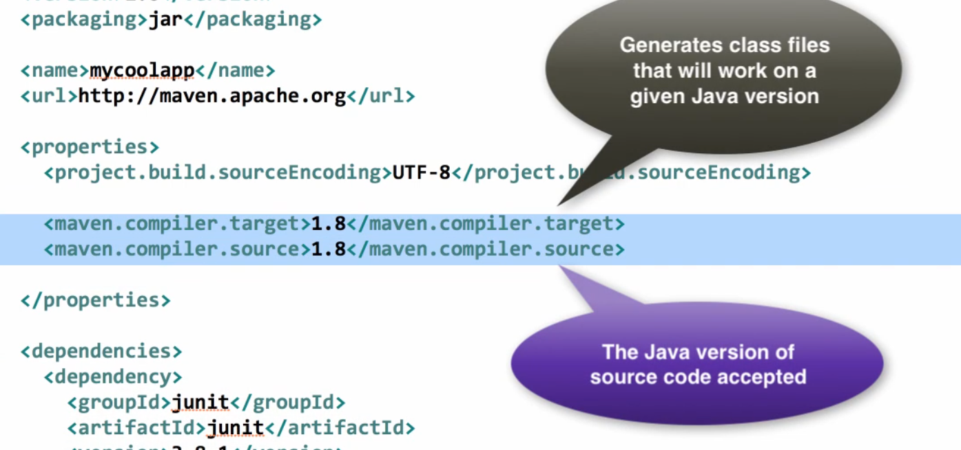

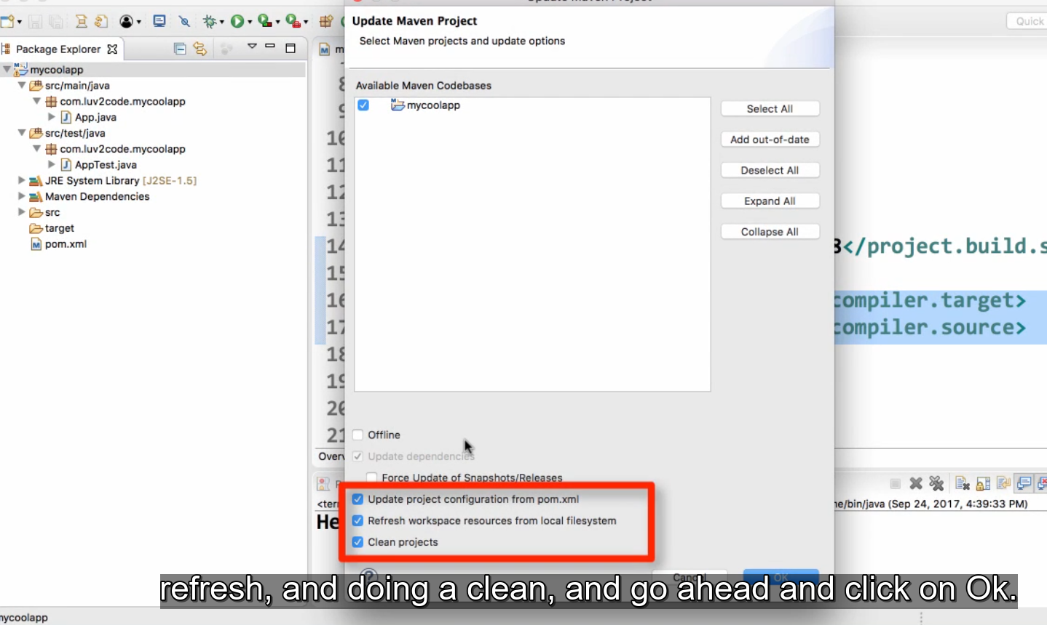

Add to project

**How to use Maven with customer-tracker project**This document explains the steps required to use the customer-tracker app with Maven.  
--  
1. Download link: **https://goo.gl/xBVDia**2. Unzip the file.  
3. Click **File > Import**4. Type the text **maven** in the search box under **Select an import source**:  
5. Select **Existing Maven Projects**  
6. Click **Browse** and select the **folder** that is the root of the Maven project (contains the  
pom.xml file)  
7. Click **OK** and then Click **Next**8. Click **OK**9. Under **Projects**: click the checkbox next to the **pom.xml** file  
10. Click **Finish**11. In the left hand panel, you will have a new Maven project for: **spring-web-customertracker**  
12. You can run this project using: right-click, Run As > Run on Server  
13. Your app will run and you will see output like this:  
Congrats! You just imported a Maven project :-)

## 47. Spring Security - Getting Started

1. Spring Security - Overview

2. Spring Security - Demo

3. Spring Security - All Java Configuration - Part 1

4. Spring Security - All Java Configuration - Part 2

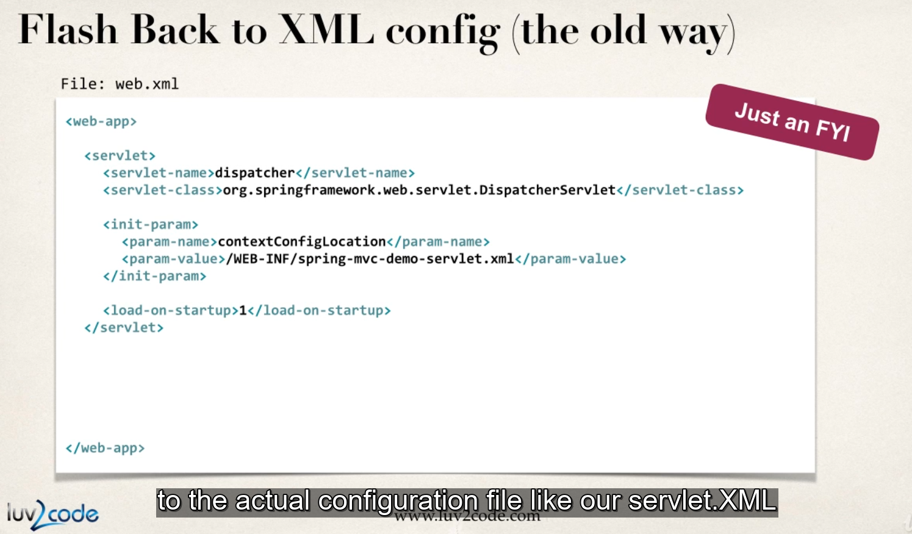

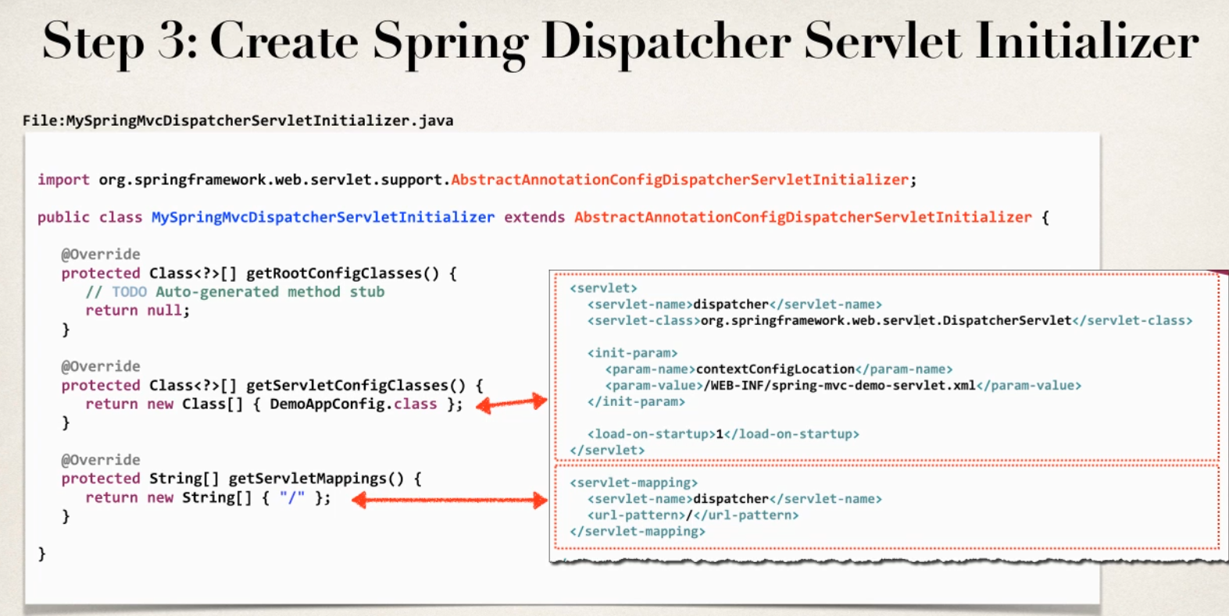



spring-security-demo-01-base-app

Import maven project error => fix add

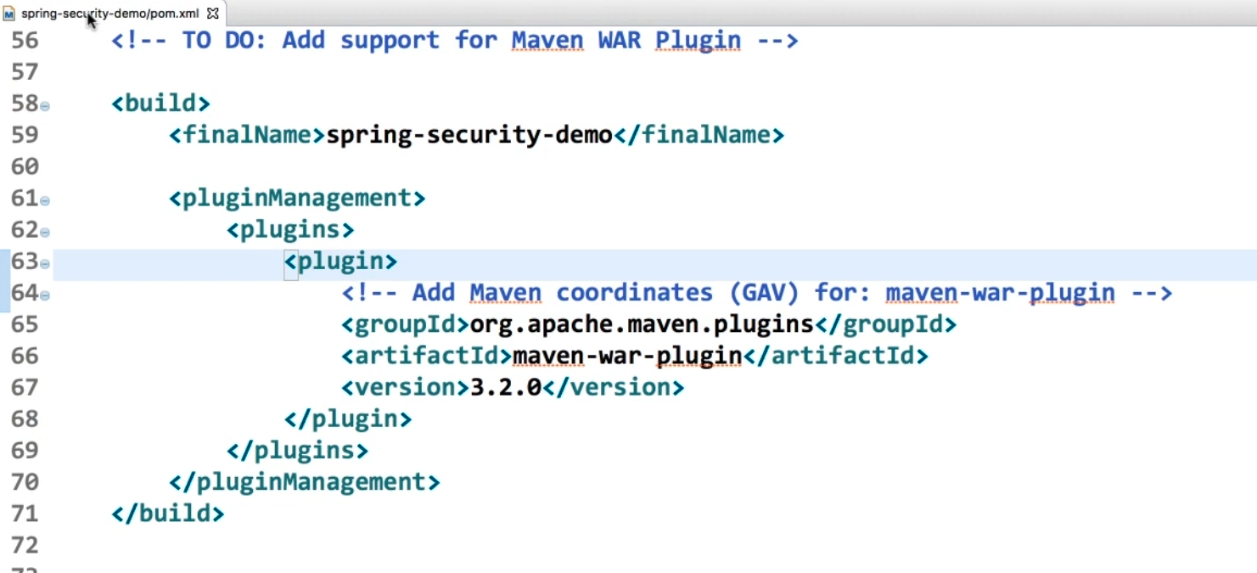

Maven update project

FAQ:  Maven can't find a class, but it is listed in the pom.xml

First, double-check that you have the correct Maven coordinates in the file (groupId, artifactId and version). Look for typos.

--

This could be caused by a corrupt local Maven repo. You can resolve it with these steps.

**Option 1:**

1. On your project, right-click: Maven > Update Project

2. In the dialog, check the box: Force Update of Snapshots/Releases

3. Click Ok

Maven will perform a rebuild.

If that doesn't solve your problem then move to option 2

**Option 2:**

1. Delete your local Maven repo, the .m2 directory on your computer

On MS Windows

either    
C:\Documents and Settings\<yourUserName>\.m2  
c:\Users\<yourUserName>\.m2

On Mac/Linux

~/.m2

--

*Note, on your OS, you may need to configure your OS to show hidden files.*

2. Once .m2 directory is deleted, restart Eclipse

3. On your project, right-click: Maven > Update Project

This will resolve your issue.

Spring Security - Latest Version.html

**UPDATES - Spring Security 5.1.1**

Spring Security 5.1.1 was released on 16 October 2018. This is a maintenance/bug fix release.

Spring Security 5.1.1 is compatible with Spring Framework 5.1.1

If you want to use the latest version, update your Maven POM file to use the compatible versions below

<springframework.version>5.1.1.RELEASE</springframework.version>

<springsecurity.version>5.1.1.RELEASE</springsecurity.version>

---

**UPDATES - Spring Security 5.1.0**

Spring Security 5.1.0 was released on 27 September 2018. This is a maintenance/bug fix release.

Spring Security 5.1.0 is compatible with Spring Framework 5.1.0

If you want to use the latest version, update your Maven POM file to use the compatible versions below

<springframework.version>5.1.0.RELEASE</springframework.version>

<springsecurity.version>5.1.0.RELEASE</springsecurity.version>

---

**UPDATES - Spring Security 5.0.7**

Spring Security 5.0.7 was released on 26 July 2018. This is a maintenance/bug fix release.

Spring Security 5.0.7 is compatible with Spring Framework 5.0.8

If you want to use the latest version, update your Maven POM file to use the compatible versions below

<springframework.version>5.0.8.RELEASE</springframework.version>

<springsecurity.version>5.0.7.RELEASE</springsecurity.version>

---

**UPDATES - Spring Security 5.0.6**

Spring Security 5.0.6 was released on 13 June 2018. This is a maintenance/bug fix release.

Spring Security 5.0.6 is compatible with Spring Framework 5.0.7

If you want to use the latest version, update your Maven POM file to use the compatible versions below

<springframework.version>5.0.7.RELEASE</springframework.version>

<springsecurity.version>5.0.6.RELEASE</springsecurity.version>

---

**UPDATES - Spring Security 5.0.5**

Spring Security 5.0.5 was released on 8 May 2018. This is a maintenance/bug fix release.

Spring Security 5.0.5 is compatible with Spring Framework 5.0.6

If you want to use the latest version, update your Maven POM file to use the compatible versions below

<springframework.version>5.0.6.RELEASE</springframework.version>

<springsecurity.version>5.0.5.RELEASE</springsecurity.version>

---

**UPDATES - Spring Security 5.0.4**

Spring Security 5.0.4 was released on 5 April 2018. This is a maintenance/bug fix release.

Spring Security 5.0.4 is compatible with Spring Framework 5.0.5

If you want to use the latest version, update your Maven POM file to use the compatible versions below

<springframework.version>5.0.5.RELEASE</springframework.version>

<springsecurity.version>5.0.4.RELEASE</springsecurity.version>

---

**UPDATES - Spring Security 5.0.3**

Spring Security 5.0.3 was released the week of 28 Feb 2018. This is a maintenance/bug fix release.

Spring Security 5.0.3 is compatible with Spring Framework 5.0.4

If you want to use the latest version, update your Maven POM file to use the compatible versions below

<springframework.version>5.0.4.RELEASE</springframework.version>

<springsecurity.version>5.0.3.RELEASE</springsecurity.version>

---

**UPDATES - Spring Security 5.0.2**

Spring Security 5.0.2 was released the week of 20 Feb 2018. This is a maintenance/bug fix release.

Spring Security 5.0.2 is compatible with Spring Framework 5.0.4

If you want to use the latest version, update your Maven POM file to use the compatible versions below

<springframework.version>5.0.4.RELEASE</springframework.version>

<springsecurity.version>5.0.2.RELEASE</springsecurity.version>

**---**

**UPDATES Spring Security 5.0.1**

Spring Security 5.0.1 was released the week of 24 Jan 2018. This is a maintenance/bug fix release.

Spring Security 5.0.1 is compatible with Spring Framework 5.0.3

If you want to use the latest version, update your Maven POM file to use the compatible versions below

<springframework.version>5.0.3.RELEASE</springframework.version>

<springsecurity.version>5.0.1.RELEASE</springsecurity.version>

## 48. Spring Security - Adding Custom Login Form

Fix error

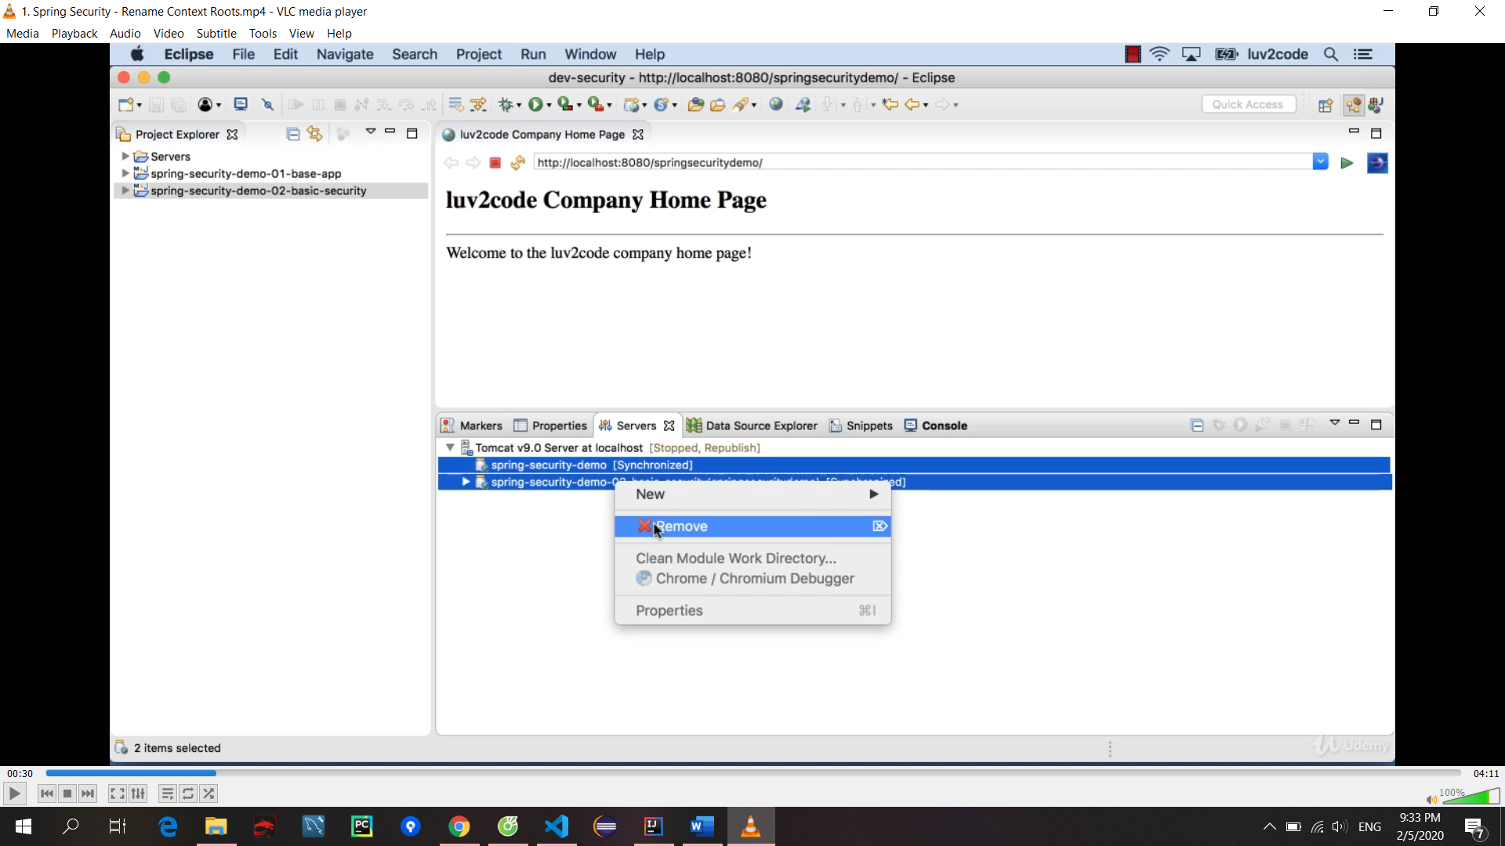

## 49. Spring Security - Boostrap CSS Login Form

5. Spring Dependency Injection - XML Configuration

50. Spring Security - Adding Logout Support

51. Spring Security - Cross Site Request Forgery (CSRF)

52. Spring Security - User Roles

53. Spring Security - Restrict Access Based on Role

54. Spring Security - Add JDBC Database Authentication

55. Spring Security - Password Encryption

56. Spring REST - Overview

57. Spring REST - JSON Data Binding

58. Spring REST - Create a Spring REST Controller

59. Spring REST - Retrieve POJOs as JSON

6. Spring Bean Scopes and Lifecycle

60. Spring REST - Using @PathVariable for REST Endpoints

61. Spring REST - Exception Handling

62. Spring REST - API Design Best Practices

63. Spring REST - CRUD Database Real-Time Project - Overview

64. Spring REST - CRUD Database Real-Time Project - Get Customers

65. Spring REST - CRUD Database Real-Time Project - Exception Handling

66. Spring REST - CRUD Database Real-Time Project - Add Customer

67. Spring REST - CRUD Database Real-Time Project - Update Customer

68. Spring REST - CRUD Database Real-Time Project - Delete Customer

69. Spring REST - Bonus Lectures

<http://www.luv2code.com/downloads/udemy-spring-hibernate/spring-rest/adding-spring-security-to-crm-rest-api.pdf>

**Bonus: Creating a REST Client with Spring**

We previously created a CRM web app using JSP. Wouldn’t it be great if we could have the CRM web app leverage the CRM REST API for data?

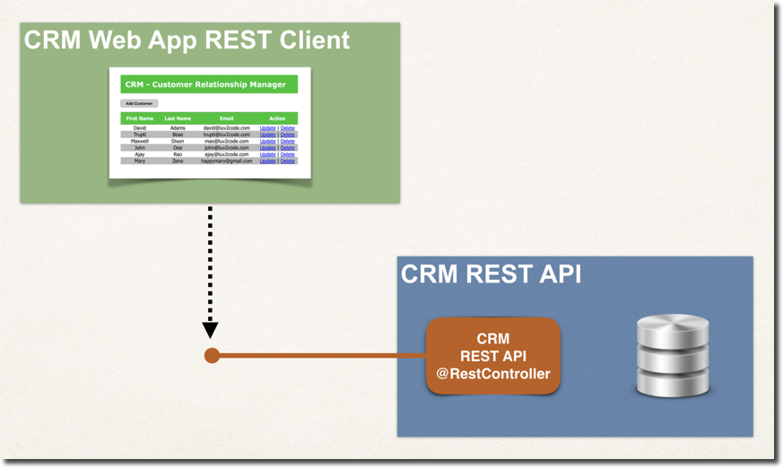

We cover this functionality in the following PDF document.

PDF: <http://www.luv2code.com/crm-web-app-rest-client-demo-pdf>

Also the full source code is available for download

Source Code: <http://www.luv2code.com/crm-web-app-rest-client-demo-code>

Enjoy!!!

7. Spring Configuration with Java Annotations - Inversion of Control

## 70. Spring Boot – Overview

Avoid SNAPSHOT version

## 71. Spring Boot - Spring Boot Dev Tools and Spring Boot Actuator

## 72. Spring Boot - Running Spring Boot Apps from the Command Line

## 73. Spring Boot - Application Properties

## 74. Spring Boot - Build a REST CRUD API with Hibernate - Real-Time Project

## 75. Spring Boot - Build a REST CRUD API with JPA - Real-Time Project

## 76. Spring Boot - Spring Data JPA - Real-Time Project

## 77. Spring Boot - Spring Data REST - Real-Time Project

## 78. Spring Boot - Thymeleaf

## 79. Spring Boot - Thymeleaf - Build HTML Tables

## 80. Spring Boot - Thymeleaf - CRUD Database Real-Time Project

## 83. Bonus Spring Boot Deployments on Tomcat

1. Deploying Spring Boot WAR file with JSP to Tomcat.html

**Deploy Spring Boot apps with JSP to Tomcat**

You can deploy a Spring Boot application using JSP to Tomcat. In this scenario, we will create a WAR file and deploy the WAR to the Tomcat server running externally. This is known as a traditional deployment.

**High-level steps**

1. Update main Spring Boot application

2. Update Maven POM file

3. Update application.properties

4. Move JSP view files to WEB-INF/view

5. Create WAR file

6. Deploy to Tomcat

**Spring Boot Reference Manual**

For full details on this process, see the [Spring Boot Reference Manual: Section 92.1 Creating a Deployable WAR file](https://docs.spring.io/spring-boot/docs/current/reference/htmlsingle/#howto-create-a-deployable-war-file)

**Working Example**

I have a full working project. You can download this app and perform test deployments to Tomcat

Download: [deploy-spring-boot-and-jsp-on-tomcat.zip](https://drive.google.com/open?id=1jgjQ1DCpowDJxlFje-dS6rjoQKRcYtCe)

This app is a very simple helloworld example that exposes a "/test" request mapping

package org.demo.bootjsp.controller;

import org.springframework.stereotype.Controller;

import org.springframework.web.bind.annotation.RequestMapping;

@Controller

public class HelloWorldController {

@RequestMapping("/test")

public String sayHello() {

return "hello";

}

}

and a simple JSP page: hello.jsp

<html><body>

<p>

Hello World! Time is <%= new java.util.Date() %>

</p>

<p>

We are running on <%= application.getServerInfo() %>!!!

</p>

</body></html>

----

**Detailed steps**

**1. Update main Spring Boot application**

In your main Spring Boot application, you need to

a. extend the SpringBootServletInitializer

b. override the configure(...) method

Your code should look like this

package org.demo.bootjsp;

import org.springframework.boot.SpringApplication;

import org.springframework.boot.autoconfigure.SpringBootApplication;

import org.springframework.boot.builder.SpringApplicationBuilder;

import org.springframework.boot.web.servlet.support.SpringBootServletInitializer;

@SpringBootApplication

public class DemowebApplication extends SpringBootServletInitializer {

@Override

protected SpringApplicationBuilder configure(SpringApplicationBuilder application) {

return application.sources(DemowebApplication.class);

}

public static void main(String[] args) {

SpringApplication.run(DemowebApplication.class, args);

}

}

**2. Update Maven POM file**

Update your POM.xml to use WAR packaging

<packaging>war</packaging>

In POM.xml, add dependency to be able to compile JSPs

<dependency>

<groupId>org.apache.tomcat.embed</groupId>

<artifactId>tomcat-embed-jasper</artifactId>

</dependency>

Make sure the Tomcat embedded does not interfere with external Tomcat server

<dependency>

<groupId>org.springframework.boot</groupId>

<artifactId>spring-boot-starter-tomcat</artifactId>

<scope>provided</scope>

</dependency>

**3. Update application.properties**

In your application.properties file, you should have

spring.mvc.view.prefix=/WEB-INF/view/

spring.mvc.view.suffix=.jsp

**4. Move JSP view files to WEB-INF/view**

Move your JSP view pages should to src/main/webapp/WEB-INF/view

**5. Create WAR file**

Create the WAR file with the command: mvn clean package

This will generate a WAR file in your project directory:  **target/bootjspdemo.war**

6. In Eclipse, stop all servers you may have running

7. Outside of Eclipse, run your Tomcat server

8. Copy your WAR file to the **<<tomcat-install-dir>>/webapps** directory

Wait for about 15-30 seconds for Tomcat to deploy your app. You will know your app is deployed when you see a new folder created based on your WAR file name. In our example, you will see a new directory named: **bootjspdemo**

9. In a web browser, access your app at: http://localhost:8080/bootjspdemo/test

Replace <<bootjspdemo>> with the name of your WAR file if you are using a different app

If everything is successful, you will see your application's web page.

Congratulations! You deployed a Spring Boot WAR file with JSP on to a Tomcat server :-)

2. Deploy Spring Boot WAR file with Thymeleaf to Tomcat.html

**Deploy Spring Boot apps with Thymeleaf to Tomcat**

You can deploy a Spring Boot application as a WAR file to Tomcat. In this scenario, we will use Thymeleaf as the view template.

We will create a WAR file and deploy the WAR to the Tomcat server. This is known as a traditional deployment.

**High-level steps**

1. Update main Spring Boot application

2. Update Maven POM file

3. Create WAR file

4. Deploy to Tomcat

**Spring Boot Reference Manual**

For full details on this process, see the [Spring Boot Reference Manual: Section 92.1 Creating a Deployable WAR file](https://docs.spring.io/spring-boot/docs/current/reference/htmlsingle/#howto-create-a-deployable-war-file)

**Working Example**

I have a full working project. You can download this app and perform test deployments to Tomcat

Download: [deploy-spring-boot-war-with-thymeleaf-on-tomcat.zip](https://drive.google.com/open?id=1YhrLfvCCNUxJ9CFfFncbtVO3qdbc7FYI)

This app is a very simple helloworld example that exposes a "/test" request mapping

package com.luv2code.deploydemo.controller;

import org.springframework.stereotype.Controller;

import org.springframework.web.bind.annotation.RequestMapping;

@Controller

public class HelloWorldController {

@RequestMapping("/test")

public String sayHello() {

return "hello";

}

}

and a simple Thymeleaf page: hello.html

<!DOCTYPE HTML>

<html lang="en" xmlns:th="http://www.thymeleaf.org">

<body>

<h3>Hello World from Thymeleaf!</h3>

<p>

We are running on <span th:text="${#servletContext.getServerInfo()}"></span>!!!

</p>

</body>

</html>

----

**Detailed steps**

**1. Update main Spring Boot application**

In your main Spring Boot application, you need to

a. extend the SpringBootServletInitializer

b. override the configure(...) method

Your code should look like this

package com.luv2code.deploydemo;

import org.springframework.boot.SpringApplication;

import org.springframework.boot.autoconfigure.SpringBootApplication;

import org.springframework.boot.builder.SpringApplicationBuilder;

import org.springframework.boot.web.servlet.support.SpringBootServletInitializer;

@SpringBootApplication

public class DeploydemoApplication extends SpringBootServletInitializer {

@Override

protected SpringApplicationBuilder configure(SpringApplicationBuilder application) {

return application.sources(DeploydemoApplication.class);

}

public static void main(String[] args) {

SpringApplication.run(DeploydemoApplication.class, args);

}

}

**2. Update Maven POM file**

Update your POM.xml to use WAR packaging

<packaging>war</packaging>

The WAR packaging should appear just after your Maven coordinates (group, artifact, version)

<groupId>com.luv2code</groupId>

<artifactId>deploydemo</artifactId>

<version>0.0.1-SNAPSHOT</version>

<packaging>war</packaging>

Make sure the Tomcat embedded does not interfere with external Tomcat server

<dependency>

<groupId>org.springframework.boot</groupId>

<artifactId>spring-boot-starter-tomcat</artifactId>

<scope>provided</scope>

</dependency>

**3. Create WAR file**

Create the WAR file with the command: mvn clean package

This will generate a WAR file in your project directory:  **target/deploydemo.war**

4. In Eclipse, stop all servers you may have running

5. Outside of Eclipse, run your Tomcat server

6. Copy your WAR file to the **<<tomcat-install-dir>>/webapps** directory

Wait for about 15-30 seconds for Tomcat to deploy your app. You will know your app is deployed when you see a new folder created based on your WAR file name. In our example, you will see a new directory named: **deploydemo**

7. In a web browser, access your app at: http://localhost:8080/deploydemo/test

Replace <<deploydemo>> with the name of your WAR file if you are using a different app

If everything is successful, you will see your application's web page.

Congratulations! You deployed a Spring Boot WAR file with Thymeleaf on a Tomcat server :-)

Optional

<https://community.oracle.com/docs/DOC-991686>

<http://www.luv2code.com/java-optional-tutorial>